云南大学数学与统计学院

上机实践报告

|  |  |  |
| --- | --- | --- |
| **课程名称**：数据结构与算法实验 | **年级**：2015级 | **上机实践成绩**： |
| **指导教师**：陆正福 | **姓名**：刘鹏 |  |
| **上机实践名称**：图结构实验 | **学号**：20151910042 | **上机实践日期**：2017-05-15 |
| **上机实践编号**：No.14 | **组号**： | **上机实践时间**：上午3、4节 |

# 一、实验目的

1. 熟悉与图有关的数据结构与算法

2. 熟悉主讲教材Chapter 14的代码片段

# 二、实验内容

1. 与图有关的数据结构设计与算法设计；

2. 调试主讲教材Chapter 14的Python程序；

# 三、实验平台

Windows 10 Enterprise 中文版；

Python 3.6.0；

Wing IDE Professional 6.0.5-1集成开发环境。

# 四、实验记录与实验结果分析

1题

用邻接图实现图结构。有向图与无向图都必须兼容。

程序代码：

|  |  |
| --- | --- |
| 1  2  3  4  5  6  7  8  9  10  11  12  13  14  15  16  17  18  19  20  21  22  23  24  25  26  27  28  29  30  31  32  33  34  35  36  37  38  39  40  41  42  43  44  45  46  47  48  49  50  51  52  53  54  55  56  57  58  59  60  61  62  63  64  65  66  67  68  69  70  71  72  73  74  75  76  77  78  79  80  81  82  83  84  85  86  87  88  89  90  91  92  93  94  95  96  97  98  99  100  101  102  103  104  105  106  107  108  109  110  111  112  113  114  115  116  117  118  119  120  121  122  123  124  125  126  127  128  129  130  131  132  133  134  135  136  137  138  139  140  141  142  143  144  145  146  147  148  149  150  151  152  153  154  155  156  157  158  159  160  161  162  163  164  165  166  167  168  169  170  171  172  173  174  175  176 | # 14.2.5 Python Implementation  **class** **Graph:**  """Representation of a simple graph using an adjacency map."""  #------------------------- nested Vertex class -------------------------  **class** **Vertex:**  """Lightweight vertex structure for a graph."""  __slots__ **=** '_element'  **def** __init__**(**self**,**x**):**  """Do not call constructor directly.  Use Graph's insert_vertex(x).  """  self**.**_element **=** x  **def** element**(**self**):**  """Return element associated with this vertex."""  **return** self**.**_element  **def** __hash__**(**self**):** # will allow vertex to be a map/set key  **return** hash**(**id**(**self**))**  #------------------------- nested Edge class -------------------------  **class** **Edge:**  """Lightweight edge structure for a graph."""  __slots__ **=** '_origin'**,**'_destination'**,**'_element'  **def** __init__**(**self**,**u**,**v**,**x**):**  """Do not call constructor directly.  Use Graph's insert_edge(u,v,x).  """  self**.**_origin **=** u  self**.**_destination **=** v  self**.**_element **=** x    **def** endpoints**(**self**):**  """Return (u,v) tuple for vertices u and v."""  **return** **(**self**.**_origin**,**self**.**_destination**)**  **def** opposite**(**self**,**v**):**  """Return the vertex that is opposite v on this edge."""  **return** self**.**_destination **if** v **is** self**.**_origin **else** self**.**_origin  **def** element**(**self**):**  """Return element associated with this edge."""  **return** self**.**_element  **def** __hash__**(**self**):** # will allow edge to be a map/set key  **return** hash**((**self**.**_origin**,**self**.**_destination**))**  #------------------------- Graph class -------------------------  **def** __init__**(**self**,**directed**=False):**  """Create an empty graph (undirected, by default).  Graph is directed if optional parameter is set to True.  """  self**.**_outgoing **=** **{}**  # only create second map for directed graph; use alias for undirected  self**.**_incoming **=** **{}** **if** directed **else** self**.**_outgoing  **def** is_directed**(**self**):**  """Return True if this is a directed graph; False if undirected.  Property is based on the original declaration of the graph, not its  contents.  """  **return** self**.**_incoming **is** **not** self**.**_outgoing  # directed if maps are distinct  **def** vertex_count**(**self**):**  """Return the number of vertices in the graph."""  **return** len**(**self**.**_outgoing**)**  **def** vertices**(**self**):**  """Return an iteration of all vertices of the graph."""  **return** self**.**_outgoing**.**keys**()**  **def** edge_count**(**self**):**  """Return the number of edges in the graph."""  total **=** sum**(**len**(**self**.**_outgoing**[**v**])** **for** v **in** self**.**_outgoing**)**  # for undirected graphs, make sure not to double-count edges  **return** total **if** self**.**is_directed**()** **else** total **//** 2  **def** edges**(**self**):**  """Return a set of all edges of the graph."""  result **=** set**()** # avoid double-reporting edges of undirected graph  **for** secondary_map **in** self**.**_outgoing**.**values**():**  result**.**update**(**secondary_map**.**values**())** # add edges to resulting set  **return** result  **def** get_edge**(**self**,**u**,**v**):**  """Return the edge from u to v, or None if not adjacent."""  **return** self**.**_outgoing**[**u**].**get**(**v**)**    **def** degree**(**self**,**v**,**outgoing**=True):**  """Return number of (outgoing) edges incident to vertex v in the graph.  If graph is directed, optional parameter used to count incoming edges.  """  adj **=** self**.**_outgoing **if** outgoing **else** self**.**_incoming  **return** len**(**adj**[**v**])**  **def** incident_edges**(**self**,**v**,**outgoing**=True):**  """Return all (outgoing) edges incedent to vertex v in the graph.  If graph is directed, optional parameter used to request incoming edges.  """  adj **=** self**.**_outgoing **if** outgoing **else** self**.**_incoming  **for** edge **in** adj**[**v**].**values**():**  **yield** edge  **def** insert_vertex**(**self**,**x**=None):**  """Insert and return a new Vertex with element x."""  v **=** self**.**Vertex**(**x**)**  self**.**_outgoing**[**v**]** **=** **{}**  **if** self**.**is_directed**():**  self**.**_incoming**[**v**]** **=** **{}** # need distinct map for incoming edges  **return** v  **def** insert_edge**(**self**,**u**,**v**,**x**=None):**  """Insert and return a new Edge from u to v with auxiliary element x."""  e **=** self**.**Edge**(**u**,** v**,** x**)**  self**.**_outgoing**[**u**][**v**]** **=** e  self**.**_incoming**[**v**][**u**]** **=** e  #------------------------------ my main function ------------------------------  G **=** Graph**()**  '''Let us generate the graph in this section! '''  u **=** G**.**insert_vertex**(**'vertex: u'**)**  v **=** G**.**insert_vertex**(**'vertex: v'**)**  w **=** G**.**insert_vertex**(**'vertex: w'**)**  z **=** G**.**insert_vertex**(**'vertex: z'**)**  e **=** G**.**insert_edge**(**u**,**v**,**'edge: e'**)**  f **=** G**.**insert_edge**(**v**,**w**,**'edge: f'**)**  g **=** G**.**insert_edge**(**u**,**w**,**'edge: g'**)**  h **=** G**.**insert_edge**(**w**,**z**,**'edge: h'**)**  i **=** G**.**insert_edge**(**u**,**z**,**'edge: LiuPeng :)'**)**  # Let us test out graph G  Gi **=** G**.**vertices**()**  Gii **=** iter**(**Gi**)**  **print(**Gii**.**__next__**().**_element**)**  **print(**u**.**_element**)**  **print(**Gii**.**__next__**().**_element**)**  **print(**v**.**_element**)**  **print(**Gii**.**__next__**().**_element**)**  **print(**w**.**_element**)**  **print(**Gii**.**__next__**().**_element**)**  **print(**z**.**_element**)**  **print(**''**)**  VertexList **=** list**(**G**.**_outgoing**.**keys**())**  **for** i **in** VertexList**:**  VertexAdj **=** list**(**G**.**incident_edges**(**i**))**  guard **=** **True**  **for** j **in** range**(**len**(**VertexAdj**)):**  **if(**guard**):**  sign **=** i**.**_element  **else:**  sign **=** 'o------->'  **print(**sign**,**VertexAdj**[**j**].**opposite**(**i**).**_element**,**\  G**.**get_edge**(**i**,**VertexAdj**[**j**].**opposite**(**i**)).**_element**)**  guard **=** **False**  **print(**''**)** |

程序代码 1

运行结果

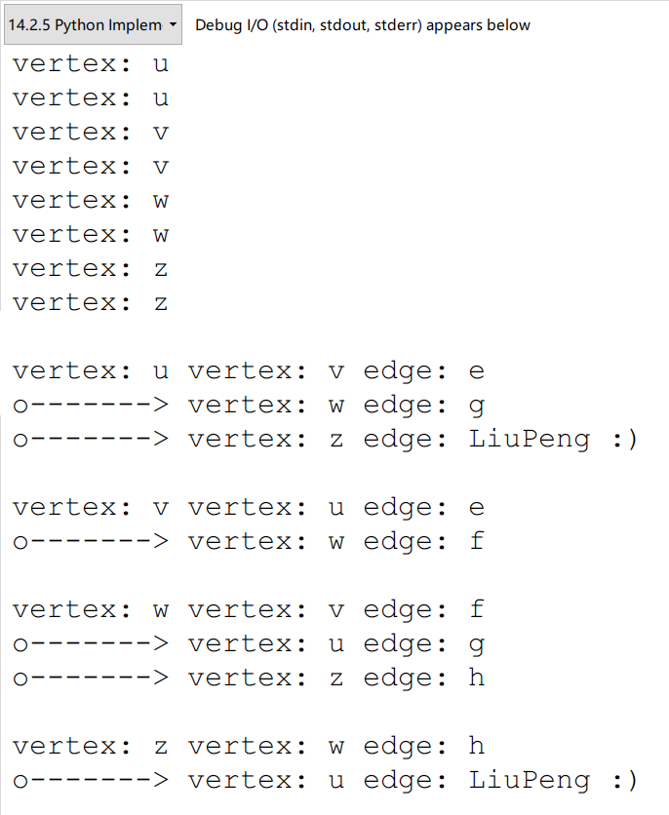

运行结果 1

代码分析：

id方法，会返回参数对象的内存地址。

经过翻译与思考，我知道了，图结构是用字典套字典的方式实现的。相对比较复杂。因为历史原因，Python的字典初始化是a = {}，而集合初始化是a = set()，这一点需要特殊注意，课本中多次提到。可以看到，在代码中，程序员给Graph类的初始化就是一个空字典。而insert_vertex方法中，可以看到，程序员先是生成一个vertex对象：v = self.Vertex(x)，然后有一句很关键的话：self._outgoing[v] = {}，即在_outgoing字典中，加入v这个key之后，对v的value进行赋予时，又赋予它一个字典，而且是空的。这充分说明了程序员采用了字典嵌套的方式。



我用书上的图进行construction，得到了代码中的图G，我另外添加了一条u，z之间的新边，以我名字命名LiuPeng。然后，通过字典key，value的迭代器生成器之类的东西，用循环，把图用文本形式输出了。

# 五、教材翻译

**Translation**

Chapter 14 Graph Algorithm

＊第十四章 图论算法

14.1 Graphs

＊14.1节 图

A ***graph*** is a way of representing relationships that exist between pairs of objects. That is, a graph is a set of objects, called vertices, together with a collection of pairwise connections between them, called edges. Graphs have applications in modeling many domains, including mapping, transportation, computer networks, and electrical engineering. By the way, this notion of a “graph” should not be confused with bar charts and function plots, as these kinds of “graphs” are unrelated to the topic of this chapter.

＊图是表示对象之间存在的关系的一种方式。也就是说，图是一组对象，即顶点与边（顶点之间的成对连接）的集合。图在许多建模领域中有应用，包括地图，运输，计算机网络和电气工程。顺便提一句，这个“图”的概念不应该与条形图和函数图像混淆，因为这些“图”与本章的主题无关。

Viewed abstractly, a ***graph*** G is simply a set V of ***vertices*** and a collection E of pairs of ***edges***. Thus, a graph is a way of representing connections or relationships between pairs of objects from some set V. Incidentally, some books use different terminology for graphs and refer to what we call vertices as ***nodes*** and what we call edges as ***arcs***. We use the terms “vertices” and “edges.”

＊抽象地看，图G只是顶点集合V与顶点之间边的集合E的并集。因此，图是表示来自某些集合V的对象之间的连接性或关系的方式。顺便提一下，一些书籍对于图使用不同的术语，并且将所谓的顶点称为节点，我们将所谓的边缘称为辐。我们使用的是“顶点”和“边”。

Edges in a graph are either ***directed*** or ***undirected***. An edge (*u*, *v*) is said to be ***directed*** from u to v if the pair (*u*, *v*) if ordered, with u preceding v. An edge (*u*, *v*) is said to be ***undirected*** if the pair (*u*, *v*) is not ordered. Undirected edges are sometimes denoted with set notation, as {*u*, *v*}, but for simplicity we use the pair notation (*u*, *v*), noting that in the undirected case (*u*, *v*) is the same as (*v*, *u*). Graphs are typically visualized by drawing the vertices as ovals or rectangles and the edges as segments or curves connecting pairs of ovals and rectangles. The following are some examples of directed and undirected graphs.

＊图中的边可能是有向的，也有可能是无向的。如果(u,v)是有序的，即u在v前面，那么(u,v)被认为是从u到v的有向边。如果(u,v)是无序的，那么(u,v)被认为是无向边。有时用{u,v}表示无向边，但为了简单起见，我们使用符号串(u,v)，注意在无向的情况下(u,v)与(v,u)相同。通常通过将顶点绘制为椭圆形或矩形，并将边缘作为连接一对椭圆或者矩形的线段或曲线来显示图形。以下是有向和无向图的一些示例。

**Example 14.1**: *We can visualize collaborations among the researchers of a certain discipline by constructing a graph whose vertices are associated with the researchers themselves, and whose edges connect pairs of vertices associated with researchers who have coauthored a paper or book. (See Figure 14.1.) Such edges are undirected because coauthorship is a* **symmetric** *relation; that is, if A has coauthored something with B, then B necessarily has coauthored something with A.*

＊示例14.1：我们可以通过构建一个图，图的顶点与本书的研究人员相对应，并且两个定点之间相互连接表示这两个研究者曾经合作写过论文与书籍，这样一来，我们就把某一学科的研究者之间的协作变得可视化了。（见图14.1）这样的边是无向的，因为共同创作是一个对称的关系；也就是说，如果A与B共同合作，则B肯定是与A合作。

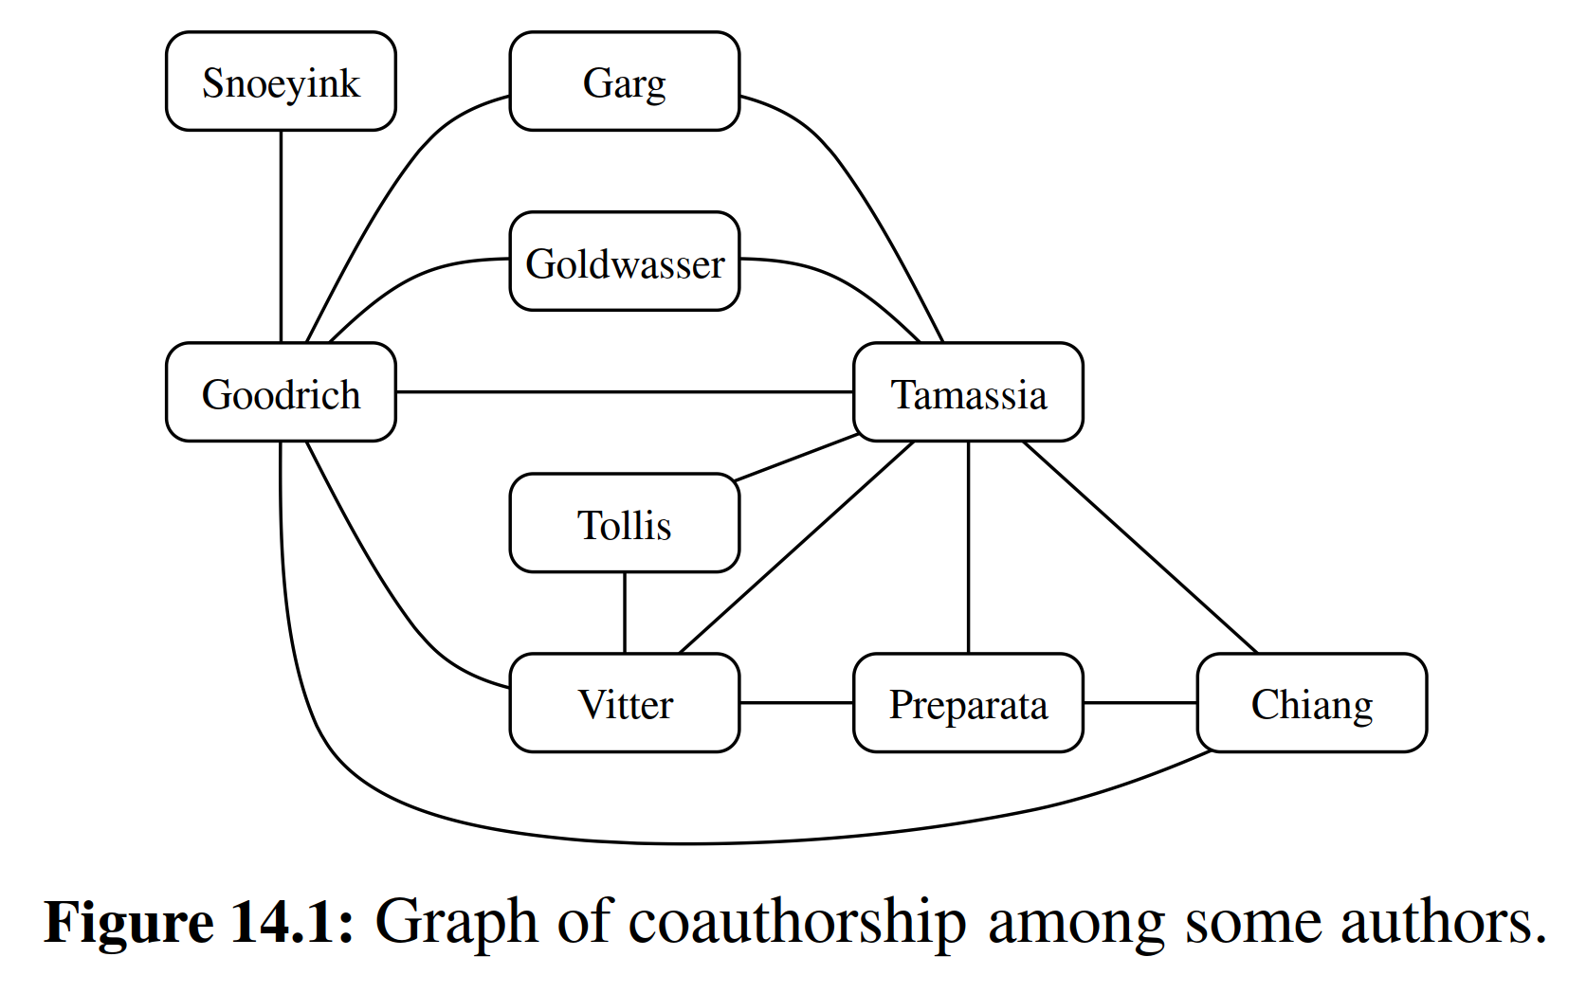

**Example 14.2**: *We can associate with an object-oriented program a graph whose vertices represent the classes deﬁned in the program, and whose edges indicate inheritance between classes. There is an edge from a vertex v to a vertex u if the class for v inherits from the class for u. Such edges are directed because the inheritance relation only goes in one direction (that is, it is* **asymmetric***).*

＊示例14.2：我们可以将面向对象的程序与顶点相关联，其顶点表示程序中定义的类，其边缘表示类之间的继承。如果v的类继承自u的类，则从顶点v到顶点u有一个边。由于继承关系仅在一个方向（即不对称）进行，因此这样的边是有向的。

If all the edges in a graph are undirected, then we say the graph is an ***undirected graph***. Likewise, a ***directed graph***, also called ***digraph***, is a graph whose edges are all directed. A graph that has both directed and undirected edges is often called a ***mixed graph***. Note that an undirected or mixed graph can be converted into a directed graph by replacing every undirected edge (*u*, *v*) by the pair of directed edges (*u*, *v*) and (*u*, *v*). It is often useful, however, to keep undirected and mixed graphs represented as they are, for such graph graphs have several applications, as the following example.

＊如果图中的所有边都是无向的，那么我们说图是一个无向图。同样地，有方向的图也称为有向图，其边都是有向的。有向和无向边都存在的图通常称为混合图。请注意，通过用一对有向边(u,v)和(v,u)替换每个无向边(u,v)，可以将无向或混合图形转换为有向图。然而，保持未定向和混合的图表通常是有用的，因为这样的图形图具有若干应用，如以下示例。

**Example 14.3**: A city map can be modeled as a graph whose vertices are intersections or dead ends, and whose edges are stretches of streets without intersections. This graph has both undirected edges, which correspond to stretches of two-way streets, and directed edges, which correspond to stretches of one-way streets. Thus, in this way, a graph modeling a city map is a mixed graph.

＊示例14.3：城市地图可以被建模为一个图，顶点是交叉点或死角，边是没有交点的街道。该图具有对应于双向街道段的无向边和对应于单向街道的有向边。因此，以这种方式构建的城市地图是混合图。

**Example 14.4**: Physical examples of graphs are present in the electrical wiring and plumbing networks of a building. Such networks can be modeled as graphs, where each connector, ﬁxture, or outlet is viewed as a vertex, and each uninterrupted stretch of wire or pipe is viewed as an edge. Such graphs are actually components of much larger graphs, namely the local power and water distribution networks. Depending on the speciﬁc aspects of these graphs that we are interested in, we may consider their edges as undirected or directed, for, in principle, water can ﬂow in a pipe and current can ﬂow in a wire in either direction.

＊示例14.4：建筑物的电气布线和管道网络是很好的物理例子。这样的网络可以被建模为图，其中每个连接器，固定件或出口被视为顶点，并且每个不间断的线或管被视为边。这些图实际上是更大图形的组成部分，即本地电力和配水网络。根据我们感兴趣的这些图表的具体方面，我们可以认为它们的边缘是无向或有向的，因为原则上，水可以在管道中流动，并且电流可以沿着任一方向流入电线。

The two vertices joined by an edge are called the ***end vertices*** (or ***endpoints***) of the edge. If an edge is directed, its ﬁrst endpoint is its ***origin*** and the other is the ***destination*** of the edge. Two vertices u and v are said to be ***adjacent*** if there is an edge whose end vertices are u and v. An edge is said to be ***incident*** to a vertex if the vertex is one of the edge’s endpoints. The ***outgoing edges*** of a vertex are the directed edges whose origin is that vertex. The ***incoming edges*** of a vertex are the directed edges whose destination is that vertex. The ***degree*** of a vertex v, denoted deg(*v*), is the number of incident edges of *v*. The ***in-degree*** and ***out-degree*** of a vertex v are the number of the incoming and outgoing edges of *v*, and are denoted indeg(*v*) and outdeg(*v*), respectively.

＊由边连接的两个顶点被称为边的端点（或端点）。如果边是有向的，则其第一个端点是其起点，而另一个是边的终点。如果存在一个端点为u和v的边，则两个顶点u和v被认为是相邻的。如果顶点是边的端点之一，则称边入射到顶点。顶点的出边是起始于该顶点的有向边。顶点的入边是终点为该顶点的有向边。顶点v的度数，表示为deg(v)，指的是v的相邻边的数量。顶点v的in-degree和out-degree分别指的是v的入边和出边的数量，并且被分别表示为indeg(v)和outdeg(v)。

**Example 14.5**: *We can study air transportation by constructing a graph G, called a* **ﬂight network***, whose vertices are associated with airports, and whose edges are associated with ﬂights. (See Figure 14.2.) In graph G, the edges are directed because a given ﬂight has a speciﬁc travel direction. The endpoints of an edge e in G correspond respectively to the origin and destination of the ﬂight corresponding to e. Two airports are adjacent in G if there is a ﬂight that ﬂies between them, and an edge e is incident to a vertex v in G if the ﬂight for e ﬂies to or from the airport for v. The outgoing edges of a vertex v correspond to the outbound ﬂights from v’s airport, and the incoming edges correspond to the inbound ﬂights to v’s airport. Finally, the in-degree of a vertex v of G corresponds to the number of inbound ﬂights to v’s airport, and the out-degree of a vertex v in G corresponds to the number of outbound ﬂights.*

＊示例14.5：我们可以通过构造一个飞行网络图G来研究飞机，G的顶点与机场相关联，其边缘与飞机相关联。（见图14.2）在图G中，边缘是有的，因为给定的航线具有特定的行进方向。G中边缘e的端点分别对应于e起点和目的地。如果两个机场的中间有一个边，则两个机场在G中相邻，并且如果飞机e飞往机场v，则边缘e入射到G中的顶点v。顶点v的出边对应于来自v机场的出站航班，入边对应于v机场的入站航班。最后，顶点v的入度对应于v机场的入度，G中的顶点v的出度对应于出站飞机的数量。

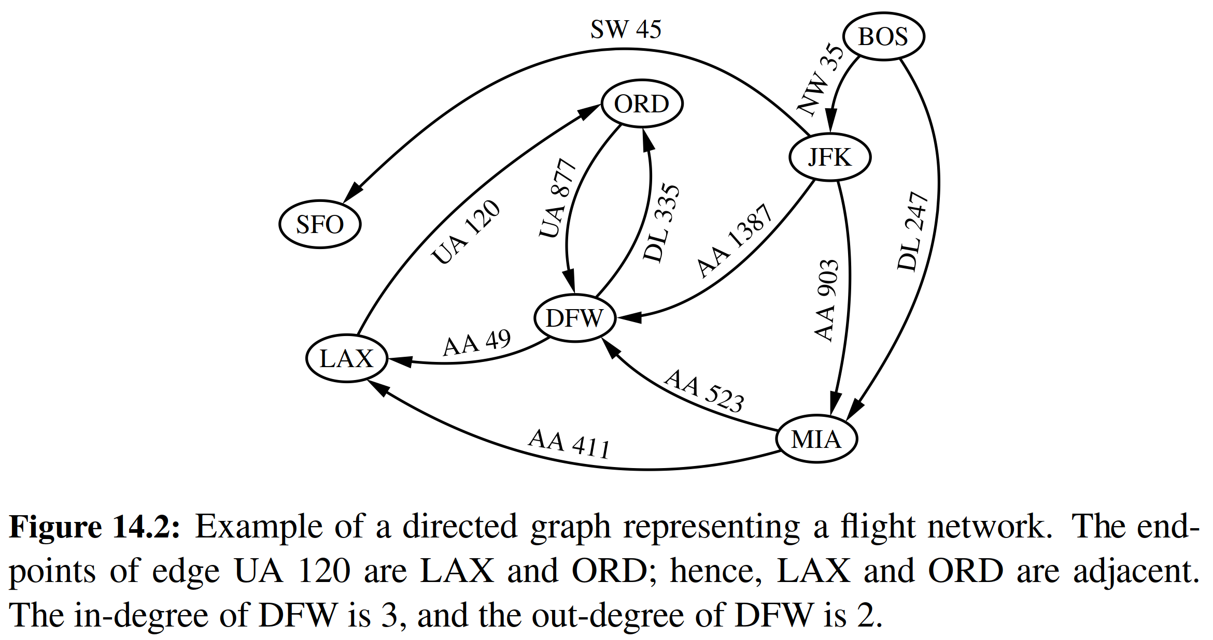

The deﬁnition of a graph refers to the group of edges as a ***collection***, not a set, thus allowing two undirected edges to have the same end vertices, and for two directed edges to have the same origin and the same destination. Such edges are called ***parallel edges*** or ***multiple edges***. A ﬂight network can contain parallel edges (Example 14.5), such that multiple edges between the same pair of vertices could indicate different ﬂights operating on the same route at different times of the day. Another special type of edge is one that connects a vertex to itself. Namely, we say that an edge (undirected or directed) is a ***self-loop*** if its two endpoints coincide. A self-loop may occur in a graph associated with a city map (Example 14.3), where it would correspond to a “circle” (a curving street that returns to its starting point).

＊在图的定义中，我们将边组称为collection，而不是set，因为它允许两个无向边具有相同的顶点，同样也允许两个有向边具有相同的起点和终点。这些边被称为平行边或多元边。飞机航线图允许包含平行边缘（例14.5），而这表示有不同的航班在一天中的不同时间飞行于这两点之间。另一种特殊类型的边是将顶点连接到其自身的边。如果边的两个端点重合，那么我们称这个边为是回路。在与城市地图相关联的图表（例14.3）中可能会出现回路，其中它将对应于“环形街道”（返回到其起点的弯曲的街道）。

With few exceptions, graphs do not have parallel edges or self-loops. Such graphs are said to be ***simple***. Thus, we can usually say that the edges of a simple graph are a ***set*** of vertex pairs (and not just a collection). Throughout this chapter, we assume that a graph is simple unless otherwise speciﬁed.

＊除了少数例外，图中没有有平行边或圈。这样的图形被称为简单图。因此，我们通常可以说简单图的边是一组顶点的set（而不仅仅是一个collection）。在本章中我们所给出的图都是简单的，除非另有说明。

A ***path*** is a sequence of alternating vertices and edges that starts at a vertex and ends at a vertex such that each edge is incident to its predecessor and successor vertex. A ***cycle*** is a path that starts and ends at the same vertex, and that includes at least one edge. We say that a path is ***simple*** if each vertex in the path is distinct, and we say that a cycle is ***simple*** if each vertex in the cycle is distinct, except for the ﬁrst and last one. A ***directed path*** is a path such that all edges are directed and are traversed along their direction. A ***directed cycle*** is similarly deﬁned. For example, in Figure 14.2, (BOS, NW 35, JFK, AA 1387, DFW) is a directed simple path, and (LAX, UA 120, ORD, UA 877, DFW, AA 49, LAX) is a directed simple cycle. Note that a directed graph may have a cycle consisting of two edges with opposite direction between the same pair of vertices, for example (ORD, UA 877, DFW, DL 335, ORD) in Figure 14.2. A directed graph is ***acyclic*** if it has no directed cycles. For example, if we were to remove the edge UA 877 from the graph in Figure 14.2, the remaining graph is acyclic. If a graph is simple, we may omit the edges when describing path P or cycle C, as these are well deﬁned, in which case P is a list of adjacent vertices and C is a cycle of adjacent vertices.

＊路径是一系列交替的顶点和边，它们从顶点开始并以顶点结束，其中的每条边都有起点与终点。圈是在同一顶点开始和结束的路径，并且圈至少包含一条边。我们说如果路径中的每个顶点是不同的，那我们就认为这是个简单路径；如果一个圈中除了起点与终点之外的顶点都是不同的，那么我们认为这个圈也是简单的。如果路径中的所有边都是有向边，并且路径方向沿边的方向，那么这个路径就是有向路径。有向圈也可以类似地定义。例如，在图14.2中，(BOS,NW 35,JFK,AA 1387,DFW)是一个有向的简单路径，(LAX,UA 120,ORD,UA 877,DFW,AA 49,LAX)是一个有向的简单圈。注意，在有向图中，允许存在由相同的一对顶点之间、具有相反方向的两个有向边所组成的圈，例如(ORD,UA 877,DFW,DL 335,ORD)。如果无有向圈，那有向图是无圈的。例如，如果我们从图14.2中删除边UA 877，那么剩余的图是无圈的。如果图形是简单的，我们可以在描述路径P或圈C的时候省略边，因为这些都是已经规定好的，而在这种情况下，P是相邻顶点的线性列表，C是相邻顶点的圈形列表（即首尾合一）。

**Example 14.6**: *Given a graph G representing a city map (see Example 14.3), we can model a couple driving to dinner at a recommended restaurant as traversing a path though G. If they know the way, and do not accidentally go through the same intersection twice, then they traverse a simple path in G. Likewise, we can model the entire trip the couple takes, from their home to the restaurant and back, as a cycle. If they go home from the restaurant in a completely different way than how they went, not even going through the same intersection twice, then their entire round trip is a simple cycle. Finally, if they travel along one-way streets for their entire trip, we can model their night out as a directed cycle.*

＊示例14.6：给定一个表示城市地图的图G（参见例14.3），我们可以把一对夫妇驾车餐厅吃饭的过程进行建模。如果它们穿过一条路，而且过程中不会穿过同一个交叉点两次，那么就说他们在G中穿过了一条简单路径。同样，我们可以模拟夫妇从家中到餐厅的整个旅程，并将其作为一个圈。如果他们以完全不同的方式从餐厅回家，期间甚至没有穿过同一个路口两次，那么他们的整个往返行程都是一个简单的圈。最后，如果他们整个旅行都沿着单行道行驶，我们可以将他们的旅行建模成一个有向的圈。

Given vertices u and v of a (directed) graph G, we say that u reaches v, and that v is ***reachable*** from u, if G has a (directed) path from u to v. In an undirected graph, the notion of ***reachability*** is symmetric, that is to say, u reaches v if an only if v reaches u. However, in a directed graph, it is possible that u reaches v but v does not reach u, because a directed path must be traversed according to the respective directions of the edges. A graph is ***connected*** if, for any two vertices, there is a path between them. A directed graph ***G*** is ***strongly connected*** if for any two vertices u and v of ***G***, u reaches v and v reaches u. (See Figure 14.3 for some examples.)

＊给定（有向）图G的顶点u和v，我们说u指向v，或者说v可以从u到达，意思是说G具有从u到v的（有向）路径，在无向图中，可达性的概念是对称的，也就是说，如果有v达到u，则有u达到v。然而在有向图中，可能u到达v但v不能到达u，因为必须根据边的相应方向遍历有向路径。如果任意两个顶点之间有一条路径，则图形是连通的。如果对于G的任何两个顶点u和v可以互相到达，那么就称有向图G是强连接通的。（例子见图14.3）

A ***subgraph*** of a graph *G* is a graph *H* whose vertices and edges are subsets of the vertices and edges of G, respectively. A ***spanning subgraph*** of G is a subgraph of G that contains all the vertices of the graph G. If a graph G is not connected, its maximal connected subgraphs are called the ***connected components*** of G. A ***forest*** is a graph without cycles. A ***tree*** is a connected forest, that is, a connected graph without cycles. A ***spanning tree*** of a graph is a spanning subgraph that is a tree. (Note that this deﬁnition of a tree is somewhat different from the one given in Chapter 8, as there is not necessarily a designated root.)

＊图G的子图H的顶点和边分别是G的顶点和边的子集。G的支撑子图包含图G的所有顶点。如果图G是非连通的，则其最大的连通子图被称为G的连通分量。森林是没有圈的图。一棵树是一个连通的森林（只有一棵树），也就是没有圈的连通图。图的生成树是图的支撑子图，当然更是一棵树。（请注意，这里的树的定义与第8章给出的定义有些不同，因为这里的树不一定指定了根。）

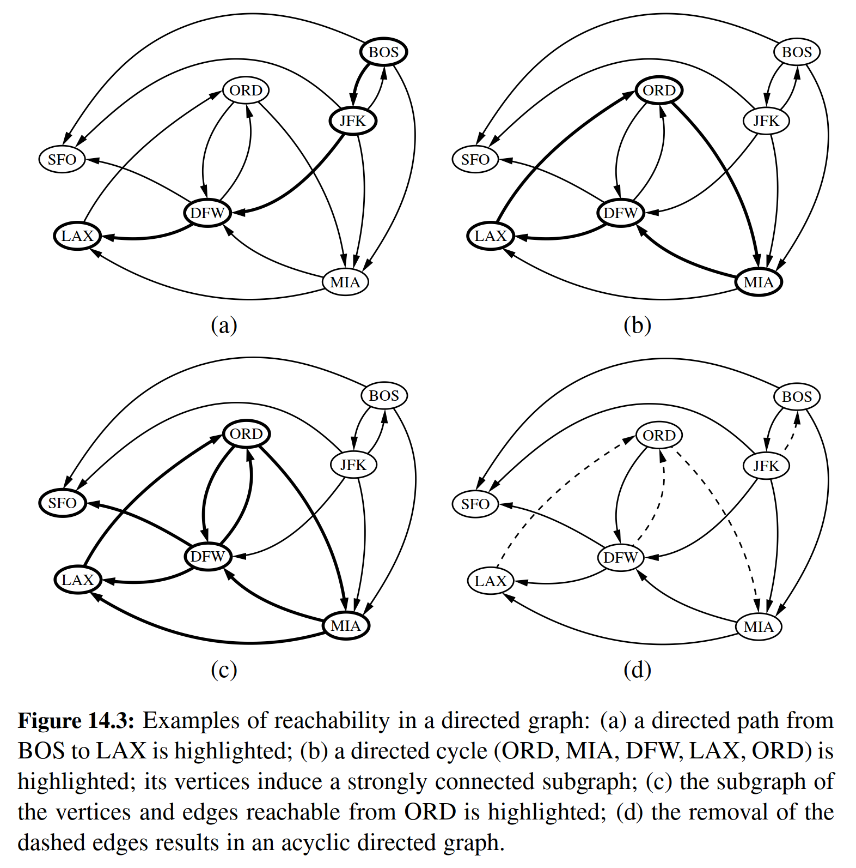

**Example 14.7**: *Perhaps the most talked about graph today is the Internet, which can be viewed as a graph whose vertices are computers and whose (undirected) edges are communication connections between pairs of computers on the Internet. The computers and the connections between them in a single domain, like* wiley.com*, form a subgraph of the Internet. If this subgraph is connected, then two users on computers in this domain can send email to one another without having their information packets ever leave their domain. Suppose the edges of this sub- graph form a spanning tree. This implies that, if even a single connection goes down (for example, because someone pulls a communication cable out of the back of a computer in this domain), then this subgraph will no longer be connected.*

＊例14.7：也许今天最受关注的图是互联网，它可以被视为一个图，其顶点是电脑，其（无向）边是互联网上计算机对之间的通信连接。计算机以及计算机之间的连接是在单一域名（局域网）下进行的，如wiley.com，而这些局域网构成了互联网的子网。如果这个子图是；连通的，则该局域网中的计算机可以彼此发送电子邮件，而不会使其信息脱离局域网。假设这个子图的边本身就是一棵支撑树。这意味着，如果单个连接断开（例如，因为有人从该局域网中断开了某些网线），则此子图将不再连接。

In the propositions that follow, we explore a few important properties of graphs.

＊在随后的命题中，我们将要探索图形的一些重要属性。

**Proposition 14.8**: If *G* is a graph with *m* edges and vertex set *V* , then

＊如果一个图G拥有m个边，顶点构成集合V，那么（所有顶点的度之和为2m）



**Justiﬁcation**: An edge (*u*, *v*) is counted twice in the summation above; once by its endpoint *u* and once by its endpoint *v*. Thus, the total contribution of the edges to the degrees of the vertices is twice the number of edges.

＊证明：在上面的总结中，边(u, v)被计数两次；一次通过其端点u，一次到其终点v。因此，边对总和贡献是顶点的两倍。

**Proposition 14.9**: If *G* is a directed graph with *m* edges and vertex set *V*, then

＊如果一个有向图G拥有m个边，顶点构成集合V，那么（所有顶点的入度之和与出度之和相等，都等于m）



**Justiﬁcation**: In a directed graph, an edge (*u*, *v*) contributes one unit to the out-degree of its origin *u* and one unit to the in-degree of its destination *v*. Thus, the total contribution of the edges to the out-degrees of the vertices is equal to the number of edges, and similarly for the in-degrees.

＊证明：在有向图中，边(u, v)为其原点u提供一个出度，为其终点v提供一个出度。因此，对于一条边而言，其构成的入度与出度相等。所以总体来看，命题成立。

We next show that a simple graph with n vertices has O(*n*2) edges.

＊我们接下来看一个具有n个顶点的简单图，它的边的数目是*O*(*n*2)量级。

**Proposition 14.10**: Let *G* be a simple graph with *n* vertices and *m* edges. If G is undirected, then *m* ≤ *n*(*n* − 1) / 2, and if *G* is directed, then *m* ≤ *n*(*n* − 1).

＊命题14.10：令*G*为包含*n*个顶点和*m*个边的简单图。如果*G*是无向的，则*m* ≤ *n*(*n* - 1) / 2，并且如果*G*有向，则*m* ≤ *n*(*n* - 1)。

**Justiﬁcation**: Suppose that *G* is undirected. Since no two edges can have the same endpoints and there are no self-loops, the maximum degree of a vertex in *G* is *n* - 1 in this case. Thus, by Proposition 14.8, 2*m* ≤ *n* (*n* - 1). Now suppose that *G* is directed. Since no two edges can have the same origin and destination, and there are no self-loops, the maximum in-degree of a vertex in *G* is *n* − 1 in this case. Thus, by Proposition 14.9, *m* ≤ *n*(*n* − 1).

＊理由：假设*G*是无向的。由于没有两个边可以具有相同的端点，并且没有自循环，所以在这种情况下，*G*中顶点的最大度为*n* - 1。因此，通过命题14.8, 2*m* ≤ *n*(*n* - 1)。现在假设*G*是有向图。由于没有两个边可以具有相同的起点和终点，并且没有自循环，所以在这种情况下，*G*中的顶点的最大度数为*n* - 1。因此，通过命题14.9，*m* ≤ *n*(*n* - 1)。

There are a number of simple properties of trees, forests, and connected graphs.

＊树，森林和连接图有许多简单的属性。

**Proposition 14.11**: Let *G* be an undirected graph with *n* vertices and *m* edges.

＊G是有n个顶点与m条边的有向图，那么：

* If *G* is connected, then *m* ≥ *n* − 1.

＊如果G是连通的，那么*m* ≥ *n* – 1。

* If *G* is a tree, then *m* = *n* − 1.

＊如果G是一棵树，那么*m* = *n* – 1。

* If *G* is a forest, then *m* ≤ *n* − 1.

＊如果G是一个森林，那么*m* ≤ *n* – 1。

14.1.1 The Graph ADT

＊图的抽象数据结构

A graph is a collection of vertices and edges. We model the abstraction as a combination of three data types: Vertex, Edge, and Graph. A Vertex is a lightweight object that stores an arbitrary element provided by the user (e.g., an airport code); we assume it supports a method, element(), to retrieve the stored element. An Edge also stores an associated object (e.g., a ﬂight number, travel distance, cost), retrieved with the element() method. In addition, we assume that an Edge supports the following methods:

＊图是顶点和边的集合。我们将图抽象为三种数据类型的组合：Vertex，Edge和Graph。Vertex是存储由用户提供的任意元素（例如机场代码）的轻型对象；我们假设它支持一个用来检索存储的元素element()方法。Edge存储使用element()方法检索的关联对象（例如，飞行数，行程距离，成本）。另外，我们假设Edge类支持以下方法：

|  |  |
| --- | --- |
| **endpoints( ) :** | Return a tuple (*u*, *v*) such that vertex *u* is the origin of the edge and vertex *v* is the destination; for an undirected graph, the orientation is arbitrary.  ＊返回一个元组(u, v)，使得顶点u是边的起点，顶点v是目标；对于无向图，方向是任意的。 |
| **opposite(v):** | Assuming vertex *v* is one endpoint of the edge (either origin or destination), return the other endpoint.  ＊假设顶点v是边（源或目的地）的一个端点，那么此方法会返回另一个端点。 |

The primary abstraction for a graph is the Graph ADT. We presume that a graph can be either ***undirected*** or ***directed***, with the designation declared upon construction; recall that a mixed graph can be represented as a directed graph, modeling edge {*u*, *v*} as a pair of directed edges (u, v) and (v, u). The Graph ADT includes the following methods:

＊图形的主要抽象是Graph ADT。我们假设一个图可以是无向的或者是有向的，并且在构建时被指定；考虑到混合图可以表示为有向图，我们可以将边{u, v}建模为一对有向边(u, v)和(v, u)。图形ADT包括以下方法：

|  |  |
| --- | --- |
| **vertex_count( ):** | Return the number of vertices of the graph.  ＊返回图的顶点数。 |
| **vertices( ):** | Return an iteration of all the vertices of the graph.  ＊返回图的所有顶点的迭代。 |
| **edge_count( ):** | Return the number of edges of the graph.  ＊返回图的边数。 |
| **edges( ):** | Return an iteration of all the edges of the graph.  ＊返回图的所有边的迭代。 |
| **get_edge(u,v):** | Return the edge from vertex u to vertex v, if one exists; otherwise return None. For an undirected graph, there is no difference between get_edge(u,v) and get_edge (v,u).  ＊返回从u到v的顶点（如果存在的话）；否则返回None。对于无向图，get_edge(u, v)和get_edge(v, u)之间没有区别。 |
| **degree(v, out=True):** | For an undirected graph, return the number of edges incident to vertex *v*. For a directed graph, return the number of outgoing (resp. incoming) edges incident to vertex v, as designated by the optional parameter.  ＊对于无向图，返回入射到顶点v的边数。对于有向图，返回由可选参数指定的顶点v的输出（当然也可以是输入）边的数量。 |
| **incident_edges(v, out=True):** | Return an iteration of all edges incident to vertex *v*. In the case of a directed graph, report outgoing edges by default; report incoming edges if the optional parameter is set to False.  ＊返回到顶点v的所有边的迭代。在有向图的情况下，返回出边；如果可选参数设置为False，则报告入边。 |
| **insert vertex(x=None):** | Create and return a new Vertex storing element *x*.  ＊创建并返回一个新的顶点存储元素x。 |
| **insert_edge(u, v, x=None):** | Create and return a new Edge from vertex *u* to vertex *v*, storing element x (None by default).  ＊创建一条从顶点u到v的新边，这个边存储元素x（默认为None）。 |
| **remove_vertex(v):** | Remove vertex *v* and all its incident edges from the graph.  ＊从图中删除顶点v及其所有的相关边。 |
| **remove_edge(e):** | Remove edge *e* from the graph.  ＊从图中删除边e。 |

14.2 Data Structures for Graphs

＊

In this section, we introduce four data structures for representing a graph. In each representation, we maintain a collection to store the vertices of a graph. However, the four representations differ greatly in the way they organize the edges.

＊在本节中，我们介绍了四个用于表示图的数据结构。 在每个表示中，我们保留一个collection用以存储图的顶点。然而，这四种表现方式在边的组织方面有很大不同。

* In an ***edge list***, we maintain an unordered list of all edges. This minimally sufﬁces, but there is no efﬁcient way to locate a particular edge (*u*, *v*), or the set of all edges incident to a vertex *v*.  
  ＊在边表中，我们保留所有边的无序列表。这种数据结构很精简，但是没有有效的方法来定位特定边缘(u, v)或者入射到顶点v的所有边的集合。
* In an ***adjacency list***, we maintain, for each vertex, a separate list containing those edges that are incident to the vertex. The complete set of edges can be determined by taking the union of the smaller sets, while the organization allows us to more efﬁciently ﬁnd all edges incident to a given vertex.  
  ＊在邻接表中，对于每个顶点，我们存储一个包含进入到该顶点的边的列表。通过采取更小的集合的联合可以确定完整的边集合，而该结构允许我们更有效地发现入射到给定顶点的所有边。
* An ***adjacency map*** is very similar to an adjacency list, but the secondary container of all edges incident to a vertex is organized as a map, rather than as a list, with the adjacent vertex serving as a key. This allows for access to a speciﬁc edge (*u*, *v*) in *O*(1) expected time.  
  ＊邻接图与邻接表非常相似，但是进入到顶点v的所有边的存储辅助容器由list被换成了map，与v相邻的顶点作为key。这允许在O(1)预期时间内访问特定边(u, v)。
* An ***adjacency matrix*** provides worst-case *O*(1) access to a speciﬁc edge (*u*, *v*) by maintaining an *n* × *n* matrix, for a graph with n vertices. Each entry is dedicated to storing a reference to the edge (u, v) for a particular pair of vertices u and v; if no such edge exists, the entry will be None.  
  ＊对于n个顶点的图，邻接矩阵通过存储n × n矩阵来提供对特定边(u, v)的最差情况为O(1)访问。每个矩阵元素专用于存储对于一对特定顶点u和v的对于边(u, v)的引用；如果没有这样的边，则该矩阵元素为None。

A summary of the performance of these structures is given in Table 14.1. We give further explanation of the structures in the remainder of this section.  
＊表14.1给出了这些结构的性能总结。我们进一步解释本节剩余部分的结构。

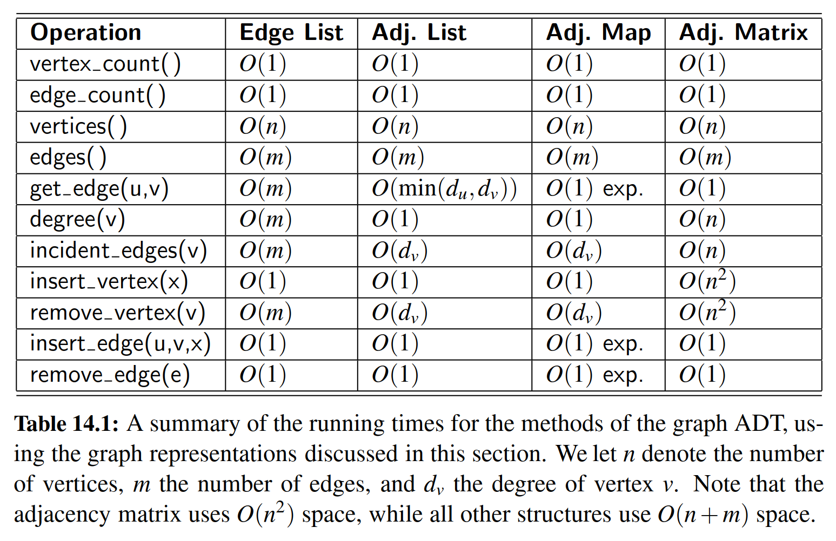

14.2.1 Edge List Structure

＊边表结构

The ***edge list*** structure is possibly the simplest, though not the most efﬁcient, representation of a graph *G*. All vertex objects are stored in an unordered list *V*, and all edge objects are stored in an unordered list *E*. We illustrate an example of the edge list structure for a graph *G* in Figure 14.4.

＊边列表结构可能是图的最简单的结构，但不是最有效的结构。所有顶点对象都存储在无序列表V中，并且所有边对象都存储在无序列表E中。图14.4中是边表结构示例。

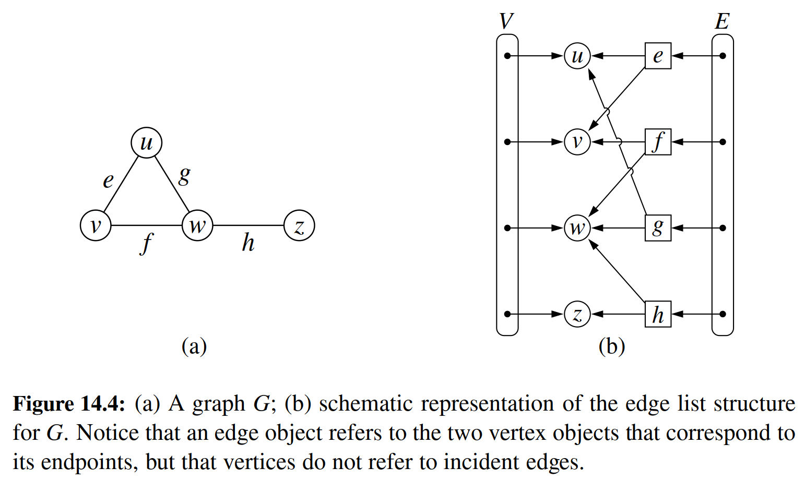

To support the many methods of the Graph ADT (Section 14.1), we assume the following additional features of an edge list representation. Collections *V* and *E* are represented with doubly linked lists using our PositionalList class from Chapter 7.

＊为了支持Graph ADT（第14.1节）的许多方法，我们假设边缘列表表示的以下附加特征。V和E集合使用我们来自第7章的PositionalList类中的双链表来表示。

**Vertex Objects**

＊顶点对象

The vertex object for a vertex *v* storing element *x* has instance variables for:

＊存储元素x的顶点对象v，具有以下特点：

* A reference to element *x*, to support the element () method.  
  ＊对元素x的引用，以支持element()方法。
* A reference to the position of the vertex instance in the list *V*, thereby allowing v to be efﬁciently removed from *V* if it were removed from the graph.  
  ＊引用列表V中的顶点实例的位置，从而允许v从图中删除后，从V中有效地删除v。

**Edge Objects**

＊边对象

The edge object for an edge e storing element x has instance variables for:

＊存储元素x的边对象e具有以下实例变量：

* A reference to element *x*, to support the element() method.  
  ＊对元素x的引用，以支持element()方法。
* References to the vertex objects associated with the endpoint vertices of *e*. These allow the edge instance to provide constant-time support for methods endpoints() and opposite(v).  
  ＊引用与端点e相关联的顶点。这允许边对象为方法endpoints()和opposite(v)提供常量级访问支持。
* A reference to the position of the edge instance in list *E*, thereby allowing *e* to be efﬁciently removed from *E* if it were removed from the graph.  
  ＊对列表E中边的位置的引用，如果从图G中删除了e，则可以将e从E中有效地删除。

**Performance of the Edge List Structure**＊边表结构的性能分析

The performance of an edge list structure in fulﬁlling the graph ADT is summarized in Table 14.2. We begin by discussing the space usage, which is *O*(*n* + *m*) for representing a graph with n vertices and *m* edges. Each individual vertex or edge instance uses *O*(1) space, and the additional lists *V* and *E* use space proportional to their number of entries.  
＊表14.2总结了graph ADT中边表结构的性能。我们首先讨论空间使用情况，这是O(n + m)的空间占用量级，因为我们要存储n个顶点和m个边。每个单独的顶点或边使用O(1)空间，列表V和E使用与它们的条目数成比例的空间。

In terms of running time, the edge list structure does as well as one could hope in terms of reporting the number of vertices or edges, or in producing an iteration of those vertices or edges. By querying the respective list *V* or *E*, the vertex_count and edge_count methods run in *O*(1) time, and by iterating through the appropriate list, the methods vertices and edges run respectively in *O*(*n*) and *O*(*m*) time.  
＊在运行时间方面，边表结构要返回边与顶点的数目，或者生成边与顶点的的迭代器。通过查询相应的列表V与E的状态信息，可以在O(1)时间内运行vertex_count和edge_count方法，通过迭代遍历列表，vertices和edges方法也可以分别在O(n)和O(m)时间内完成运行。

The most signiﬁcant limitations of an edge list structure, especially when compared to the other graph representations, are the O(m) running times of methods get_edge(u, v), degree(v), and incident_edges(v). The problem is that with all edges of the graph in an unordered list *E*, the only way to answer those queries is through an exhaustive inspection of all edges. The other data structures introduced in this section will implement these methods more efﬁciently.  
＊与其他图呈现结构相比，边表结构最显着的局限性，，是get_edge(u, v)，degree(v)和incident_edges(v)。问题在于，在无序列表E中运行这些方法是，可实现的唯一途径就是对所有边进行过滤检查。本节中介绍的其他数据结构将更有效地实现这些方法。

Finally, we consider the methods that update the graph. It is easy to add a new vertex or a new edge to the graph in *O*(1) time. For example, a new edge can be added to the graph by creating an Edge instance storing the given element as data, adding that instance to the positional list *E*, and recording its resulting Position within *E* as an attribute of the edge. That stored position can later be used to locate and remove this edge from *E* in *O*(1) time, and thus implement the method remove_edge(e).  
＊最后，我们考虑更新图形的方法。在O(1)时间内，可以轻松地向图中添加新的顶点或新的边。例如，可以创建存储给定元素的边，然后将该边添加到图形中，将该实例添加到位置列表E，并将其结果的位置记录在E中作为边的属性。该存储位置可以稍后用于在O(1)时间内从E中定位和移除该边，从而实现remove_edge(e)方法。

It is worth discussing why the remove_vertex(v) method has a running time of *O*(*m*). As stated in the graph ADT, when a vertex *v* is removed from the graph, all edges incident to *v* must also be removed (otherwise, we would have a contradiction of edges that refer to vertices that are not part of the graph). To locate the incident edges to the vertex, we must examine all edges of *E*.  
＊为什么remove_vertex(v)方法的运行时间为O(m)呢？。如图ADT所示，当从图形中去除顶点v时，还必须除去与v相关的所有边。为了将边定位到vertex，我们必须检查E的所有边。

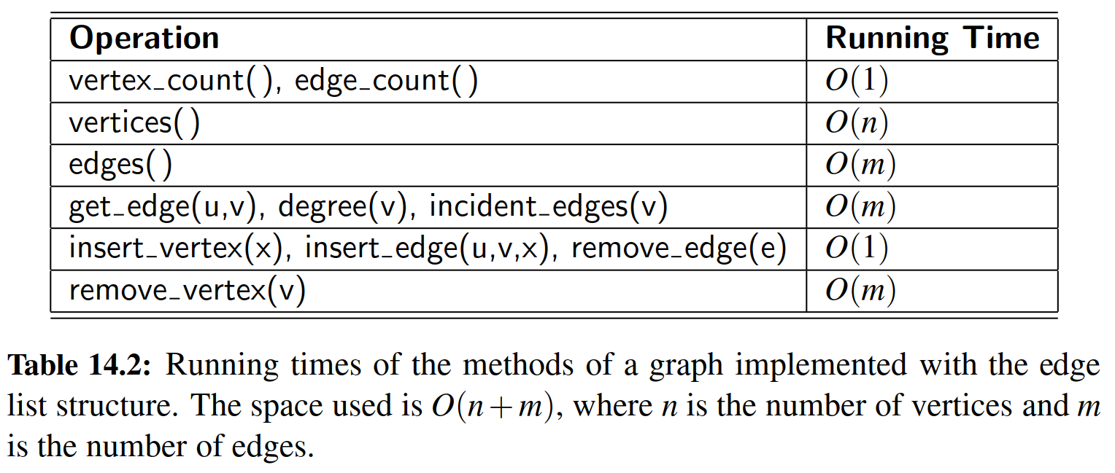

14.2.2 Adjacency List Structure

＊邻接表结构

In contrast to the edge list representation of a graph, the ***adjacency list*** structure groups the edges of a graph by storing them in smaller, secondary containers that are associated with each individual vertex. Speciﬁcally, for each vertex v, we maintain a collection *I*(*v*), called the ***incidence collection*** of v, whose entries are edges incident to *v*. (In the case of a directed graph, outgoing and incoming edges can be respectively stored in two separate collections, *I*out(*v*) and *I*in(*v*).) Traditionally, the incidence collection *I*(*v*) for a vertex *v* is a list, which is why we call this way of representing a graph the a***djacency list*** structure.

＊与图的边表表示相反，邻接列表结构通过将图形的边存储在与每个单独顶点相关联的较小的辅助容器中，以此进行分组。特别地，对于每个顶点v，我们存储一个集合I(v)，称为v的入射集合，其条目是入射到v的边缘（在有向图的情况下，可以分别在两个个单独的集合中存储输入和输出边，Iout（v）和Iin（v））。传统上，对于顶点v的存储结构I(v)是列表，这就是为什么我们称之为表示邻接关系列表结构。

We require that the primary structure for an adjacency list maintain the collection *V* of vertices in a way so that we can locate the secondary structure *I*(*v*) for a given vertex *v* in *O*(1) time. This could be done by using a positional list to represent *V* , with each Vertex instance maintaining a direct reference to its *I*(*v*) incidence collection; we illustrate such an adjacency list structure of a graph in Figure 14.5. If vertices can be uniquely numbered from 0 to *n* − 1, we could instead use a primary array-based structure to access the appropriate secondary lists.

＊我们要求邻接列表的主要结构以某种方式存储顶点的集合V，以便我们可以在O(1)时间内为给定v找到二级结构I(v)。这可以通过使用位置列表来来完成，每个顶点实例保持对其I(v)入口集合的直接引用；我们在图14.5中描绘了一个图形的邻接列表结构。如果顶点可以从0到n-1唯一编号，我们可以改为使用基于数组的结构来得到适当的辅助列表。

The primary beneﬁt of an adjacency list is that the collection *I*(*v*) contains exactly those edges that should be reported by the method incident_edges(v). Therefore, we can implement this method by iterating the edges of *I*(*v*) in *O*(deg(*v*)) time, where deg(*v*) is the degree of vertex *v*. This is the best possible outcome for any graph representation, because there are deg(*v*) edges to be reported.

＊邻接列表的主要好处在于，对象I(v)恰好包含应该由方法incident_edges(v)所需要返回边。因此，我们可以通过在O(deg(v))时间中迭代I(v)的边来实现这个方法，其中deg(v)是顶点v的度，这是所有图的表示中最好的结果。

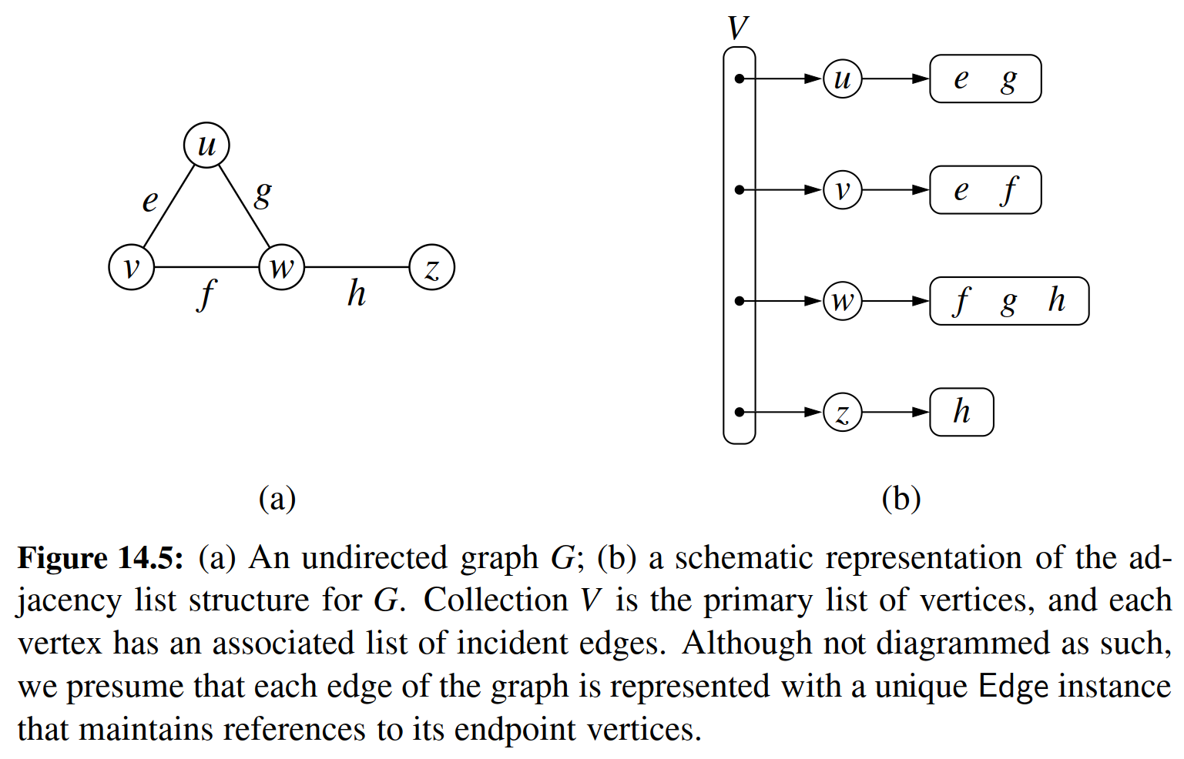

**Performance of the Adjacency List Structure**

＊邻接表结构的性能

Table 14.3 summarizes the performance of the adjacency list structure implementation of a graph, assuming that the primary collection *V* and all secondary collections *I*(*v*) are implemented with doubly linked lists.

＊表14.3总结了图形的邻接列表结构实现的性能，假设主集合V和所有辅助集合I(v)都用双向链表实现。

Asymptotically, the space requirements for an adjacency list are the same as an edge list structure, using *O*(*n* + *m*) space for a graph with *n* vertices and *m* edges. The primary list of vertices uses *O*(*n*) space. The sum of the lengths of all secondary lists is *O*(*m*), for reasons that were formalized in Propositions 14.8 and 14.9. In short, an undirected edge (*u*, *v*) is referenced in both *I*(*u*) and *I*(*v*), but its presence in the graph results in only a constant amount of additional space.

＊渐近地，邻接表的空间要求与边表结构相同，对于具有n个顶点和m个边缘的图形，使用O(m + n)量级的空间。顶点的主列表使用O(n)空间。所有二级列表的长度之和为O(m)，原因是在第14.8和14.9号命题中被正式化。简而言之，在I(u)和I(v)中都引用了一个无向边(u, v)，但是它在图中的存在仅产生一个空间占用。

We have already noted that the incident_edges(v) method can be achieved in *O*(deg(*v*)) time based on use of *I*(*v*). We can achieve the degree(*v*) method of the graph ADT to use *O*(1) time, assuming collection *I*(*v*) can report its size in similar time. To locate a speciﬁc edge for implementing get_edge(u,v), we can search through either *I*(*u*) and *I*(*v*). By choosing the smaller of the two, we get *O*(min(deg(*u*), deg(*v*))) running time.

＊我们已经注意到，基于使用I(v)，可以在O(deg(v))时间内实现incident_edges(v)方法。假设集合I(v)可以反馈其容量信息，那么我们可以在O(1)时间内实现deg(v)方法。为了找到get_edge(u, v)所返回的特定边，我们可以通过对I(u)和I(v)进行搜索。通过选择两者中较小的一个，我们得到O(min(deg(u)，deg(v)))的运行时间。

The rest of the bounds in Table 14.3 can be achieved with additional care. To efﬁciently support deletions of edges, an edge(*u*, *v*) would need to maintain a reference to its positions within both *I*(*u*) and *I*(*v*), so that it could be deleted from those collections in *O*(1) time. To remove a vertex v, we must also remove any incident edges, but at least we can locate those edges in *O*(deg(*v*)) time.

＊表14.3中的其余部分可以通过其他方法实现。为了有效地支持边删除，边(u, v)将需要存储对I(u)和I(v)中的引用，从而可以在O(1)时间内从这些集合中删除它。要删除顶点v，我们还必须删除与之相关的所有边，但至少我们可以在O(deg(v))时间内找到这些边。

The easiest way to support edges() in *O*(*m*) and count_edges() in *O*(1) is to maintain an auxiliary list *E* of edges, as in the edge list representation. Otherwise, we can implement the edges method in *O*(*n* + *m*) time by accessing each secondary list and reporting its edges, taking care not to report an undirected edge(*u*, *v*) twice.

＊

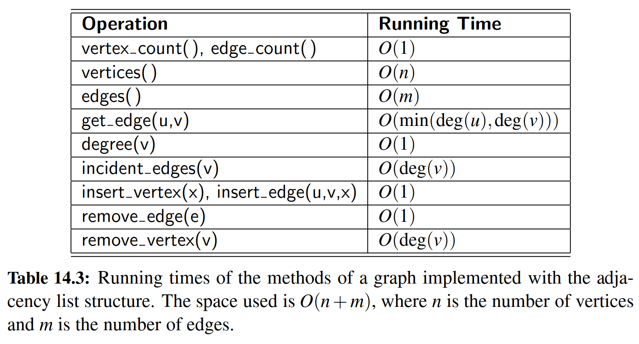

14.2.3 Adjacency Map Structure

＊

In the adjacency list structure, we assume that the secondary incidence collections are implemented as unordered linked lists. Such a collection *I*(*v*) uses space proportional to *O*(deg(*v*)), allows an edge to be added or removed in *O*(1) time, and allows an iteration of all edges incident to vertex v in *O*(deg(*v*)) time. However, the best implementation of get_edge(u,v) requires *O*(min(deg(*u*), deg(*v*))) time, because we must search through either *I*(*u*) or *I*(*v*).

＊

We can improve the performance by using a hash-based map to implement *I*(*v*) for each vertex *v*. Speciﬁcally, we let the opposite endpoint of each incident edge serve as a key in the map, with the edge structure serving as the value. We call such a graph representation an ***adjacency map***. (See Figure 14.6.) The space usage for an adjacency map remains *O*(*n* + *m*), because *I*(*v*) uses *O*(deg(*v*)) space for each vertex *v*, as with the adjacency list.

＊

The advantage of the adjacency map, relative to an adjacency list, is that the get_edge(u,v) method can be implemented in ***expected*** *O*(1) time by searching for vertex u as a key in *I*(*v*), or vice versa. This provides a likely improvement over the adjacency list, while retaining the worst-case bound of *O*(min(deg(*u*), deg(*v*))).

＊

In comparing the performance of adjacency map to other representations (see Table 14.1), we ﬁnd that it essentially achieves optimal running times for all methods, making it an excellent all-purpose choice as a graph representation.

＊

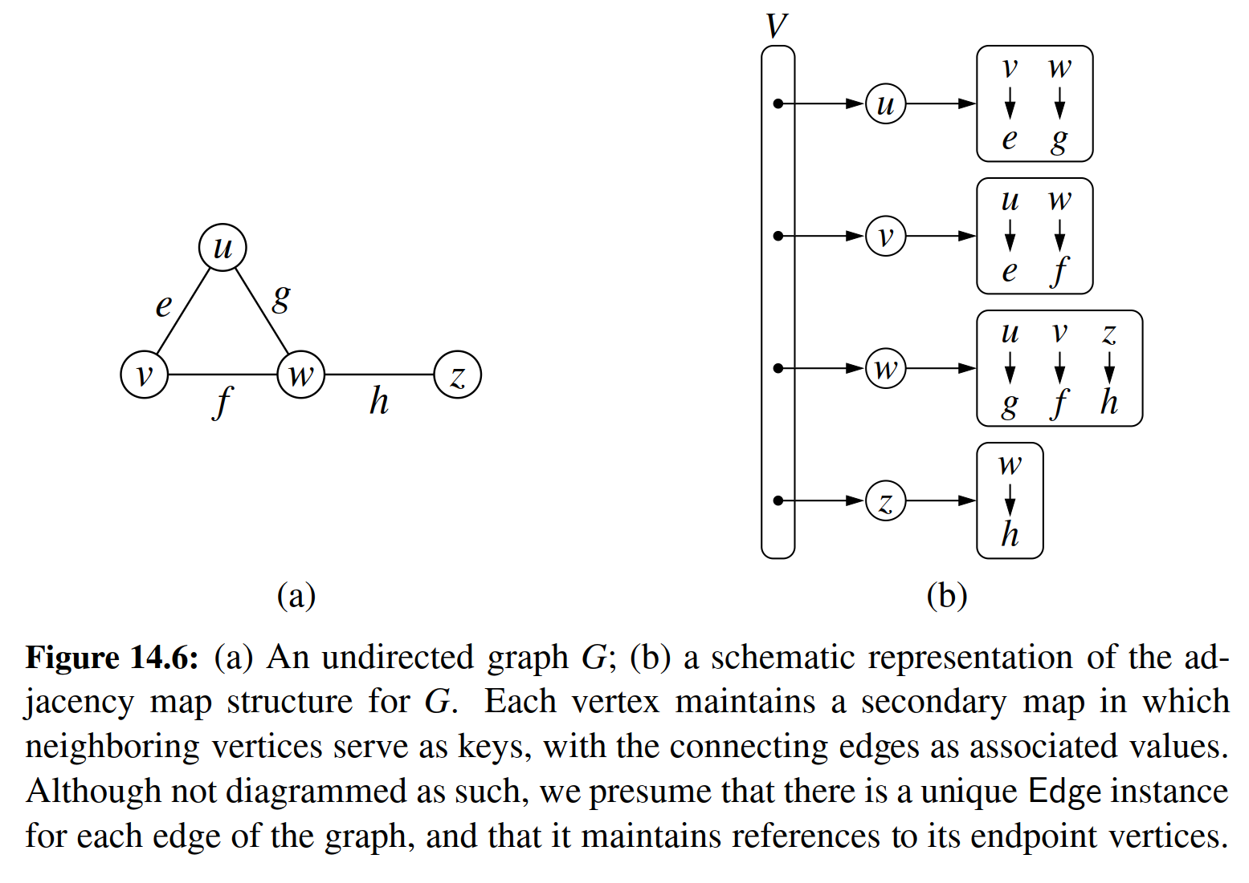

14.2.4 Adjacency Matrix Structure

＊邻接矩阵表示

The ***adjacency matrix*** structure for a graph *G* augments the edge list structure with a matrix *A* (that is, a two-dimensional array, as in Section 5.6), which allows us to locate an edge between a given pair of vertices in worst-case constant time. In the adjacency matrix representation, we think of the vertices as being the integers in the set {0, 1, ... , *n* − 1} and the edges as being pairs of such integers. This allows us to store references to edges in the cells of a two-dimensional *n* × *n* array *A*. Speciﬁcally, the cell *A*[*i*, *j*] holds a reference to the edge (*u*, *v*), if it exists, where *u* is the vertex with index *i* and *v* is the vertex with index *j*. If there is no such edge, then *A*[*i*, *j*]= None. We note that array *A* is symmetric if graph *G* is undirected, as *A*[*i*, *j*]= *A*[*j*, *i*] for all pairs *i* and *j*. (See Figure 14.7.)

＊图G的邻接矩阵结构用矩阵*A*（第5.6节中的二维数组）来构造生成，这允许我们在最坏情况下，仍然在常量时间内定位给定的顶点对之间的边。我们将顶点视为集合{0,1, ... , *n*-1}中的数，并将边视为这种整数的二元对。这允许我们把边存到二维数组A的单元格中。具体来说，单元格A[i, j]保存边(*u*, *v*)，如果边是存在的，那么*u*行坐标，*v*是列坐标。如果没有这样的边，那么A[*i*, *j*] = None。 我们注意到，如果图*G*是无向的，则阵列A是对称的，对于所有对*i*和*j*，*A*[*i*, *j*] = *A*[*j*, *i*]。（见图14.7）

The most signiﬁcant advantage of an adjacency matrix is that any edge (*u*, *v*) can be accessed in worst-case *O*(1) time; recall that the adjacency map supports that operation in *O*(1) *expected* time. However, several operations are less efﬁcient with an adjacency matrix. For example, to ﬁnd the edges incident to vertex *v*, we must presumably examine all *n* entries in the row associated with *v*; recall that an adjacency list or map can locate those edges in optimal O(deg(*v*)) time. Adding or removing vertices from a graph is problematic, as the matrix must be resized.

＊邻接矩阵最显着的优点是任何边(*u*, *v*)都可以在最坏情况的*O*(1)时间内被访问；就像邻接图支持*O*(1)预期时间的操作那样。然而，邻接矩阵对于几个操作而言却不太高效，例如，为了找出入射到顶点v的边，我们必须推测检查与*v*相关联的行中的所有*n*个条目；回想一下，邻接表或邻接图可以将这些边缘定位在最佳*O*(deg(*v*))时间。另外，从图中添加或删除顶点是有问题的，因为矩阵必须调整大小。

Furthermore, the *O*(*n*2) space usage of an adjacency matrix is typically far worse than the *O*(*n* + *m*) space required of the other representations. Although, in the worst case, the number of edges in a ***dense*** graph will be proportional to *n*2, most real-world graphs are ***sparse***. In such cases, use of an adjacency matrix is inefﬁcient. However, if a graph is dense, the constants of proportionality of an adjacency matrix can be smaller than that of an adjacency list or map. In fact, if edges do not have auxiliary data, a Boolean adjacency matrix can use one bit per edge slot, such that *A*[*i*, *j*]= True if and only if associated (*u*, *v*) is an edge.

＊此外，邻接关系的*O*(*n*2)空间使用通常比其他表示所需的*O*(*n* + *m*)空间差得多。尽管在最坏的情况下，密集图中边缘的数量将与*n*2成比例，但大多数真实世界的图形都是稀疏的。在这种情况下，使用邻接矩阵是无效的。然而，如果图形密集，则邻接矩阵的比例常数可以小于邻接列表或邻接图的常数。实际上，如果边没有辅助数据，则布尔相邻矩阵可以在每个边中使用一个整数位，即如果(*u*, *v*)存在时，*A*[*i*, *j*] = True。

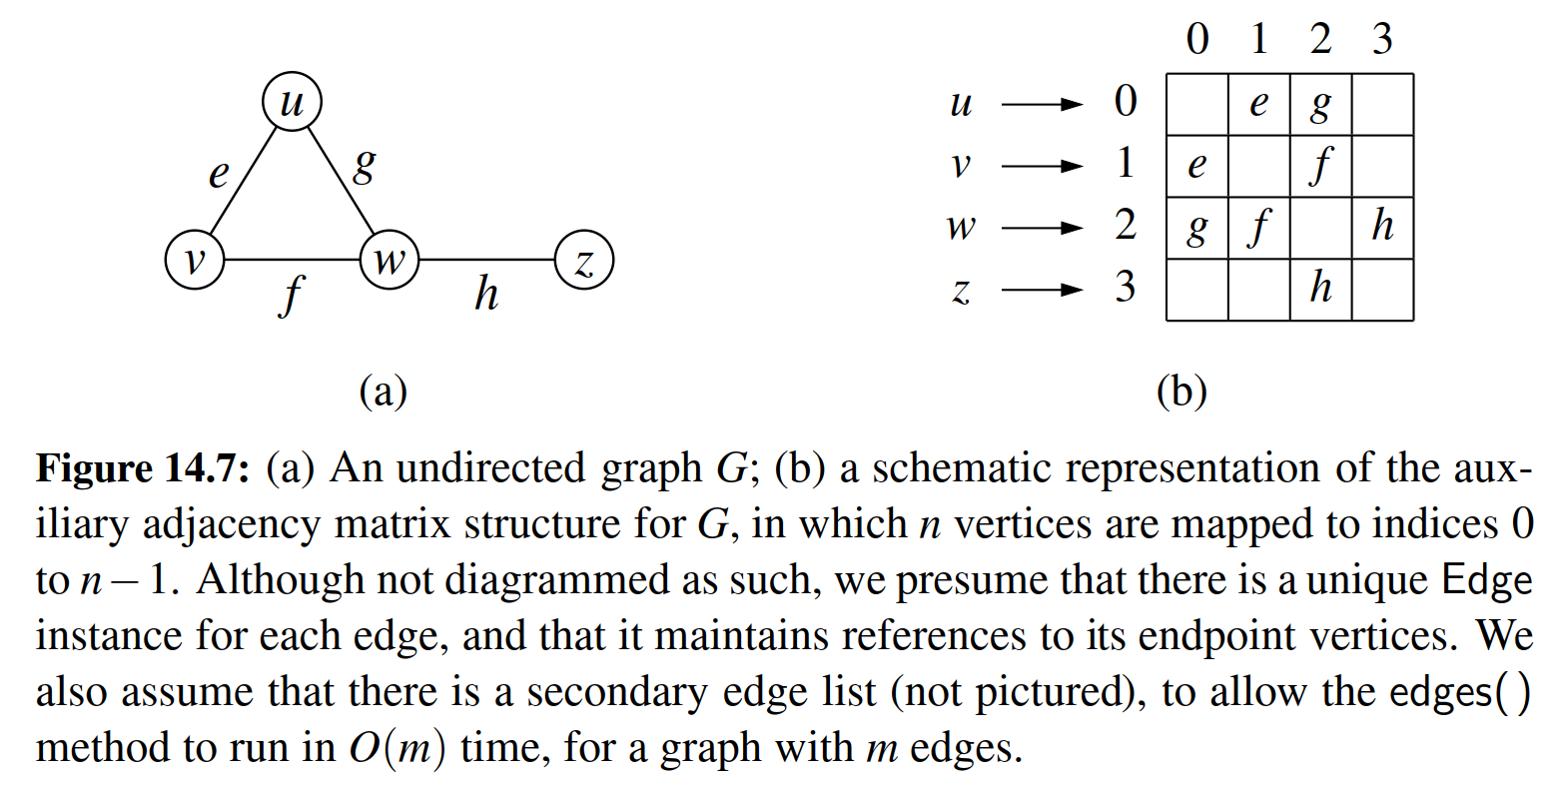

14.2.5 Python Implementation

＊Python实现

In this section, we provide an implementation of the Graph ADT. Our implementation will support directed or undirected graphs, but for ease of explanation, we ﬁrst describe it in the context of an undirected graph.

＊在本节中，我们提供了图ADT的实现。我们的实现将支持有向以及无向的图，但是为了便于说明，我们首先在无向图的上下文中描述它。

We use a variant of the ***adjacency map*** representation. For each vertex *v*, we use a Python dictionary to represent the secondary incidence map *I*(*v*). However, we do not explicitly maintain lists *V* and *E*, as originally described in the edge list representation. The list *V* is replaced by a top-level dictionary *D* that maps each vertex *v* to its incidence map *I*(*v*); note that we can iterate through all vertices by generating the set of keys for dictionary *D*. By using such a dictionary *D* to map vertices to the secondary incidence maps, we need not maintain references to those incidence maps as part of the vertex structures. Also, a vertex does not need to explicitly maintain a reference to its position in *D*, because it can be determined in *O*(1) expected time. This greatly simpliﬁes our implementation. However, a consequence of our design is that some of the worst-case running time bounds for the graph ADT operations, given in Table 14.1, become expected bounds. Rather than maintain list *E*, we are content with taking the union of the edges found in the various incidence maps; technically, this runs in *O*(*n* + *m*) time rather than strictly *O*(*m*) time, as the dictionary *D* has *n* keys, even if some incidence maps are empty.

＊我们使用邻接图表示的变体来具体实现图结构。对于顶点*v*，我们用Python字典来表示二次入射映射*I*(*v*)。但是，我们不会按照边表中最初的描述来明确地存储列表*V*和*E*。列表*V*由顶层字典*D*代替，字典*D*将每个顶点*v*映射到*I*(*v*)；请注意，我们可以通过生成字典*D*的密钥集来遍历所有顶点。通过使用这样一个字典*D*将顶点映射到次要字典，我们不需要保留对那些二级字典的引用。此外，顶点不需要明确地保持对其在*D*中的位置的引用，因为它可以在*O*(1)预期时间中确定。这大大简化了我们的实现。然而，我们设计的一个结果是，表14.1给出的图ADT操作的最坏情况运行时间范围的一些变成预期的界限。而不是保持列表E，我们满足于在各种发现地图中找到的边的联合；在技术上，这会导致运行时间时*O*(*n* + *m*)而不是严格的*O*(*m*)，因为字典*D*有*n*个key，即使一些二级字典是空的。

Our implementation of the graph ADT is given in Code Fragments 14.1 through 14.3. Classes Vertex and Edge, given in Code Fragment 14.1, are rather simple, and can be nested within the more complex Graph class. Note that we deﬁne the __hash__ method for both Vertex and Edge so that those instances can be used as keys in Python’s hash-based sets and dictionaries. The rest of the Graph class is given in Code Fragments 14.2 and 14.3. Graphs are undirected by default, but can be declared as directed with an optional parameter to the constructor.

＊我们在代码片段14.1到14.3中给出了图ADT的实现。代码片段14.1中给出的类顶点和边是相当简单的，并且可以嵌套在更复杂的Graph类中。请注意，我们为Vertex和Edge定义__hash__方法，以便这些实例可以用作Python的基于哈希的集合和字典中的key。Graph类的其余部分在代码片段14.2和14.3中给出。默认情况下，图形无向，但可以通过参数设置，将之设置为有向。

Internally, we manage the directed case by having two different top-level dictionary instances, outgoing and incoming, such that _outgoing[v] maps to another dictionary representing *I*out(*v*), and _incoming[v] maps to a representation of *I*in(*v*). In order to unify our treatment of directed and undirected graphs, we continue to use the _outgoing and _incoming identiﬁers in the undirected case, yet as aliases to the same dictionary. For convenience, we deﬁne a utility named is directed to allow us to distinguish between the two cases.

＊在内部，我们通过使用两个不同的字典实例来管理入射与出射边，即_outgoing和_incoming，从而_outgoing[v]映射到另一个表示*I*out(*v*)的字典，_incoming[v]映射到代表的*I*in(*v*)。为了统一我们对有向和无向图形的处理，我们继续在无向的情况下使用_outgoing和_incoming标识符，而使用同一个字典的别名。为了方便起见，我们定义了一个名为is_directed的实用程序，旨在让我们区分两种情况。

For methods degree and incident_edges, which each accept an optional parameter to differentiate between the outgoing and incoming orientations, we choose the appropriate map before proceeding. For method insert_vertex, we always initialize _outgoing[v] to an empty dictionary for new vertex *v*. In the directed case, we independently initialize _incoming[v] as well. For the undirected case, that step is unnecessary as _outgoing and _incoming are aliases. We leave the implementations of methods remove_vertex and remove_edge as exercises (C-14.37 and C-14.38).

＊对于方法degree和incident_edges，每个都接受一个可选参数来区分传出和传入方向，我们在继续之前选择合适的映射。对于方法insert_vertex，我们总是将_outgoing[v]初始化为一个新的顶点v的空字典。在有向的情况下，我们也独立地初始化_incoming[v]。对于无向的情况，该步骤是不必要的，因为_incoming和_outgoing是同一对象的两个别名。我们将方法remove_vertex和remove_edge的实现作为练习（C-14.37和C-14.38）。

14.3 Graph Traversals

＊

Greek mythology tells of an elaborate labyrinth that was built to house the monstrous Minotaur, which was part bull and part man. This labyrinth was so complex that neither beast nor human could escape it. No human, that is, until the Greek hero, Theseus, with the help of the king’s daughter, Ariadne, decided to implement a ***graph traversal*** algorithm. Theseus fastened a ball of thread to the door of the labyrinth and unwound it as he traversed the twisting passages in search of the monster. Theseus obviously knew about good algorithm design, for, after ﬁnding and defeating the beast, Theseus easily followed the string back out of the labyrinth to the loving arms of Ariadne.

＊

Formally, a ***traversal*** is a systematic procedure for exploring a graph by examining all of its vertices and edges. A traversal is efﬁcient if it visits all the vertices and edges in time proportional to their number, that is, in linear time.

＊

Graph traversal algorithms are key to answering many fundamental questions about graphs involving the notion of ***reachability***, that is, in determining how to travel from one vertex to another while following paths of a graph. Interesting problems that deal with reachability in an undirected graph G include the following:

＊

* Computing a path from vertex *u* to vertex *v*, or reporting that no such path exists.  
  ＊
* Given a start vertex s of *G*, computing, for every vertex *v* of *G*, a path with the minimum number of edges between *s* and *v*, or reporting that no such path exists.  
  ＊
* Testing whether *G* is connected.  
  ＊
* Computing a spanning tree of *G*, if *G* is connected.  
  ＊
* Computing the connected components of *G*.  
  ＊
* Computing a cycle in *G*, or reporting that *G* has no cycles.  
  ＊

Interesting problems that deal with reachability in a directed graph ***G*** include the following:  
＊

* Computing a directed path from vertex *u* to vertex *v*, or reporting that no such path exists.  
  ＊
* Finding all the vertices of ***G*** that are reachable from a given vertex *s*.  
  ＊
* Determine whether ***G*** is acyclic.  
  ＊
* Determine whether ***G*** is strongly connected.  
  ＊

In the remainder of this section, we present two efﬁcient graph traversal algorithms, called ***depth-ﬁrst search*** and ***breadth-ﬁrst search***, respectively.

＊

14.3.1 Depth-First Search

The ﬁrst traversal algorithm we consider in this section is ***depth-ﬁrst search*** (DFS). Depth-ﬁrst search is useful for testing a number of properties of graphs, including whether there is a path from one vertex to another and whether or not a graph is connected.

＊

Depth-ﬁrst search in a graph *G* is analogous to wandering in a labyrinth with a string and a can of paint without getting lost. We begin at a speciﬁc starting vertex *s* in *G*, which we initialize by ﬁxing one end of our string to *s* and painting *s* as “visited.” The vertex *s* is now our “current” vertex—call our current vertex *u*. We then traverse *G* by considering an (arbitrary) edge (*u*, *v*) incident to the current vertex *u*. If the edge (*u*, *v*) leads us to a vertex *v* that is already visited (that is, painted), we ignore that edge. If, on the other hand, (*u*, *v*) leads to an unvisited vertex *v*, then we unroll our string, and go to *v*. We then paint *v* as “visited,” and make it the current vertex, repeating the computation above. Eventually, we will get to a “dead end,” that is, a current vertex *v* such that all the edges incident to *v* lead to vertices already visited. To get out of this impasse, we roll our string back up, backtracking along the edge that brought us to v, going back to a previously visited vertex *u*. We then make *u* our current vertex and repeat the computation above for any edges incident to *u* that we have not yet considered. If all of *u*’s incident edges lead to visited vertices, then we again roll up our string and backtrack to the vertex we came from to get to *u*, and repeat the procedure at that vertex. Thus, we continue to backtrack along the path that we have traced so far until we ﬁnd a vertex that has yet unexplored edges, take one such edge, and continue the traversal. The process terminates when our backtracking leads us back to the start vertex *s*, and there are no more unexplored edges incident to *s*.

＊

The pseudo-code for a depth-ﬁrst search traversal starting at a vertex *u* (see Code Fragment 14.4) follows our analogy with string and paint. We use recursion to implement the string analogy, and we assume that we have a mechanism (the paint analogy) to determine whether a vertex or edge has been previously explored.

＊

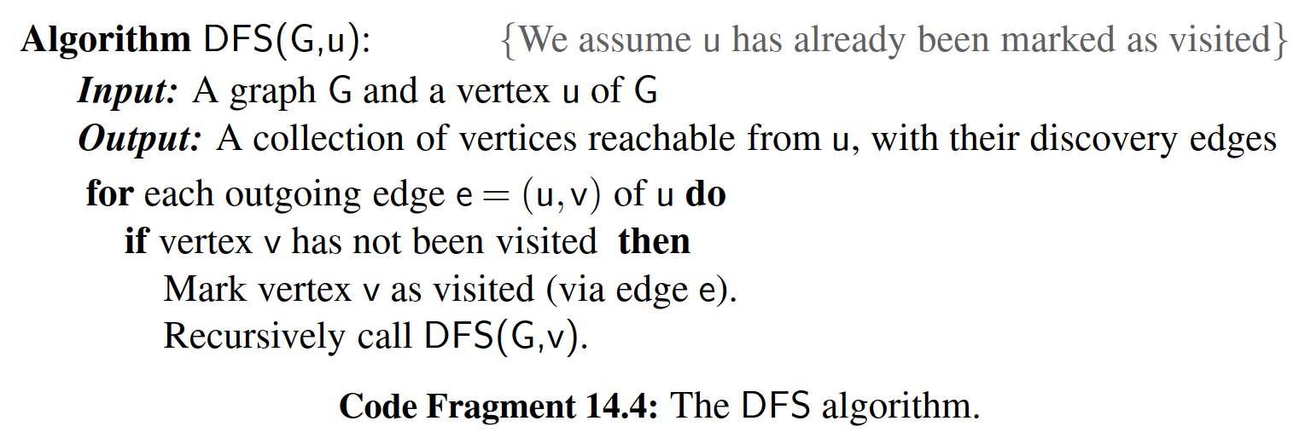

**Classifying Graph Edges with DFS**

An execution of depth-ﬁrst search can be used to analyze the structure of a graph, based upon the way in which edges are explored during the traversal. The DFS process naturally identiﬁes what is known as the ***depth-ﬁrst search tree*** rooted at a starting vertex *s*. Whenever an edge *e* = (*u*, *v*) is used to discover a new vertex *v* during the DFS algorithm of Code Fragment 14.4, that edge is known as a ***discovery edge*** or ***tree edge***, as oriented from *u* to *v*. All other edges that are considered during the execution of DFS are known as ***nontree edges***, which take us to a previously visited vertex. In the case of an undirected graph, we will ﬁnd that all nontree edges that are explored connect the current vertex to one that is an ancestor of it in the DFS tree. We will call such an edge a ***back edge***. When performing a DFS on a directed graph, there are three possible kinds of nontree edges:

＊

* ***back edges***, which connect a vertex to an ancestor in the DFS tree  
  ＊
* ***forward edges***, which connect a vertex to a descendant in the DFS tree  
  ＊
* ***cross edges***, which connect a vertex to a vertex that is neither its ancestor nor its descendant.  
  ＊

An example application of the DFS algorithm on a directed graph is shown in Figure 14.8, demonstrating each type of nontree edge. An example application of the DFS algorithm on an undirected graph is shown in Figure 14.9.  
＊

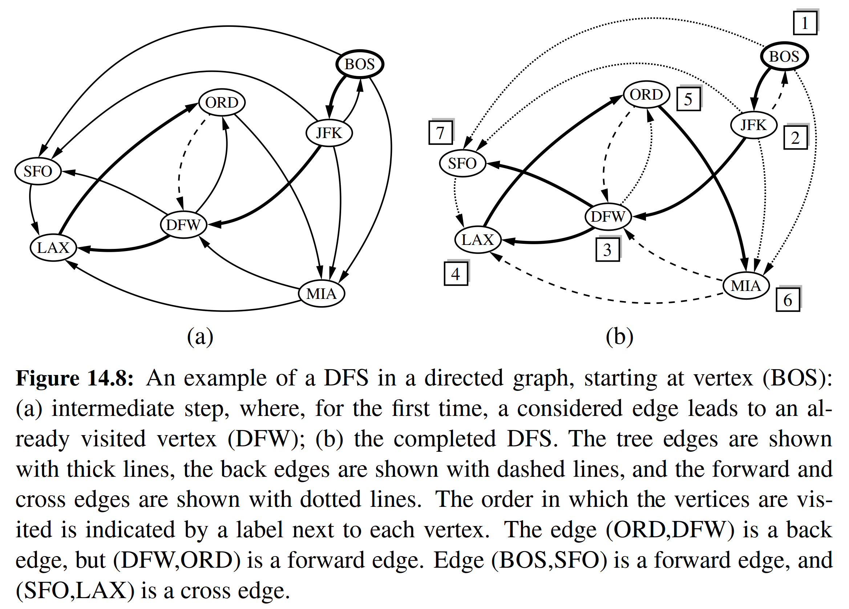

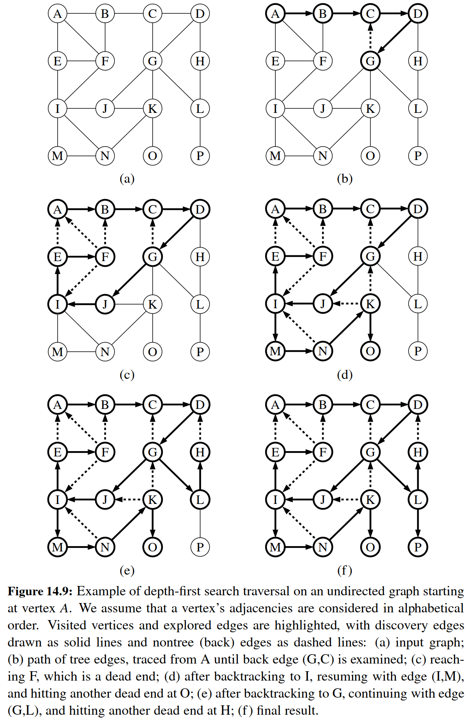

**Properties of a Depth-First Search**

＊

There are a number of observations that we can make about the depth-ﬁrst search algorithm, many of which derive from the way the DFS algorithm partitions the edges of a graph G into groups. We begin with the most signiﬁcant property.  
＊

**Proposition 14.12**: Let G be an undirected graph on which a DFS traversal starting at a vertex s has been performed. Then the traversal visits all vertices in the connected component of s, and the discovery edges form a spanning tree of the connected component of *s*.

＊

**Justiﬁcation**: Suppose there is at least one vertex *w* in *s*’s connected component not visited, and let *v* be the ﬁrst unvisited vertex on some path from *s* to *w* (we may have *v* = *w*). Since *v* is the ﬁrst unvisited vertex on this path, it has a neighbor *u* that was visited. But when we visited *u*, we must have considered the edge (*u*, *v*); hence, it cannot be correct that *v* is unvisited. Therefore, there are no unvisited vertices in s’s connected component.

＊

Since we only follow a discovery edge when we go to an unvisited vertex, we will never form a cycle with such edges. Therefore, the discovery edges form a connected subgraph without cycles, hence a tree. Moreover, this is a spanning tree because, as we have just seen, the depth-ﬁrst search visits each vertex in the connected component of *s*.

＊

**Proposition 14.13**: Let ***G*** be a directed graph. Depth-ﬁrst search on ***G*** starting at a vertex s visits all the vertices of ***G*** that are reachable from s. Also, the DFS tree contains directed paths from s to every vertex reachable from s.

＊

**Justiﬁcation**: Let *Vs* be the subset of vertices of ***G*** visited by DFS starting at vertex *s*. We want to show that *Vs* contains *s* and every vertex reachable from s belongs to *Vs*. Suppose now, for the sake of a contradiction, that there is a vertex *w* reachable from *s* that is not in *Vs*. Consider a directed path from *s* to *w*, and let (*u*, *v*) be the ﬁrst edge on such a path taking us out of *Vs*, that is, *u* is in *Vs* but *v* is not in *Vs*. When DFS reaches *u*, it explores all the outgoing edges of *u*, and thus must reach also vertex v via edge (*u*, *v*). Hence, *v* should be in *Vs*, and we have obtained a contradiction. Therefore, *Vs* must contain every vertex reachable from *s*.

＊

We prove the second fact by induction on the steps of the algorithm. We claim that each time a discovery edge (*u*, *v*) is identiﬁed, there exists a directed path from s to *v* in the DFS tree. Since *u* must have previously been discovered, there exists a path from s to *u*, so by appending the edge (*u*, *v*) to that path, we have a directed path from s to *v*.

＊

Note that since back edges always connect a vertex *v* to a previously visited vertex *u*, each back edge implies a cycle in *G*, consisting of the discovery edges from *u* to *v* plus the back edge (*u*, *v*).

＊

**Running Time of Depth-First Search**

＊

In terms of its running time, depth-ﬁrst search is an efﬁcient method for traversing a graph. Note that DFS is called at most once on each vertex (since it gets marked as visited), and therefore every edge is examined at most twice for an undirected graph, once from each of its end vertices, and at most once in a directed graph, from its origin vertex. If we let *ns* ≤ *n* be the number of vertices reachable from a vertex *s*, and *ms* ≤ *m* be the number of incident edges to those vertices, a DFS starting at s runs in *O*(*ns* + *ms*) time, provided the following conditions are satisﬁed:

＊

* The graph is represented by a data structure such that creating and iterating through the incident_edges(v) takes *O*(deg(*v*)) time, and the e.opposite(v) method takes *O*(1) time. The adjacency list structure is one such structure, but the adjacency matrix structure is not.  
  ＊
* We have a way to “mark” a vertex or edge as explored, and to test if a vertex or edge has been explored in *O*(1) time. We discuss ways of implementing DFS to achieve this goal in the next section.  
  ＊

Given the assumptions above, we can solve a number of interesting problems.

＊

**Proposition 14.14**: Let ***G*** be an undirected graph with *n* vertices and *m* edges. A DFS traversal of ***G*** can be performed in *O*(*n* + *m*) time, and can be used to solve the following problems in *O*(*n* + *m*) time:

＊

* Computing a path between two given vertices of ***G***, if one exists.  
  ＊
* Testing whether ***G*** is connected.  
  ＊
* Computing a spanning tree of ***G***, if ***G*** is connected.  
  ＊
* Computing the connected components of ***G***.  
  ＊
* Computing a cycle in ***G***, or reporting that ***G*** has no cycles.  
  ＊

**Proposition 14.15**: Let ***G*** be a directed graph with n vertices and m edges. A DFS traversal of ***G*** can be performed in *O*(*n* + *m*) time, and can be used to solve the following problems in *O*(*n* + *m*) time:

＊

* Computing a directed path between two given vertices of ***G***, if one exists.  
  ＊
* Computing the set of vertices of ***G*** that are reachable from a given vertex s.  
  ＊
* Testing whether ***G*** is strongly connected.  
  ＊
* Computing a directed cycle in ***G*** , or reporting that ***G*** is acyclic.  
  ＊
* Computing the **transitive closure** of ***G*** (see Section 14.4).  
  ＊

The justiﬁcation of Propositions 14.14 and 14.15 is based on algorithms that use slightly modiﬁed versions of the DFS algorithm as subroutines. We will explore some of those extensions in the remainder of this section.

＊

14.3.2 DFS Implementation and Extensions

We begin by providing a Python implementation of the basic depth-ﬁrst search algorithm, originally described with pseudo-code in Code Fragment 14.4. Our DFS function is presented in Code Fragment 14.5.

＊

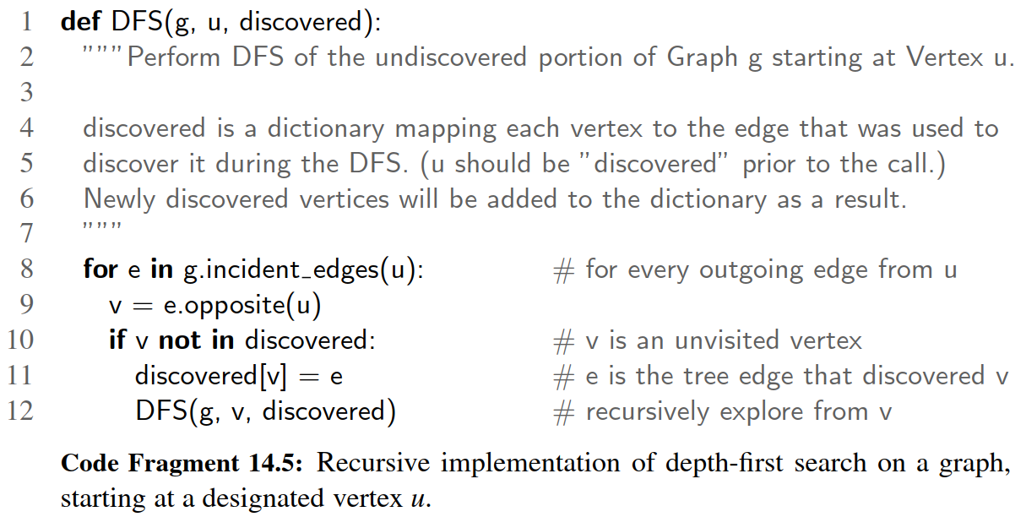

In order to track which vertices have been visited, and to build a representation of the resulting DFS tree, our implementation introduces a third parameter, named discovered. This parameter should be a Python dictionary that maps a vertex of the graph to the tree edge that was used to discover that vertex. As a technicality, we assume that the source vertex u occurs as a key of the dictionary, with None as its value. Thus, a caller might start the traversal as follows:

＊

result = {u : **None**} # a new dictionary, with u trivially dis covered

DFS(g, u, result)

The dictionary serves two purposes. Internally, the dictionary provides a mechanism for recognizing visited vertices, as they will appear as keys in the dictionary. Externally, the DFS function augments this dictionary as it proceeds, and thus the values within the dictionary are the DFS tree edges at the conclusion of the process.

＊

Because the dictionary is hash-based, the test, “**if** v **not** **in** discovered,” and the record-keeping step, “discovered[*v*] = e,” run in *O*(1) ***expected*** time, rather than worst-case time. In practice, this is a compromise we are willing to accept, but it does violate the formal analysis of the algorithm, as given on page 643. If we could assume that vertices could be numbered from 0 to *n* − 1, then those numbers could be used as indices into an array-based lookup table rather than a hash-based map. Alternatively, we could store each vertex’s discovery status and associated tree edge directly as part of the vertex instance.

＊

**Reconstructing a Path from u to v**

＊

We can use the basic DFS function as a tool to identify the (directed) path leading from vertex *u* to *v*, if *v* is reachable from *u*. This path can easily be reconstructed from the information that was recorded in the discovery dictionary during the traversal. Code Fragment 14.6 provides an implementation of a secondary function that produces an ordered list of vertices on the path from *u* to *v*.

＊

To reconstruct the path, we begin at the end of the path, examining the discovery dictionary to determine what edge was used to reach vertex *v*, and then what the other endpoint of that edge is. We add that vertex to a list, and then repeat the process to determine what edge was used to discover it. Once we have traced the path all the way back to the starting vertex *u*, we can reverse the list so that it is properly oriented from *u* to *v*, and return it to the caller. This process takes time proportional to the length of the path, and therefore it runs in *O*(*n*) time (in addition to the time originally spent calling DFS).

＊

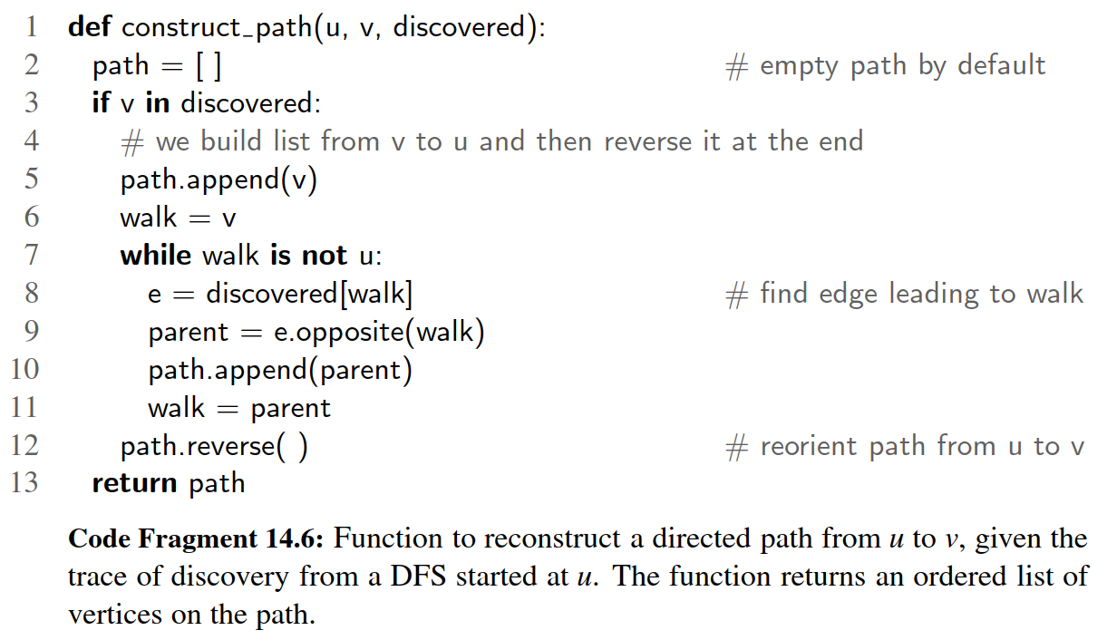

**Testing for Connectivity**

＊

We can use the basic DFS function to determine whether a graph is connected. In the case of an undirected graph, we simply start a depth-ﬁrst search at an arbitrary vertex and then test whether len(discovered) equals *n* at the conclusion. If the graph is connected, then by Proposition 14.12, all vertices will have been discovered; conversely, if the graph is not connected, there must be at least one vertex *v* that is not reachable from *u*, and that will not be discovered.

＊

For directed graph, ***G***, we may wish to test whether it is strongly connected, that is, whether for every pair of vertices *u* and *v*, both *u* reaches *v* and v reaches *u*. If we start an independent call to DFS from each vertex, we could determine whether this was the case, but those n calls when combined would run in *O*(*n*(*n* + *m*)). However, we can determine if ***G*** is strongly connected much faster than this, requiring only two depth-ﬁrst searches.

＊

We begin by performing a depth-ﬁrst search of our directed graph G- starting at an arbitrary vertex s. If there is any vertex of G- that is not visited by this traversal, and is not reachable from s, then the graph is not strongly connected. If this ﬁrst

depth-ﬁrst search visits each vertex of ***G***, we need to then check whether s is reachable from all other vertices. Conceptually, we can accomplish this by making a copy of graph ***G***, but with the orientation of all edges reversed. A depth-ﬁrst search starting at s in the reversed graph will reach every vertex that could reach s in the original. In practice, a better approach than making a new graph is to reimplement a version of the DFS method that loops through all ***incoming*** edges to the current vertex, rather than all ***outgoing*** edges. Since this algorithm makes just two DFS traversals of ***G***, it runs in *O*(*n* + *m*) time.

＊

**Computing all Connected Components**

＊

When a graph is not connected, the next goal we may have is to identify all of the connected components of an undirected graph, or the strongly connected components of a directed graph. We begin by discussing the undirected case.

＊

If an initial call to DFS fails to reach all vertices of a graph, we can restart a new call to DFS at one of those unvisited vertices. An implementation of such a comprehensive DFS_all method is given in Code Fragment 14.7.

＊

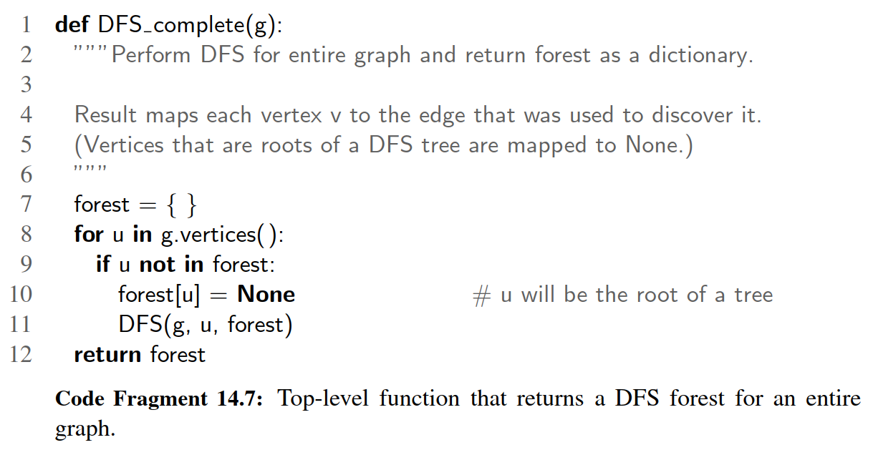

Although the DFS complete function makes multiple calls to the original DFS function, the total time spent by a call to DFS complete is O(n + m). For an undirected graph, recall from our original analysis on page 643 that a single call to DFS starting at vertex s runs in time O(ns + ms) where ns is the number of vertices reachable from s, and ms is the number of incident edges to those vertices. Because each call to DFS explores a different component, the sum of ns + ms terms is n + m. The O(n + m) total bound applies to the directed case as well, even though the sets of reachable vertices are not necessarily disjoint. However, because the same discovery dictionary is passed as a parameter to all DFS calls, we know that the DFS subroutine is called once on each vertex, and then each outgoing edge is explored only once during the process.

＊

The DFS_complete function can be used to analyze the connected components of an undirected graph. The discovery dictionary it returns represents a ***DFS forest*** for the entire graph. We say this is a forest rather than a tree, because the graph may not be connected. The number of connected components can be determined by the number of vertices in the discovery dictionary that have None as their discovery edge (those are roots of DFS trees). A minor modiﬁcation to the core DFS method could be used to tag each vertex with a component number when it is discovered. (See Exercise C-14.44.)

＊

The situation is more complex for ﬁnding strongly connected components of a directed graph. There exists an approach for computing those components in *O*(*n* + *m*) time, making use of two separate depth-ﬁrst search traversals, but the details are beyond the scope of this book.

＊

**Detecting Cycles with DFS**

＊

For both undirected and directed graphs, a cycle exists if and only if a ***back edge*** exists relative to the DFS traversal of that graph. It is easy to see that if a back edge exists, a cycle exists by taking the back edge from the descendant to its ancestor and then following the tree edges back to the descendant. Conversely, if a cycle exists in the graph, there must be a back edge relative to a DFS (although we do not prove this fact here).

＊

Algorithmically, detecting a back edge in the undirected case is easy, because all edges are either tree edges or back edges. In the case of a directed graph, additional modiﬁcations to the core DFS implementation are needed to properly categorize a nontree edge as a back edge. When a directed edge is explored leading to a previously visited vertex, we must recognize whether that vertex is an ancestor of the current vertex. This requires some additional bookkeeping, for example, by tagging vertices upon which a recursive call to DFS is still active. We leave details as an exercise (C-14.43).

＊

14.3.3 Breadth-First Search

＊

The advancing and backtracking of a depth-ﬁrst search, as described in the previous section, deﬁnes a traversal that could be physically traced by a single person exploring a graph. In this section, we consider another algorithm for traversing a connected component of a graph, known as a breadth-ﬁrst search (BFS). The BFS algorithm is more akin to sending out, in all directions, many explorers who collectively traverse a graph in coordinated fashion.

A BFS proceeds in rounds and subdivides the vertices into levels. BFS starts at vertex s, which is at level 0. In the ﬁrst round, we paint as “visited,” all vertices adjacent to the start vertex s—these vertices are one step away from the beginning and are placed into level 1. In the second round, we allow all explorers to go two steps (i.e., edges) away from the starting vertex. These new vertices, which are adjacent to level 1 vertices and not previously assigned to a level, are placed into level 2 and marked as “visited.” This process continues in similar fashion, terminating when no new vertices are found in a level.

A Python implementation of BFS is given in Code Fragment 14.8. We follow a convention similar to that of DFS (Code Fragment 14.5), using a discovered dictionary both to recognize visited vertices, and to record the discovery edges of the BFS tree. We illustrate a BFS traversal in Figure 14.10.

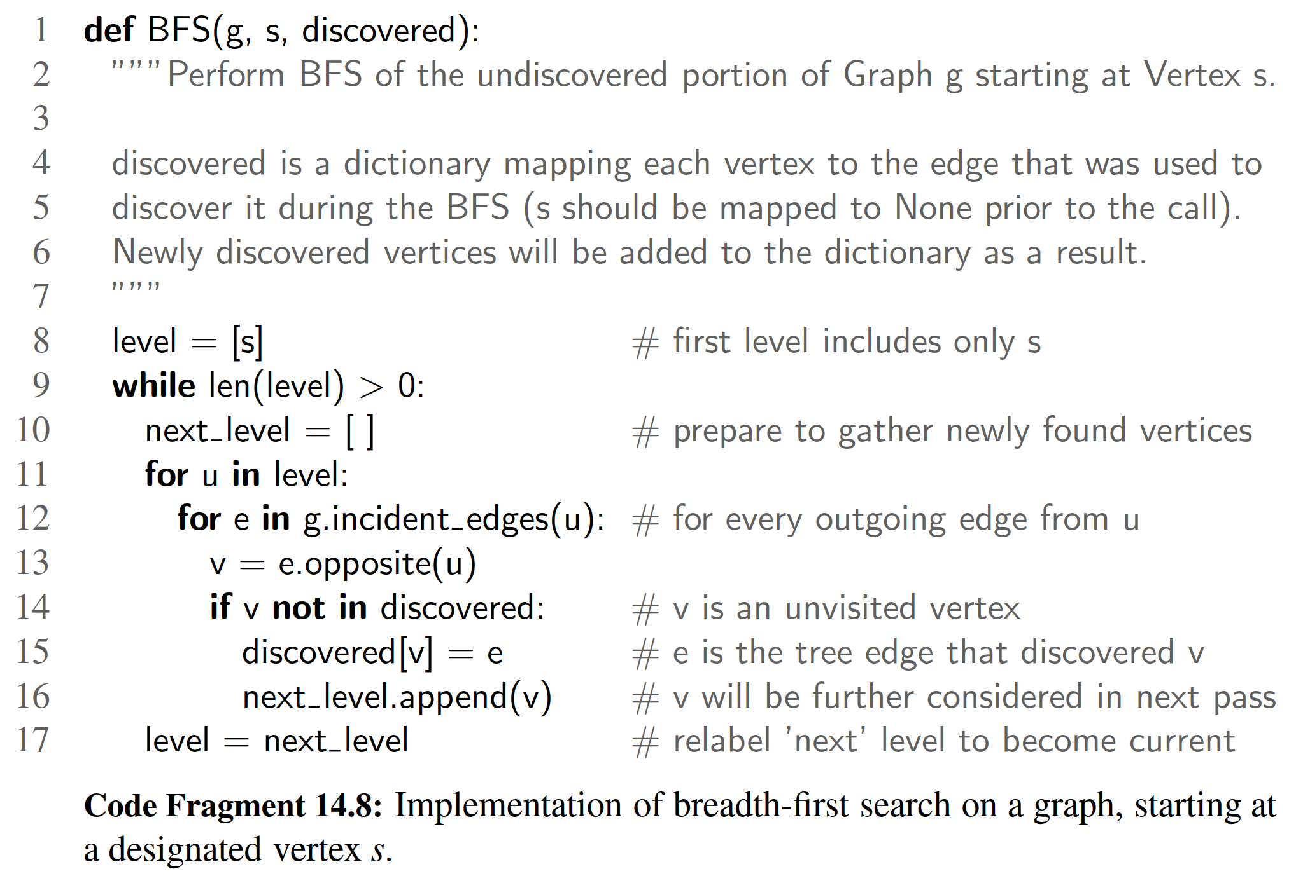

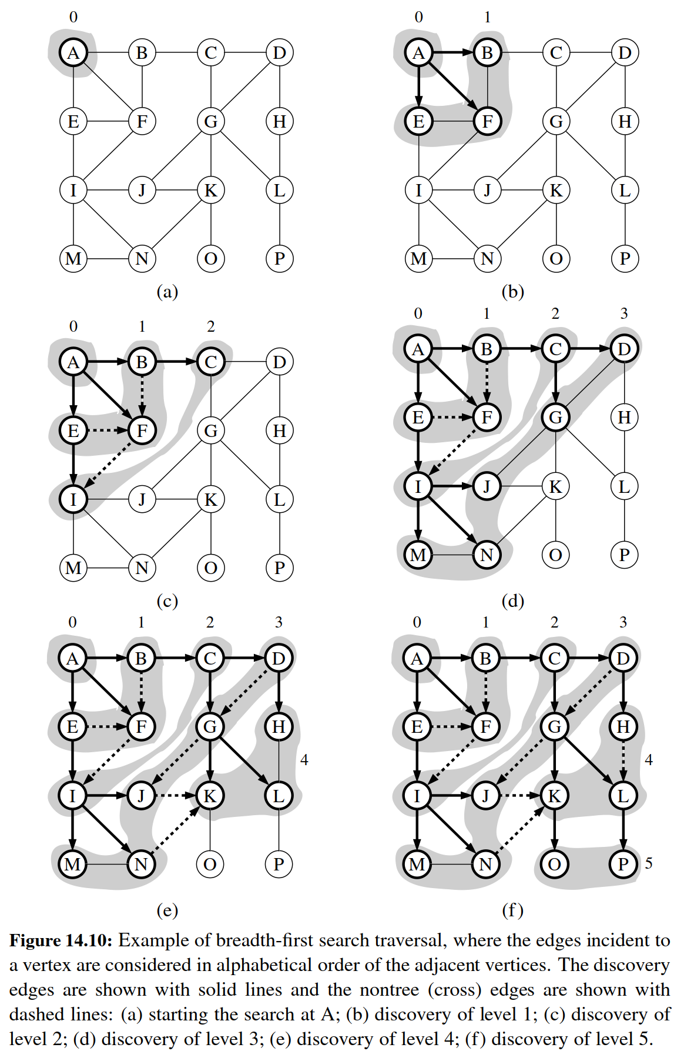

When discussing DFS, we described a classiﬁcation of nontree edges being either back edges, which connect a vertex to one of its ancestors, forward edges, which connect a vertex to one of its descendants, or cross edges, which connect a vertex to another vertex that is neither its ancestor nor its descendant. For BFS on an undirected graph, all nontree edges are cross edges (see Exercise C-14.47), and for BFS on a directed graph, all nontree edges are either back edges or cross edges (see Exercise C-14.48).

The BFS traversal algorithm has a number of interesting properties, some of which we explore in the proposition that follows. Most notably, a path in a breadth- ﬁrst search tree rooted at vertex s to any other vertex v is guaranteed to be the shortest such path from s to v in terms of the number of edges.

Proposition 14.16: Let G be an undirected or directed graph on which a BFS traversal starting at vertex s has been performed. Then

• The traversal visits all vertices of G that are reachable from s.

For each vertex v at level i, the path of the BFS tree T between s and v has i

edges, and any other path of G from s to v has at least i edges.

If (u, v) is an edge that is not in the BFS tree, then the level number of v can be at most 1 greater than the level number of u.

We leave the justiﬁcation of this proposition as an exercise (C-14.50).

The analysis of the running time of BFS is similar to the one of DFS, with the algorithm running in O(n + m) time, or more speciﬁcally, in O(ns + ms) time if ns is the number of vertices reachable from vertex s, and ms ≤ m is the number of incident edges to those vertices. To explore the entire graph, the process can be restarted at another vertex, akin to the DFS complete function of Code Fragment 14.7. Also, the actual path from vertex s to vertex v can be reconstructed using the construct path function of Code Fragment 14.6

Proposition 14.17: Let G be a graph with n vertices and m edges represented with the adjacency list structure. A BFS traversal of G takes O(n + m) time.

Although our implementation of BFS in Code Fragment 14.8 progresses level by level, the BFS algorithm can also be implemented using a single FIFO queue to represent the current fringe of the search. Starting with the source vertex in the queue, we repeatedly remove the vertex from the front of the queue and insert any of its unvisited neighbors to the back of the queue. (See Exercise C-14.51.)

In comparing the capabilities of DFS and BFS, both can be used to efﬁciently ﬁnd the set of vertices that are reachable from a given source, and to determine paths to those vertices. However, BFS guarantees that those paths use as few edges as possible. For an undirected graph, both algorithms can be used to test connectivity, to identify connected components, or to locate a cycle. For directed graphs, the DFS algorithm is better suited for certain tasks, such as ﬁnding a directed cycle in the graph, or in identifying the strongly connected components.

14.4 Transitive Closure

We have seen that graph traversals can be used to answer basic questions of reach- ability in a directed graph. In particular, if we are interested in knowing whether there is a path from vertex u to vertex v in a graph, we can perform a DFS or BFS traversal starting at u and observe whether v is discovered. If representing a graph with an adjacency list or adjacency map, we can answer the question of reachability for u and v in O(n + m) time (see Propositions 14.15 and 14.17).

In certain applications, we may wish to answer many reachability queries more efﬁciently, in which case it may be worthwhile to precompute a more convenient representation of a graph. For example, the ﬁrst step for a service that computes driving directions from an origin to a destination might be to assess whether the destination is reachable. Similarly, in an electricity network, we may wish to be able to quickly determine whether current ﬂows from one particular vertex to an- other. Motivated by such applications, we introduce the following deﬁnition. The transitive closure of a directed graph G- is itself a directed graph G- ∗ such that the vertices of G- ∗ are the same as the vertices of G- , and G- ∗ has an edge (u, v), when- ever G- has a directed path from u to v (including the case where (u, v) is an edge of the original G- ).

If a graph is represented as an adjacency list or adjacency map, we can compute its transitive closure in O(n(n + m)) time by making use of n graph traversals, one from each starting vertex. For example, a DFS starting at vertex u can be used to determine all vertices reachable from u, and thus a collection of edges originating with u in the transitive closure.

In the remainder of this section, we explore an alternative technique for computing the transitive closure of a directed graph that is particularly well suited for when a directed graph is represented by a data structure that supports O(1)-time lookup

for the get edge(u,v) method (for example, the adjacency-matrix structure). Let G-be a directed graph with n vertices and m edges. We compute the transitive closure of G- in a series of rounds. We initialize G- 0 = G- . We also arbitrarily number the vertices of G- as v1, v2,... , vn. We then begin the computation of the rounds, beginning with round 1. In a generic round k, we construct directed graph G- k starting with G- k = G- k−1 and adding to G- k the directed edge (vi, v j) if directed graph G- k−1

contains both the edges (vi, vk) and (vk, v j). In this way, we will enforce a simple rule embodied in the proposition that follows.

Proposition 14.18: For i = 1,..., n, directed graph G- k has an edge (vi, v j) if and

only if directed graph G- has a directed path from vi to v j, whose intermediate

vertices (if any) are in the set v1,... , vk . In particular, G- n is equal to G- ∗, the transitive closure of G- .

Proposition 14.18 suggests a simple algorithm for computing the transitive closure of G- that is based on the series of rounds to compute each G- k. This algorithm is known as the Floyd-Warshall algorithm, and its pseudo-code is given in Code

Fragment 14.9. We illustrate an example run of the Floyd-Warshall algorithm in Figure 14.11.

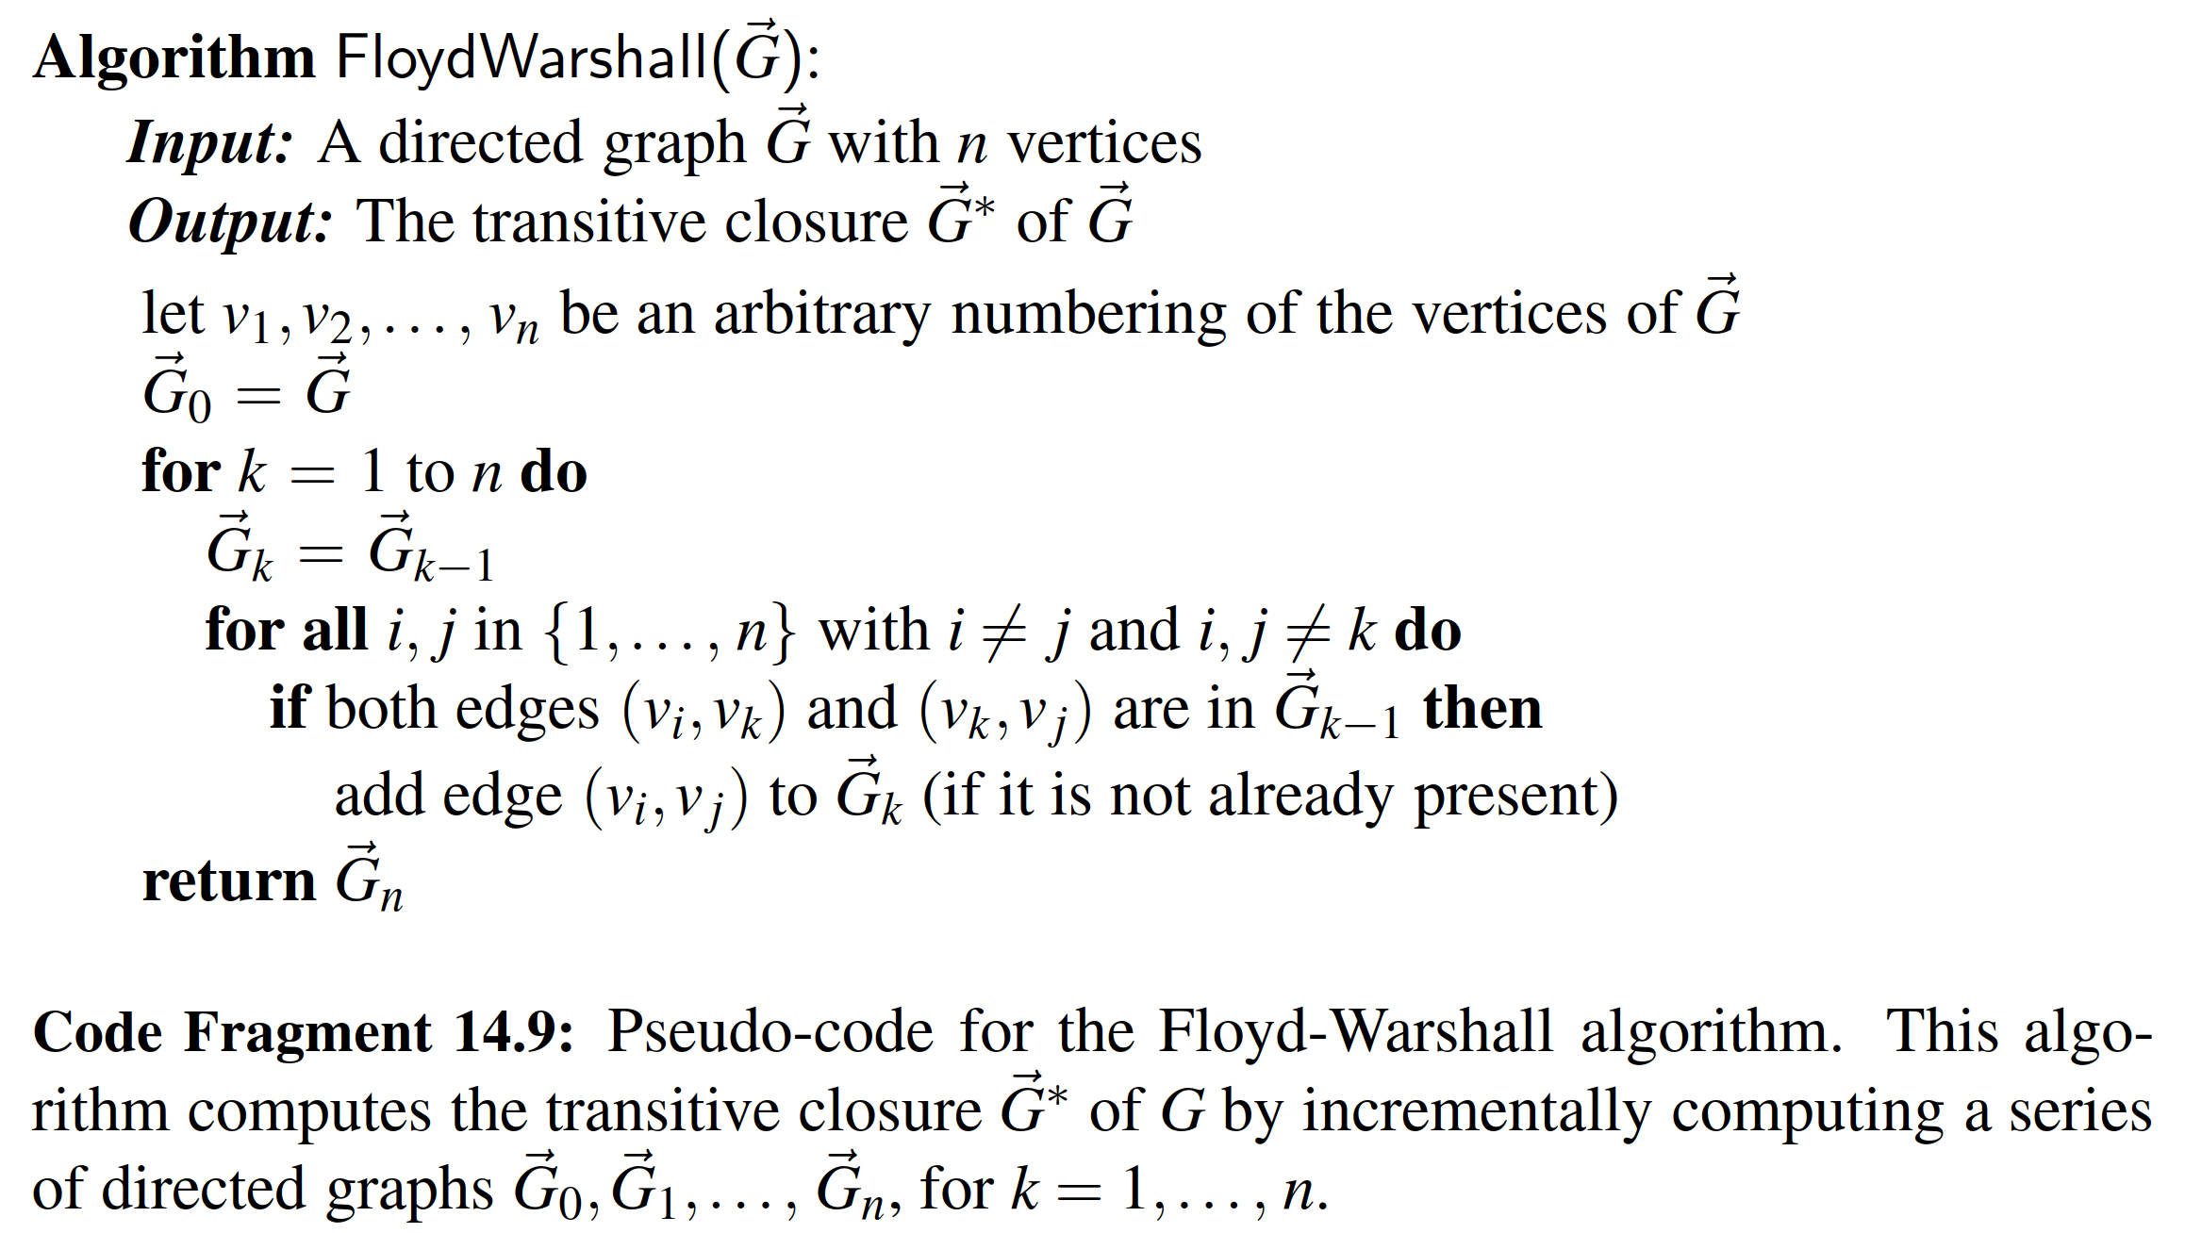

From this pseudo-code, we can easily analyze the running time of the Floyd- Warshall algorithm assuming that the data structure representing G supports methods get edge and insert edge in O(1) time. The main loop is executed n times and the inner loop considers each of O(n2) pairs of vertices, performing a constant-time computation for each one. Thus, the total running time of the Floyd-Warshall algorithm is O(n3). From the description and analysis above we may immediately derive the following proposition.

Proposition 14.19: Let G- be a directed graph with n vertices, and let G- be represented by a data structure that supports lookup and update of adjacency information in O(1) time. Then the Floyd-Warshall algorithm computes the transitive closure

G- ∗ of G- in O(n3) time.

Performance of the Floyd-Warshall Algorithm

Asymptotically, the O(n3) running time of the Floyd-Warshall algorithm is no better than that achieved by repeatedly running DFS, once from each vertex, to compute the reachability. However, the Floyd-Warshall algorithm matches the asymptotic bounds of the repeated DFS when a graph is dense, or when a graph is sparse but represented as an adjacency matrix. (See Exercise R-14.12.)

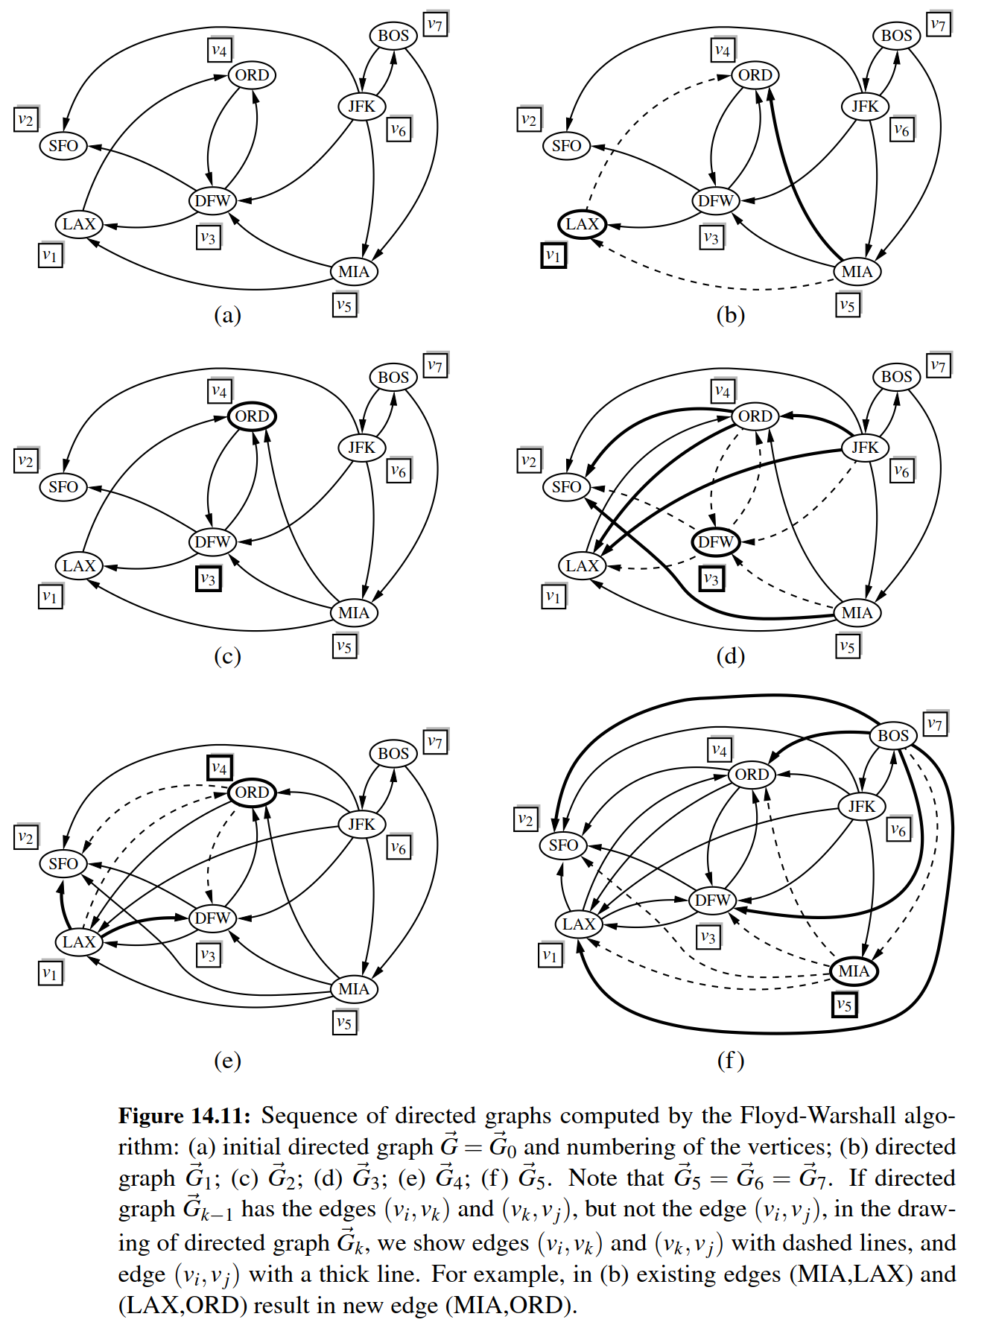

The importance of the Floyd-Warshall algorithm is that it is much easier to implement than DFS, and much faster in practice because there are relatively few low-level operations hidden within the asymptotic notation. The algorithm is par- ticularly well suited for the use of an adjacency matrix, as a single bit can be used to designate the reachability modeled as an edge (u, v) in the transitive closure.

However, note that repeated calls to DFS results in better asymptotic perfor- mance when the graph is sparse and represented using an adjacency list or adjacency map. In that case, a single DFS runs in O(n + m) time, and so the transitive closure can be computed in O(n2 + nm) time, which is preferable to O(n3).

**Python Implementation**

We conclude with a Python implementation of the Floyd-Warshall algorithm, as presented in Code Fragment 14.10. Although the original algorithm is described using a series of directed graphs G- 0, G- 1,... , G- n, we create a single copy of the

original graph (using the deepcopy method of Python’s copy module) and then repeatedly add new edges to the closure as we progress through rounds of the Floyd-Warshall algorithm.

The algorithm requires a canonical numbering of the graph’s vertices; therefore, we create a list of the vertices in the closure graph, and subsequently index that list for our order. Within the outermost loop, we must consider all pairs i and j. Finally, we optimize by only iterating through all values of j after we have veriﬁed that i has been chosen such that (vi, vk) exists in the current version of our closure.

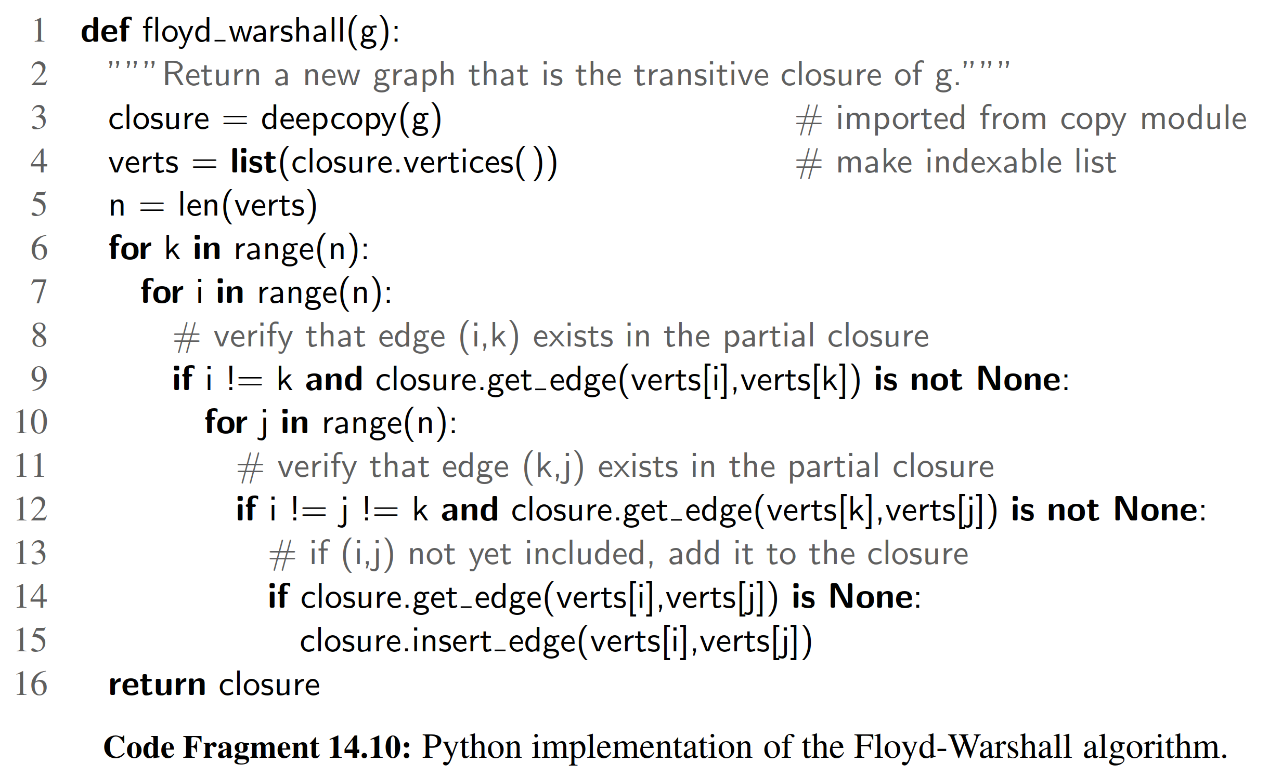

14.5 Directed Acyclic Graphs

Directed graphs without directed cycles are encountered in many applications. Such a directed graph is often referred to as a directed acyclic graph, or DAG, for short. Applications of such graphs include the following:

• Prerequisites between courses of a degree program.

• Inheritance between classes of an object-oriented program.

• Scheduling constraints between the tasks of a project.

We explore this latter application further in the following example:

Example 14.20: In order to manage a large project, it is convenient to break it up into a collection of smaller tasks. The tasks, however, are rarely independent, be- cause scheduling constraints exist between them. (For example, in a house building project, the task of ordering nails obviously precedes the task of nailing shingles to the roof deck.) Clearly, scheduling constraints cannot have circularities, because they would make the project impossible. (For example, in order to get a job you need to have work experience, but in order to get work experience you need to have a job.) The scheduling constraints impose restrictions on the order in which the tasks can be executed. Namely, if a constraint says that task a must be completed before task b is started, then a must precede b in the order of execution of the tasks. Thus, if we model a feasible set of tasks as vertices of a directed graph, and we place a directed edge from u to v whenever the task for u must be executed before the task for v, then we deﬁne a directed acyclic graph.

14.5.1 Topological Ordering

The example above motivates the following deﬁnition. Let G be a directed graph

with n vertices. A topological ordering of G- is an ordering v1,... ,vn of the vertices of G- such that for every edge (vi, v j) of G- , it is the case that i < j. That is, a topo- logical ordering is an ordering such that any directed path in G- traverses vertices in increasing order. Note that a directed graph may have more than one topological ordering. (See Figure 14.12.)

Proposition 14.21:

G- has a topological ordering if and only if it is acyclic.

Justiﬁcation: The necessity (the “only if” part of the statement) is easy to demonstrate. Suppose G- is topologically ordered. Assume, for the sake of a contradiction, that G- has a cycle consisting of edges (vi0 , vi1 ),(vi1 , vi2 ),... ,(vik−1 , vi0 ).

Because of the topological ordering, we must have i0 < i1 < < ik−1 < i0, which is clearly impossible. Thus, G- must be acyclic.

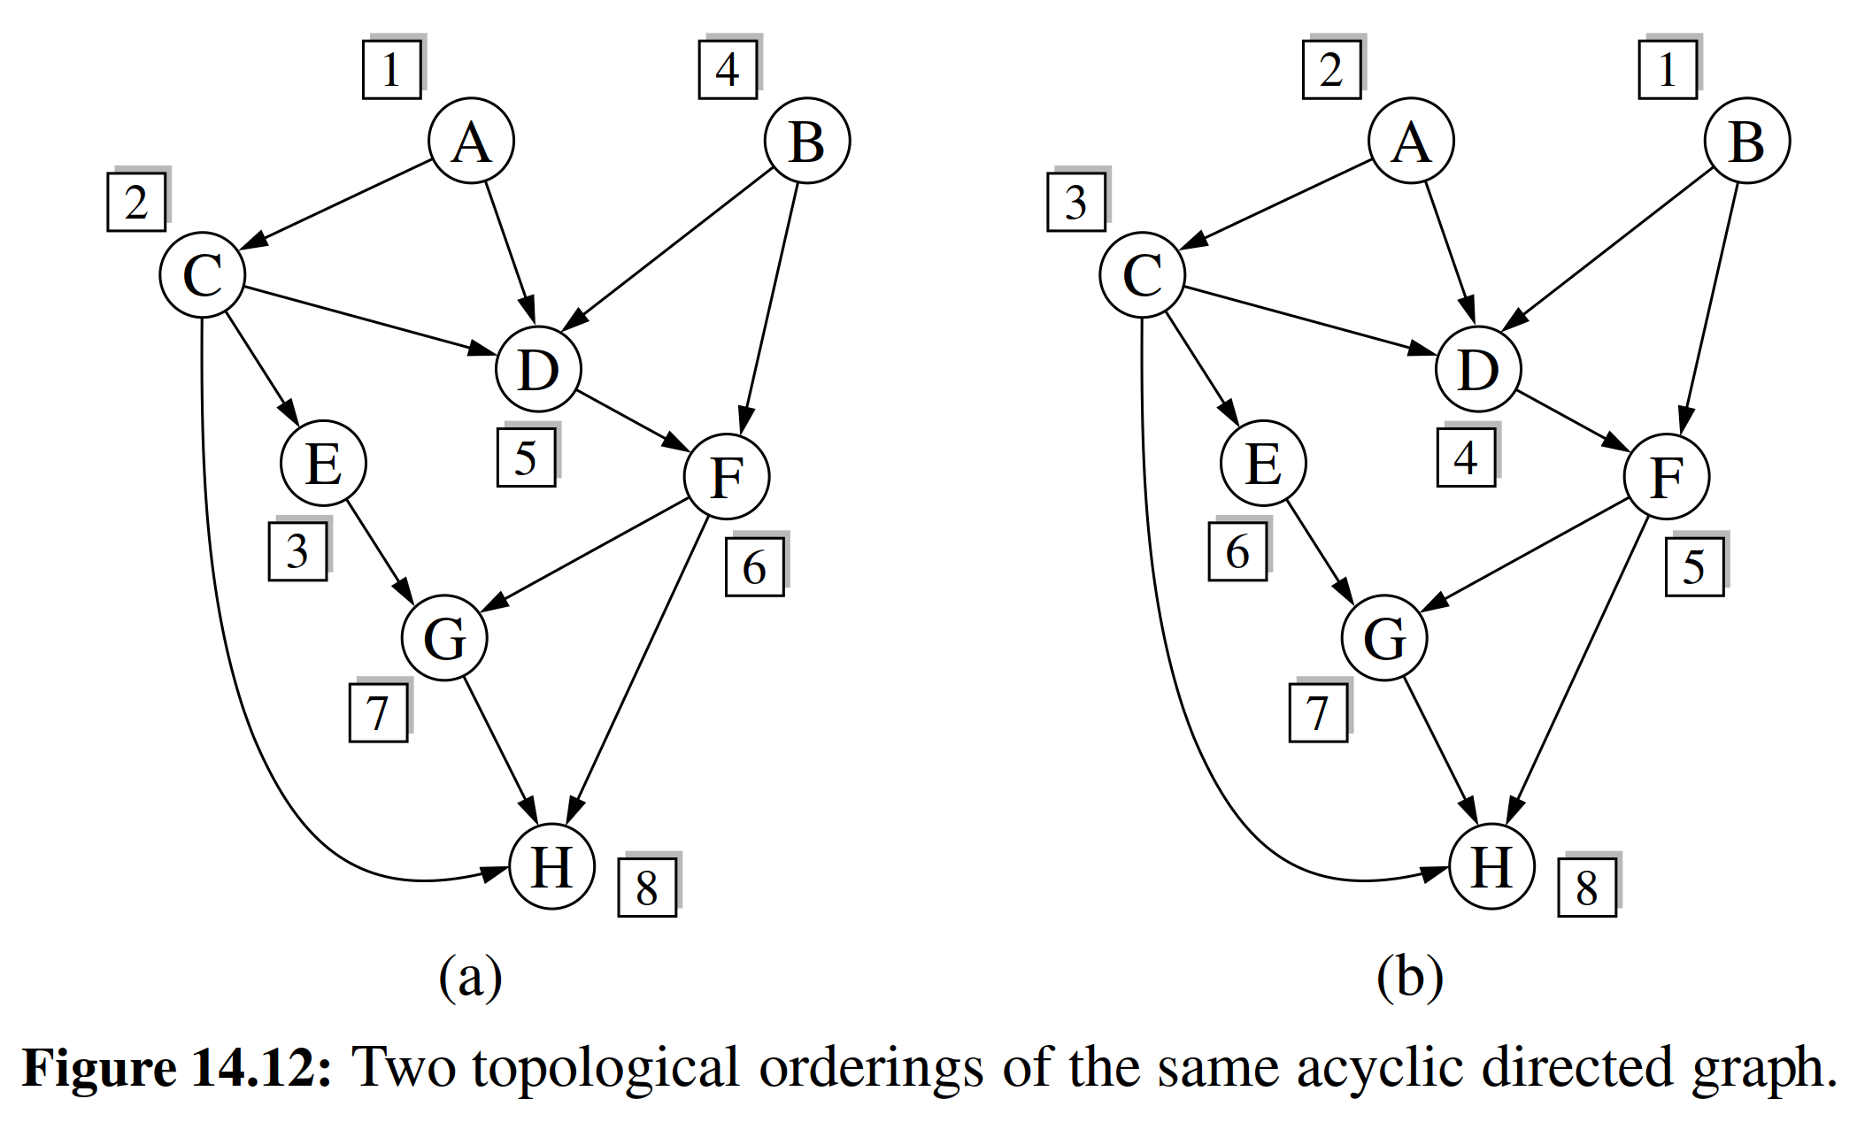

We now argue the sufﬁciency of the condition (the “if” part). Suppose G- is

acyclic. We will give an algorithmic description of how to build a topological

ordering for G- . Since G-

is acyclic, G-

must have a vertex with no incoming edges

(that is, with in-degree 0). Let v1 be such a vertex. Indeed, if v1 did not exist, then in tracing a directed path from an arbitrary start vertex, we would eventually encounter a previously visited vertex, thus contradicting the acyclicity of G- . If we remove v1 from G- , together with its outgoing edges, the resulting directed graph is still acyclic. Hence, the resulting directed graph also has a vertex with no incoming

edges, and we let v2 be such a vertex. By repeating this process until the directed graph becomes empty, we obtain an ordering v1,... ,vn of the vertices of G- . Because of the construction above, if (vi, v j) is an edge of G- , then vi must be deleted before v j can be deleted, and thus, i < j. Therefore, v1,... , vn is a topological ordering.

Proposition 14.21’s justiﬁcation suggests an algorithm for computing a topo- logical ordering of a directed graph, which we call topological sorting. We present a Python implementation of the technique in Code Fragment 14.11, and an example execution of the algorithm in Figure 14.13. Our implementation uses a dictionary, named incount, to map each vertex v to a counter that represents the current number of incoming edges to v, excluding those coming from vertices that have previously been added to the topological order. Technically, a Python dictionary provides O(1) expected time access to entries, rather than worst-case time; as was the case with our graph traversals, this could be converted to worst-case time if vertices could be indexed from 0 to n − 1, or if we store the counter as an element of a vertex.

As a side effect, the topological sorting algorithm of Code Fragment 14.11

also tests whether the given directed graph G-

is acyclic. Indeed, if the algorithm

terminates without ordering all the vertices, then the subgraph of the vertices that have not been ordered must contain a directed cycle.

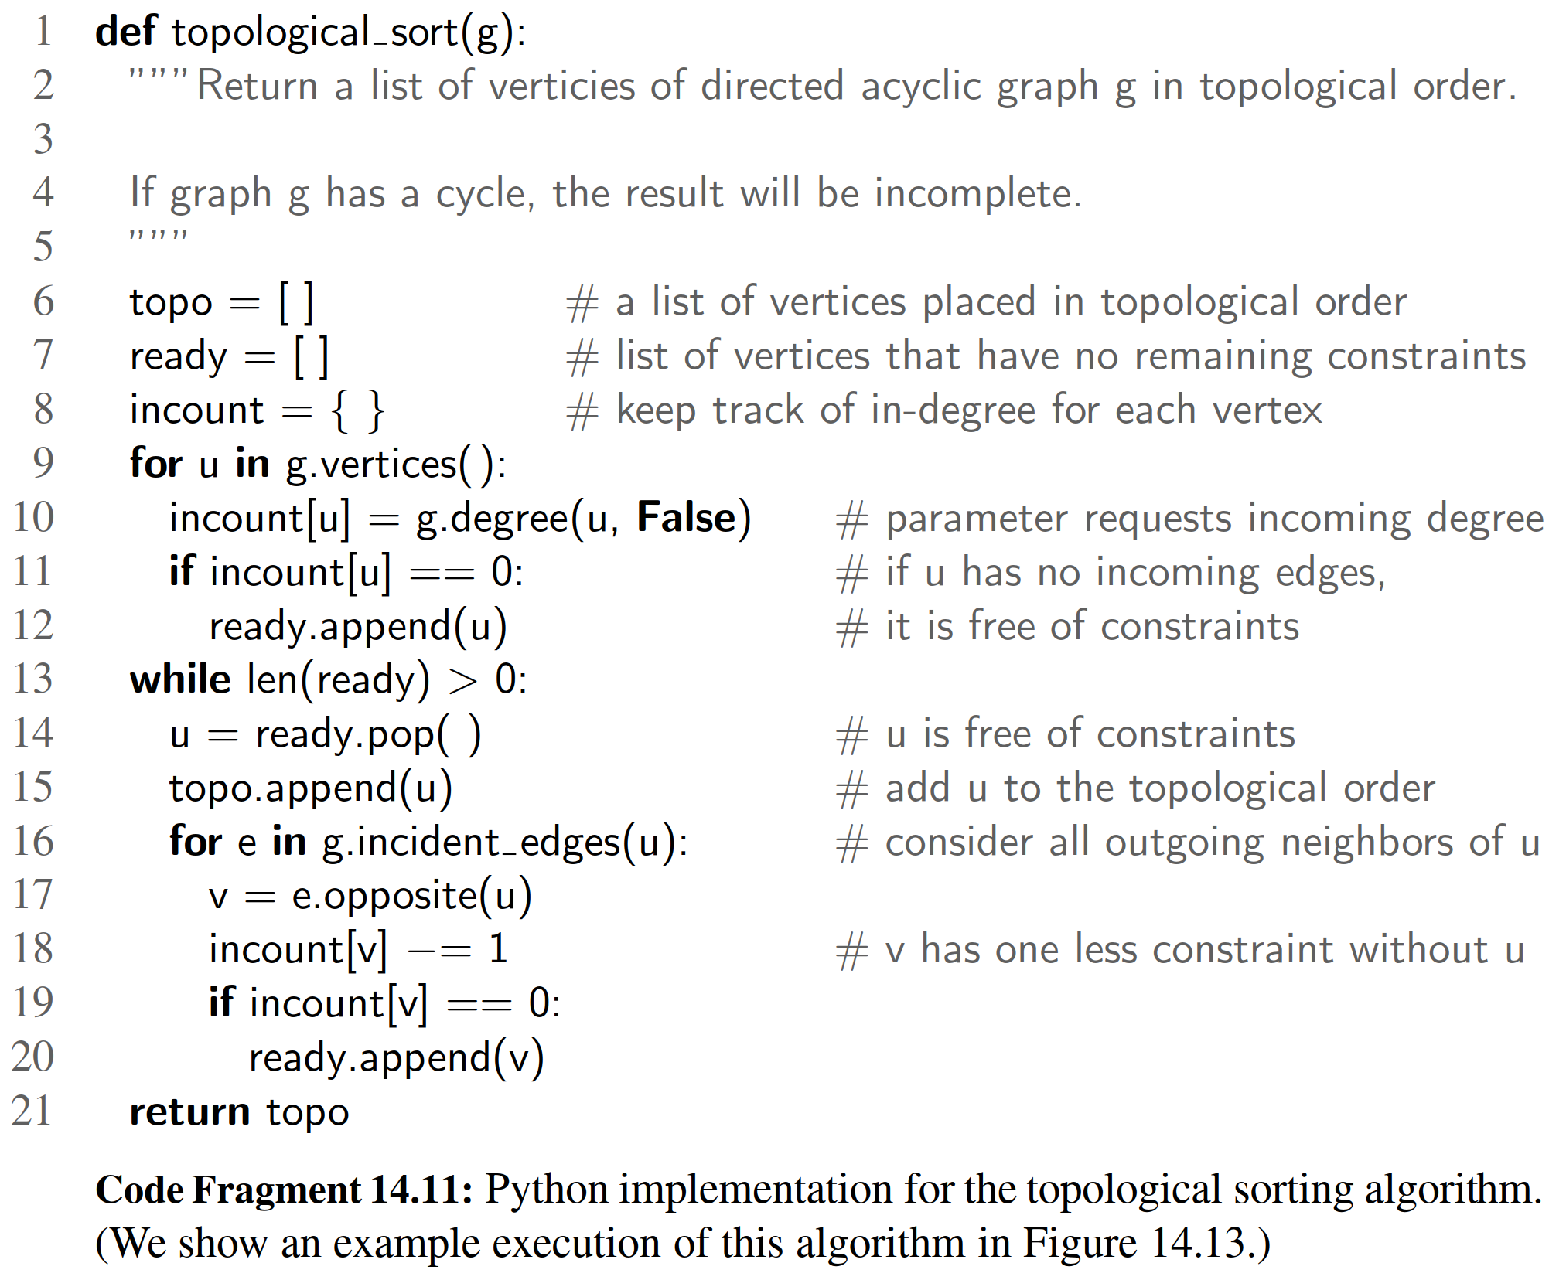

Performance of Topological Sorting

Proposition 14.22: Let G- be a directed graph with n vertices and m edges, using an adjacency list representation. The topological sorting algorithm runs in O(n + m) time using O(n) auxiliary space, and either computes a topological ordering of G- or fails to include some vertices, which indicates that G- has a directed cycle.

Justiﬁcation: The initial recording of the n in-degrees uses O(n) time based on the degree method. Say that a vertex u is visited by the topological sorting algorithm when u is removed from the ready list. A vertex u can be visited only when incount(u) is 0, which implies that all its predecessors (vertices with outgoing edges into u) were previously visited. As a consequence, any vertex that is on a directed cycle will never be visited, and any other vertex will be visited exactly once. The algorithm traverses all the outgoing edges of each visited vertex once, so its running time is proportional to the number of outgoing edges of the visited vertices. In accordance with Proposition 14.9, the running time is (n + m). Regarding the space usage, observe that containers topo, ready, and incount have at most one entry per vertex, and therefore use O(n) space.

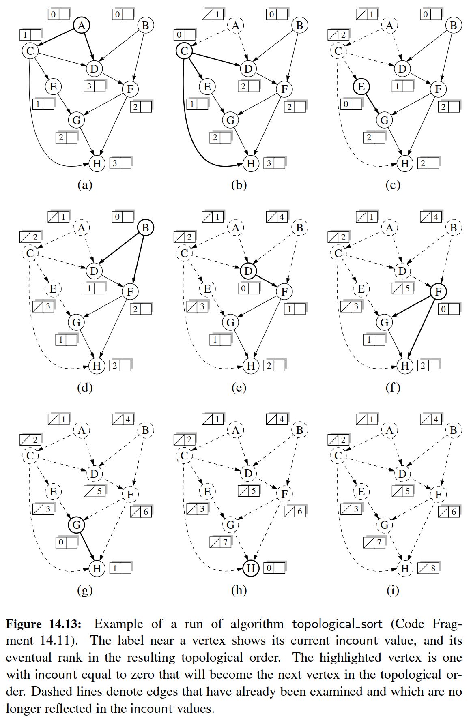

14.6 Shortest Paths

As we saw in Section 14.3.3, the breadth-ﬁrst search strategy can be used to ﬁnd a shortest path from some starting vertex to every other vertex in a connected graph. This approach makes sense in cases where each edge is as good as any other, but there are many situations where this approach is not appropriate.

For example, we might want to use a graph to represent the roads between cities, and we might be interested in ﬁnding the fastest way to travel cross-country. In this case, it is probably not appropriate for all the edges to be equal to each other, for some inter-city distances will likely be much larger than others. Likewise, we might be using a graph to represent a computer network (such as the Internet), and we might be interested in ﬁnding the fastest way to route a data packet between two computers. In this case, it again may not be appropriate for all the edges to be equal to each other, for some connections in a computer network are typically much faster than others (for example, some edges might represent low-bandwidth connections, while others might represent high-speed, ﬁber-optic connections). It is natural, therefore, to consider graphs whose edges are not weighted equally.

14.6.1 Weighted Graphs

A weighted graph is a graph that has a numeric (for example, integer) label w(e) associated with each edge e, called the weight of edge e. For e = (u, v), we let notation w(u, v)= w(e). We show an example of a weighted graph in Figure 14.14.

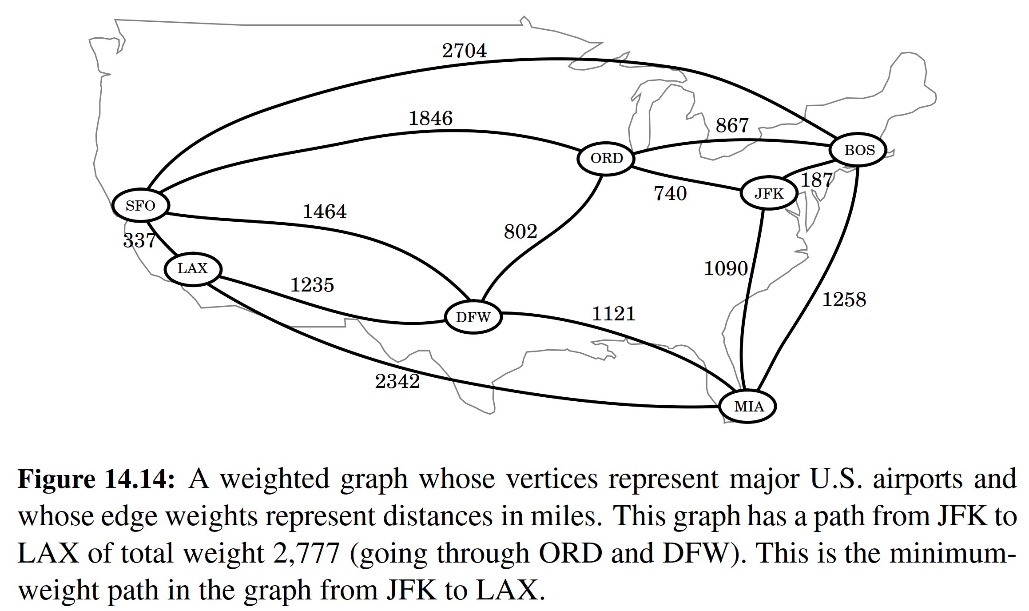

Deﬁning Shortest Paths in a Weighted Graph

Let G be a weighted graph. The length (or weight) of a path is the sum of the weights of the edges of P. That is, if P = ((v0, v1),(v1, v2),... , (vk−1, vk)), then the length of P, denoted w(P), is deﬁned as

k−1

w(P)=  w(vi, vi+1).

i=0

The distance from a vertex u to a vertex v in G, denoted d(u, v), is the length of a minimum-length path (also called shortest path) from u to v, if such a path exists.

People often use the convention that d(u, v)= if there is no path at all from u to v in G. Even if there is a path from u to v in G, however, if there is a cycle in G whose total weight is negative, the distance from u to v may not be deﬁned. For example, suppose vertices in G represent cities, and the weights of edges in G represent how much money it costs to go from one city to another. If someone were willing to actually pay us to go from say JFK to ORD, then the “cost” of the edge (JFK,ORD) would be negative. If someone else were willing to pay us to go from ORD to JFK, then there would be a negative-weight cycle in G and distances would no longer be deﬁned. That is, anyone could now build a path (with cycles) in G from any city A to another city B that ﬁrst goes to JFK and then cycles as many times as he or she likes from JFK to ORD and back, before going on to B. The existence of such paths would allow us to build arbitrarily low negative-cost paths (and, in this case, make a fortune in the process). But distances cannot be arbitrarily low negative numbers. Thus, any time we use edge weights to represent distances, we must be careful not to introduce any negative-weight cycles.

Suppose we are given a weighted graph G, and we are asked to ﬁnd a shortest path from some vertex s to each other vertex in G, viewing the weights on the edges as distances. In this section, we explore efﬁcient ways of ﬁnding all such shortest paths, if they exist. The ﬁrst algorithm we discuss is for the simple, yet common, case when all the edge weights in G are nonnegative (that is, w(e) ≥ 0 for each edge e of G); hence, we know in advance that there are no negative-weight cycles in G.

Recall that the special case of computing a shortest path when all weights are equal to one was solved with the BFS traversal algorithm presented in Section 14.3.3.

There is an interesting approach for solving this single-source problem based on the greedy method design pattern (Section 13.4.2). Recall that in this pattern we solve the problem at hand by repeatedly selecting the best choice from among those available in each iteration. This paradigm can often be used in situations where we are trying to optimize some cost function over a collection of objects. We can add objects to our collection, one at a time, always picking the next one that optimizes the function from among those yet to be chosen.

14.6.2 Dijkstra’s Algorithm

The main idea in applying the greedy method pattern to the single-source shortest- path problem is to perform a “weighted” breadth-ﬁrst search starting at the source vertex s. In particular, we can use the greedy method to develop an algorithm that iteratively grows a “cloud” of vertices out of s, with the vertices entering the cloud in order of their distances from s. Thus, in each iteration, the next vertex chosen is the vertex outside the cloud that is closest to s. The algorithm terminates when no more vertices are outside the cloud (or when those outside the cloud are not connected to those within the cloud), at which point we have a shortest path from s to every vertex of G that is reachable from s. This approach is a simple, but nevertheless powerful, example of the greedy method design pattern. Applying the greedy method to the single-source, shortest-path problem, results in an algorithm known as Dijkstra’s algorithm.

**Edge Relaxation**

Let us deﬁne a label D[v] for each vertex v in V , which we use to approximate the distance in G from s to v. The meaning of these labels is that D[v] will always store the length of the best path we have found so far from s to v. Initially, D[s]= 0 and D[v]= ∞ for each v /= s, and we deﬁne the set C, which is our “cloud” of vertices, to initially be the empty set. At each iteration of the algorithm, we select a vertex u not in C with smallest D[u] label, and we pull u into C. (In general, we will use a priority queue to select among the vertices outside the cloud.) In the very ﬁrst iteration we will, of course, pull s into C. Once a new vertex u is pulled into C, we then update the label D[v] of each vertex v that is adjacent to u and is outside of C, to reﬂect the fact that there may be a new and better way to get to v via u. This update operation is known as a relaxation procedure, for it takes an old estimate and checks if it can be improved to get closer to its true value. The speciﬁc edge relaxation operation is as follows:

Edge Relaxation:

if D[u]+ w(u, v) < D[v] then

D[v] = D[u]+ w(u, v)

**Algorithm Description and Example**

We give the pseudo-code for Dijkstra’s algorithm in Code Fragment 14.12, and illustrate several iterations of Dijkstra’s algorithm in Figures 14.15 through 14.17.

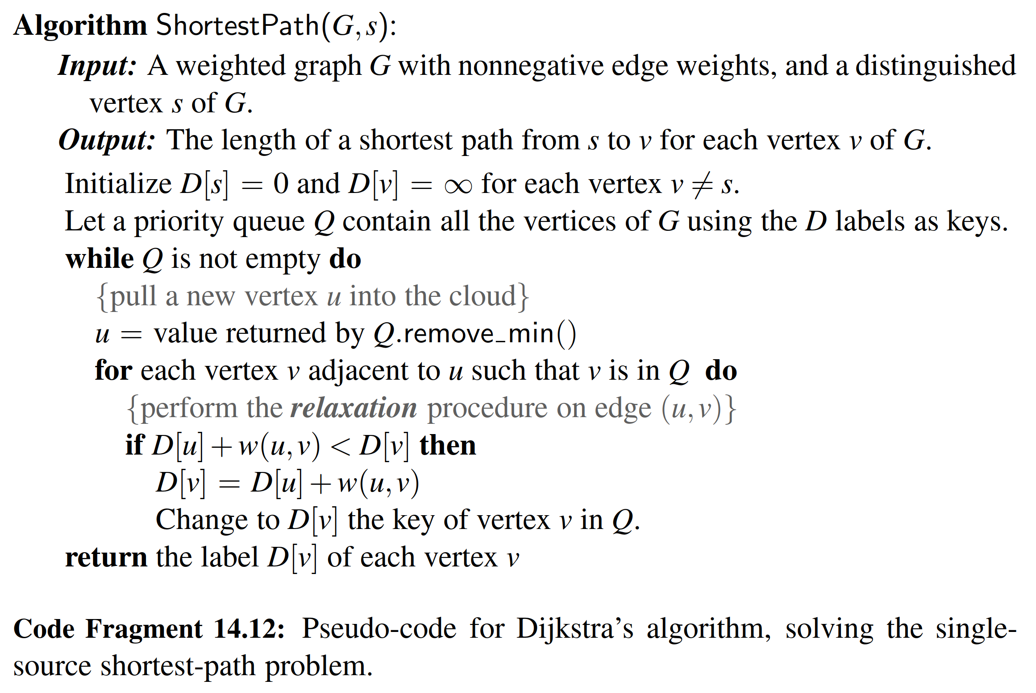

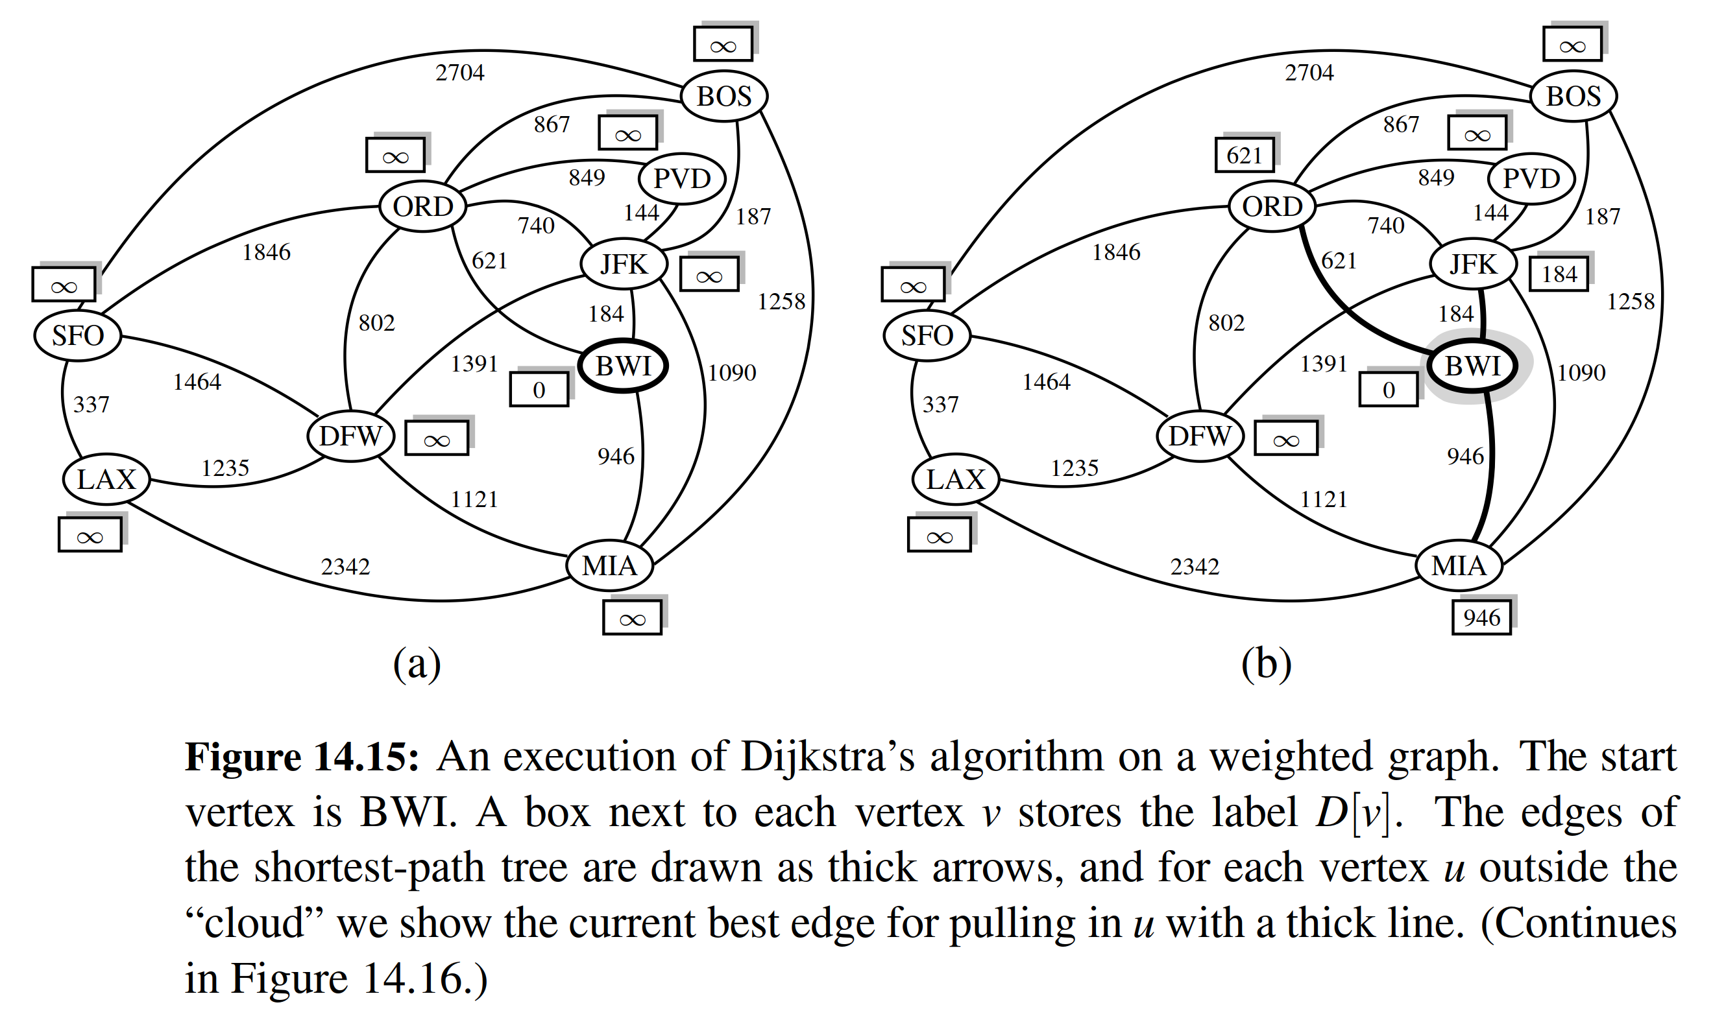

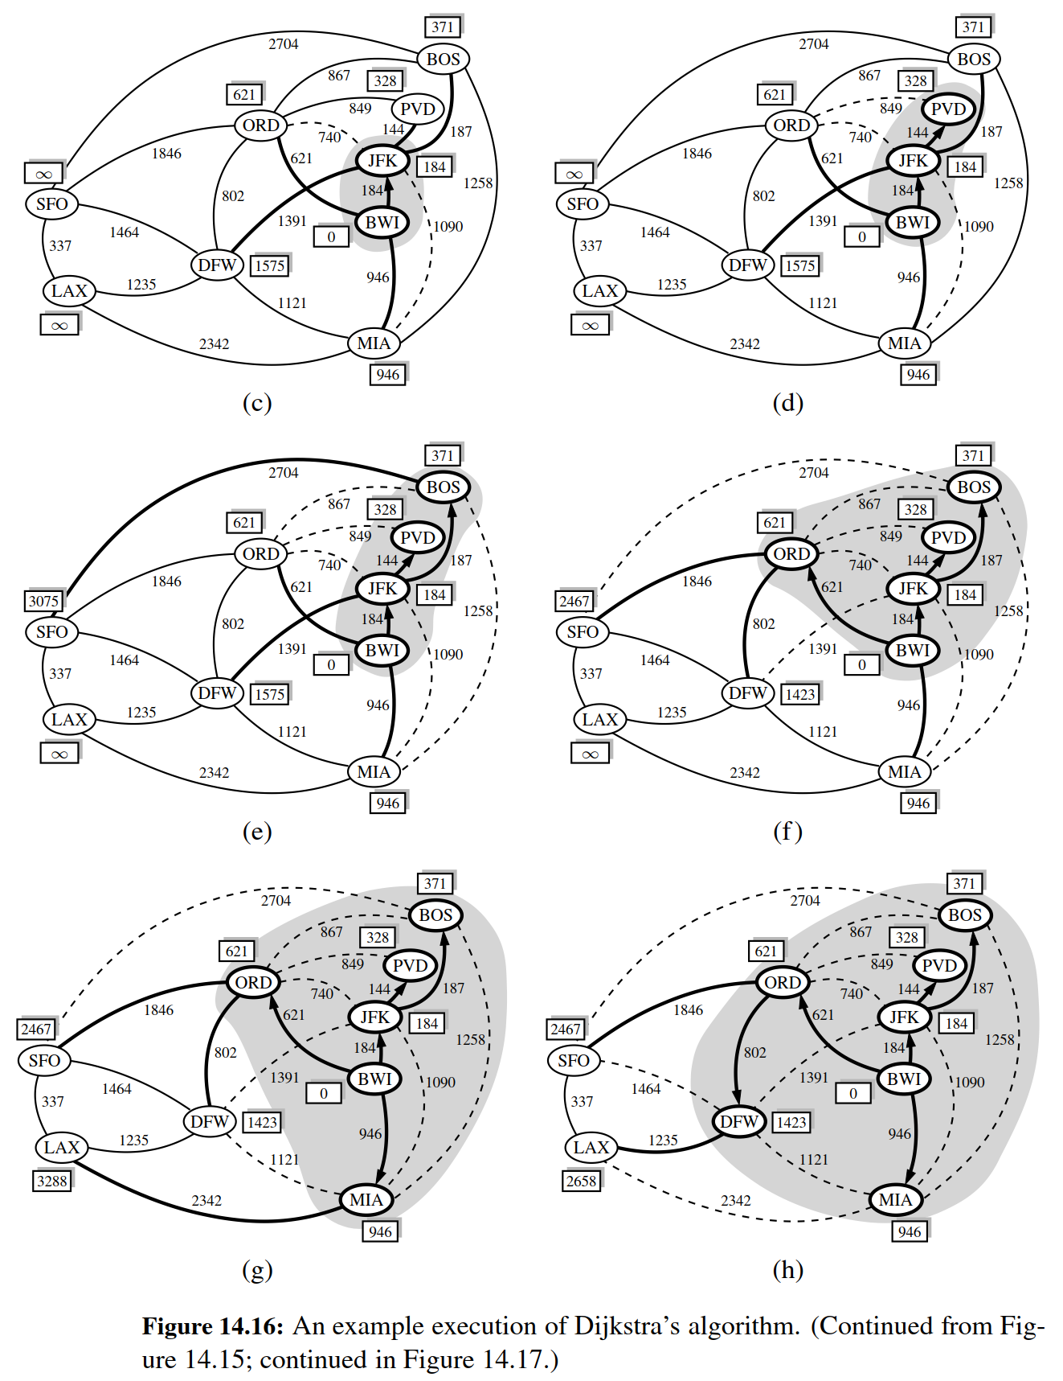

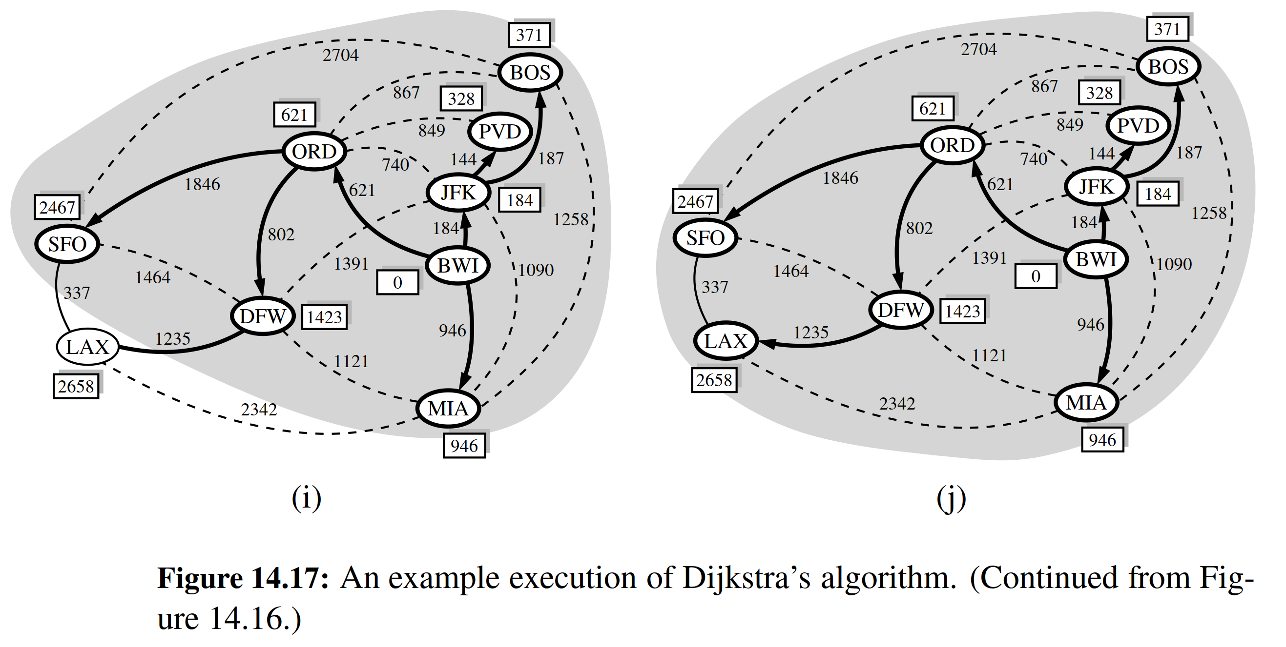

**Why It Works**

The interesting aspect of the Dijkstra algorithm is that, at the moment a vertex u is pulled into C, its label D[u] stores the correct length of a shortest path from v to u. Thus, when the algorithm terminates, it will have computed the shortest-path distance from s to every vertex of G. That is, it will have solved the single-source shortest-path problem.

It is probably not immediately clear why Dijkstra’s algorithm correctly ﬁnds the shortest path from the start vertex s to each other vertex u in the graph. Why is it that the distance from s to u is equal to the value of the label D[u] at the time vertex u is removed from the priority queue Q and added to the cloud C? The answer to this question depends on there being no negative-weight edges in the graph, for it allows the greedy method to work correctly, as we show in the proposition that follows.

Proposition 14.23: In Dijkstra’s algorithm, whenever a vertex v is pulled into the cloud, the label D[v] is equal to d(s, v), the length of a shortest path from s to v.

Justiﬁcation: Suppose that D[v] > d(s, v) for some vertex v in V , and let z

be the ﬁrst vertex the algorithm pulled into the cloud C (that is, removed from

Q) such that D[z] > d(s, z). There is a shortest path P from s to z (for otherwise d(s, z)= ∞ = D[z]). Let us therefore consider the moment when z is pulled into C, and let y be the ﬁrst vertex of P (when going from s to z) that is not in C at this

moment. Let x be the predecessor of y in path P (note that we could have x = s). (See Figure 14.18.) We know, by our choice of y, that x is already in C at this point.

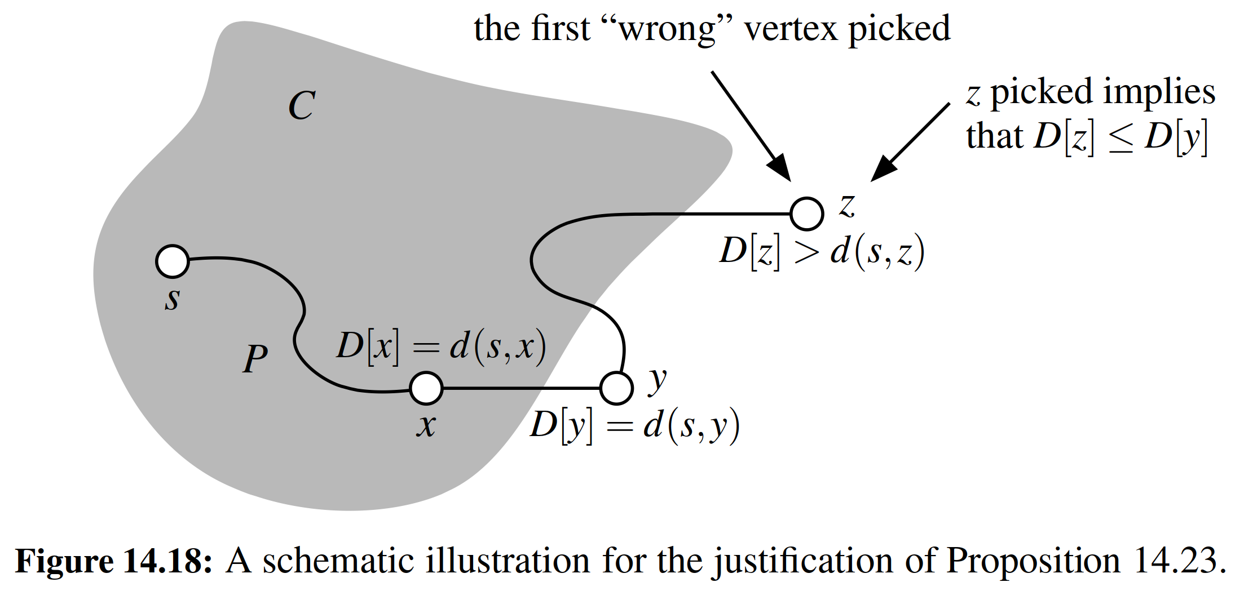

Moreover, D[x]= d(s, x), since z is the ﬁrst incorrect vertex. When x was pulled into C, we tested (and possibly updated) D[y] so that we had at that point

D[y] ≤ D[x]+ w(x, y)= d(s, x)+ w(x, y).

But since y is the next vertex on the shortest path from s to z, this implies that

D[y]= d(s, y).

But we are now at the moment when we are picking z, not y, to join C; hence,

D[z] ≤ D[y].

It should be clear that a subpath of a shortest path is itself a shortest path. Hence, since y is on the shortest path from s to z,

d(s, y)+ d(y, z)= d(s, z).

Moreover, d(y, z) ≥ 0 because there are no negative-weight edges. Therefore,

D[z] ≤ D[y]= d(s, y) ≤ d(s, y)+ d(y, z)= d(s, z).

But this contradicts the deﬁnition of z; hence, there can be no such vertex z.

The Running Time of Dijkstra’s Algorithm

In this section, we analyze the time complexity of Dijkstra’s algorithm. We denote with n and m the number of vertices and edges of the input graph G, respectively. We assume that the edge weights can be added and compared in constant time. Because of the high level of the description we gave for Dijkstra’s algorithm in Code Fragment 14.12, analyzing its running time requires that we give more details on its implementation. Speciﬁcally, we should indicate the data structures used and how they are implemented.

Let us ﬁrst assume that we are representing the graph G using an adjacency list or adjacency map structure. This data structure allows us to step through the vertices adjacent to u during the relaxation step in time proportional to their number. Therefore, the time spent in the management of the nested for loop, and the number of iterations of that loop, is



u in VG

outdeg(u),

which is O(m) by Proposition 14.9. The outer while loop executes O(n) times, since a new vertex is added to the cloud during each iteration. This still does not settle all the details for the algorithm analysis, however, for we must say more about how to implement the other principal data structure in the algorithm—the priority queue Q.

Referring back to Code Fragment 14.12 in search of priority queue operations, we ﬁnd that n vertices are originally inserted into the priority queue; since these are the only insertions, the maximum size of the queue is n. In each of n iterations of the while loop, a call to remove min is made to extract the vertex u with smallest D label from Q. Then, for each neighbor v of u, we perform an edge relaxation, and may potentially update the key of v in the queue. Thus, we actually need an implementation of an adaptable priority queue (Section 9.5), in which case the key of a vertex v is changed using the method update(£, k), where £ is the locator for the priority queue entry associated with vertex v. In the worst case, there could be one such update for each edge of the graph. Overall, the running time of Dijkstra’s algorithm is bounded by the sum of the following:

• n insertions into Q.

• n calls to the remove min method on Q.

• m calls to the update method on Q.

If Q is an adaptable priority queue implemented as a heap, then each of the above operations run in O(log n), and so the overall running time for Dijkstra’s algorithm is O((n + m) log n). Note that if we wish to express the running time as a function of n only, then it is O(n2 log n) in the worst case.

Let us now consider an alternative implementation for the adaptable priority queue Q using an unsorted sequence. (See Exercise P-9.58.) This, of course, re- quires that we spend O(n) time to extract the minimum element, but it affords very fast key updates, provided Q supports location-aware entries (Section 9.5.1). Speciﬁcally, we can implement each key update done in a relaxation step in O(1) time—we simply change the key value once we locate the entry in Q to update. Hence, this implementation results in a running time that is O(n2 + m), which can be simpliﬁed to O(n2) since G is simple.

Comparing the Two Implementations

We have two choices for implementing the adaptable priority queue with location- aware entries in Dijkstra’s algorithm: a heap implementation, which yields a run- ning time of O((n + m) log n), and an unsorted sequence implementation, which yields a running time of O(n2). Since both implementations would be fairly simple to code, they are about equal in terms of the programming sophistication needed. These two implementations are also about equal in terms of the constant factors in their worst-case running times. Looking only at these worst-case times, we prefer the heap implementation when the number of edges in the graph is small (that is, when m < n2/ log n), and we prefer the sequence implementation when the number of edges is large (that is, when m > n2/ log n).

Proposition 14.24: Given a weighted graph G with n vertices and m edges, such that the weight of each edge is nonnegative, and a vertex s of G, Dijkstra’s algorithm can compute the distance from s to all other vertices of G in the better of O(n2) or O((n + m) log n) time.

We note that an advanced priority queue implementation, known as a Fibonacci heap, can be used to implement Dijkstra’s algorithm in O(m + n log n) time.

**Programming Dijkstra’s Algorithm in Python**

Having given a pseudo-code description of Dijkstra’s algorithm, let us now present Python code for performing Dijkstra’s algorithm, assuming we are given a graph whose edge elements are nonnegative integer weights. Our implementation of the algorithm is in the form of a function, shortest path lengths, that takes a graph and a designated source vertex as parameters. (See Code Fragment 14.13.) It returns a dictionary, named cloud, mapping each vertex v that is reachable from the source to its shortest-path distance d(s, v). We rely on our AdaptableHeapPriorityQueue developed in Section 9.5.2 as an adaptable priority queue.

As we have done with other algorithms in this chapter, we rely on dictionaries to map vertices to associated data (in this case, mapping v to its distance bound D[v] and its adaptable priority queue locator). The expected O(1)-time access to elements of these dictionaries could be converted to worst-case bounds, either by numbering vertices from 0 to n − 1 to use as indices into a list, or by storing the information within each vertex’s element.

The pseudo-code for Dijkstra’s algorithm begins by assigning d[v] = ∞ for each v other than the source. We rely on the special value ﬂoat( inf ) in Python to provide a numeric value that represents positive inﬁnity. However, we avoid including vertices with this “inﬁnite” distance in the resulting cloud that is returned by the function. The use of this numeric limit could be avoided altogether by waiting to add a vertex to the priority queue until after an edge that reaches it is relaxed. (See Exercise C-14.64.)

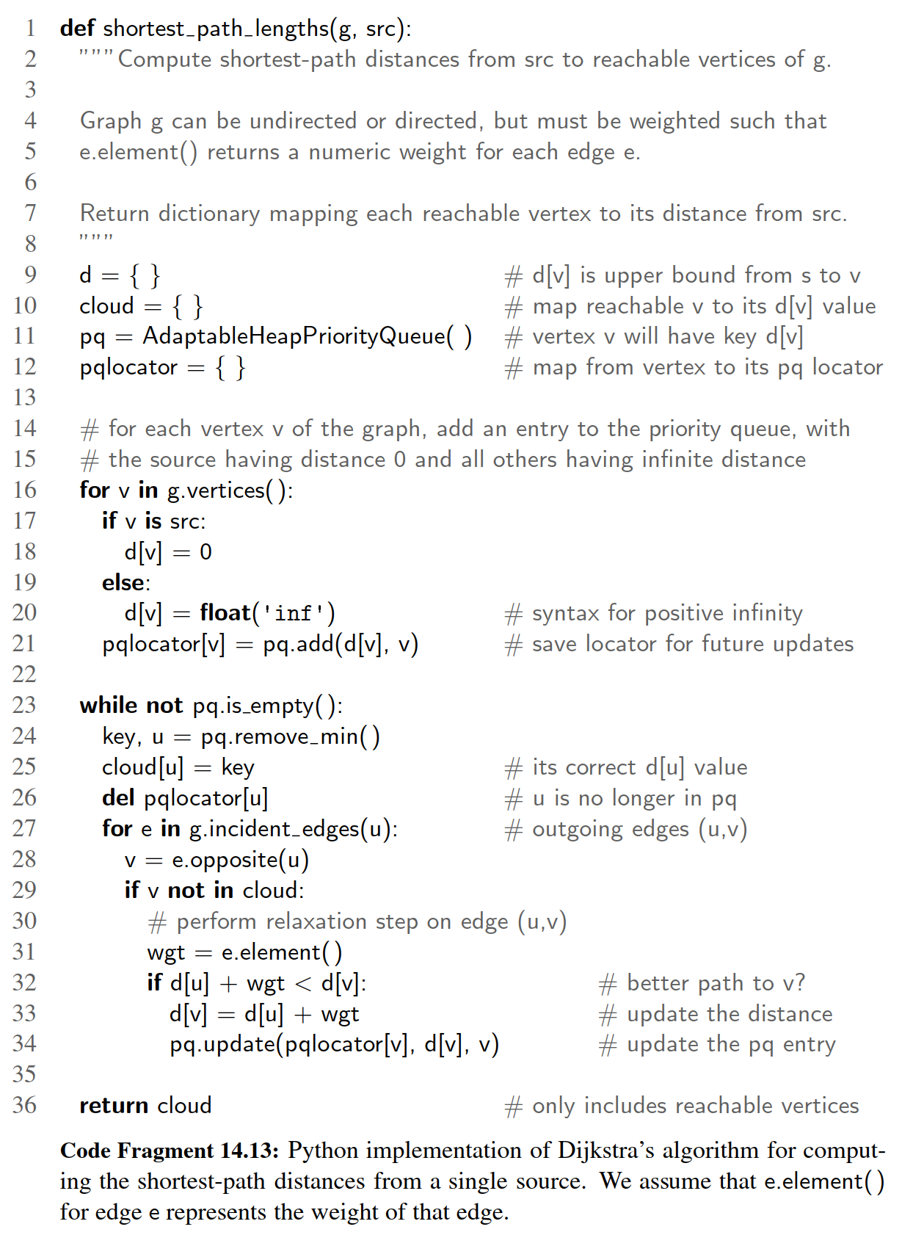

**Reconstructing the Shortest-Path Tree**

Our pseudo-code description of Dijkstra’s algorithm in Code Fragment 14.12, and our implementation in Code Fragment 14.13, computes the value d[v], for each vertex v, that is the length of the shortest path from the source vertex s to v. However, those forms of the algorithm do not explicitly compute the actual paths that achieve those distances. The collection of all shortest paths emanating from source s can be compactly represented by what is known as the shortest-path tree. The paths form a rooted tree because if a shortest path from s to v passes through an intermediate vertex u, it must begin with a shortest path from s to u.

In this section, we demonstrate that the shortest-path tree rooted at source s can be reconstructed in O(n + m) time, given the set of d[v] values produced by Dijkstra’s algorithm using s as the source. As we did when representing the DFS and BFS trees, we will map each vertex v /= s to a parent u (possibly, u = s), such

that u is the vertex immediately before v on a shortest path from s to v. If u is the vertex just before v on the shortest path from s to v, it must be that d[u]+ w(u, v)= d[v].

Conversely, if the above equation is satisﬁed, then the shortest path from s to u, followed by the edge (u, v) is a shortest path to v.

Our implementation in Code Fragment 14.14 reconstructs the tree based on this logic, testing all incoming edges to each vertex v, looking for a (u, v) that satisﬁes the key equation. The running time is O(n + m), as we consider each vertex and all incoming edges to those vertices. (See Proposition 14.9.)

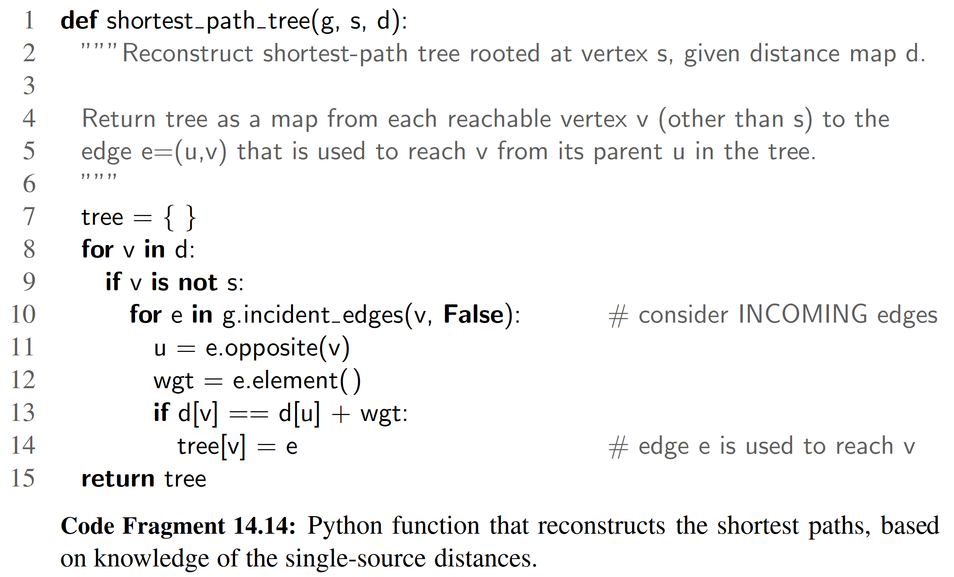

14.7 Minimum Spanning Trees

Suppose we wish to connect all the computers in a new ofﬁce building using the least amount of cable. We can model this problem using an undirected, weighted graph G whose vertices represent the computers, and whose edges represent all the possible pairs (u, v) of computers, where the weight w(u, v) of edge (u, v) is equal to the amount of cable needed to connect computer u to computer v. Rather than computing a shortest-path tree from some particular vertex v, we are interested instead in ﬁnding a tree T that contains all the vertices of G and has the minimum total weight over all such trees. Algorithms for ﬁnding such a tree are the focus of this section.

**Problem Deﬁnition**

Given an undirected, weighted graph G, we are interested in ﬁnding a tree T that contains all the vertices in G and minimizes the sum

w(T )= 

(u, v) in T

w(u, v).

A tree, such as this, that contains every vertex of a connected graph G is said to be a spanning tree, and the problem of computing a spanning tree T with smallest total weight is known as the minimum spanning tree (or MST) problem.

The development of efﬁcient algorithms for the minimum spanning tree problem predates the modern notion of computer science itself. In this section, we discuss two classic algorithms for solving the MST problem. These algorithms are both applications of the greedy method, which, as was discussed brieﬂy in the previous section, is based on choosing objects to join a growing collection by iteratively picking an object that minimizes some cost function. The ﬁrst algorithm we discuss is the Prim-Jarn´ık algorithm, which grows the MST from a single root vertex, much in the same way as Dijkstra’s shortest-path algorithm. The second algorithm we discuss is Kruskal’s algorithm, which “grows” the MST in clusters by considering edges in nondecreasing order of their weights.

In order to simplify the description of the algorithms, we assume, in the follow- ing, that the input graph G is undirected (that is, all its edges are undirected) and simple (that is, it has no self-loops and no parallel edges). Hence, we denote the edges of G as unordered vertex pairs (u, v).

Before we discuss the details of these algorithms, however, let us give a crucial fact about minimum spanning trees that forms the basis of the algorithms.

A Crucial Fact about Minimum Spanning Trees

The two MST algorithms we discuss are based on the greedy method, which in this case depends crucially on the following fact. (See Figure 14.19.)

e Belongs to a Minimum Spanning Tree

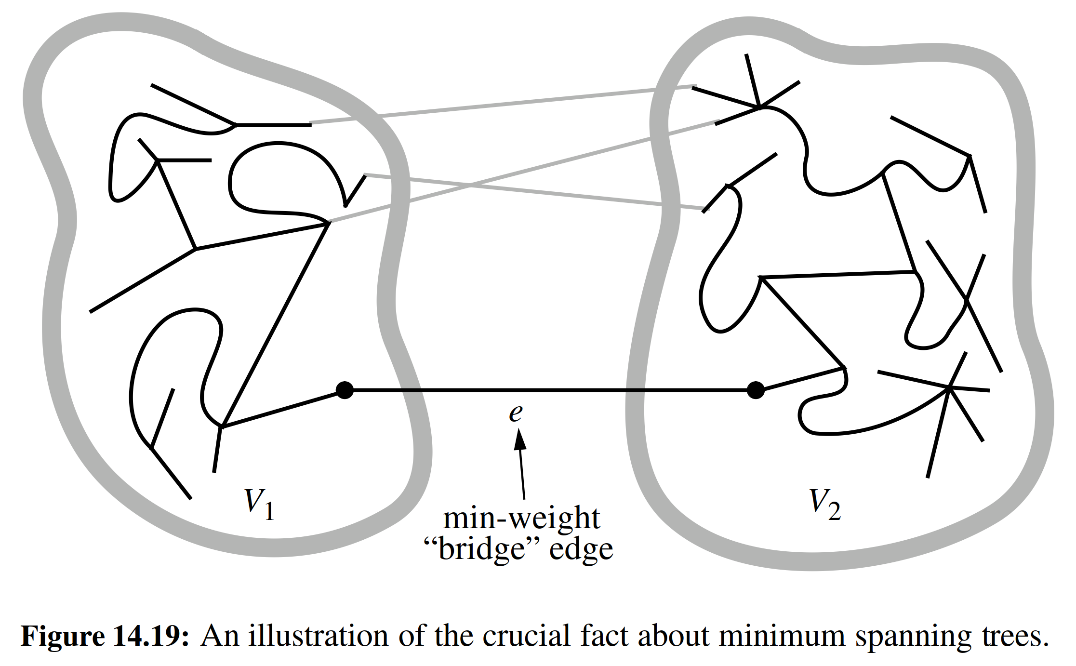

Proposition 14.25: Let G be a weighted connected graph, and let V1 and V2 be a partition of the vertices of G into two disjoint nonempty sets. Furthermore, let e be an edge in G with minimum weight from among those with one endpoint in V1 and the other in V2. There is a minimum spanning tree T that has e as one of its edges.

Justiﬁcation: Let T be a minimum spanning tree of G. If T does not contain edge e, the addition of e to T must create a cycle. Therefore, there is some edge f /= e of this cycle that has one endpoint in V1 and the other in V2. Moreover, by the choice of e, w(e) w( f ). If we remove f from T e , we obtain a spanning tree whose total weight is no more than before. Since T was a minimum spanning tree, this new tree must also be a minimum spanning tree.

In fact, if the weights in G are distinct, then the minimum spanning tree is unique; we leave the justiﬁcation of this less crucial fact as an exercise (C-14.65). In addition, note that Proposition 14.25 remains valid even if the graph G con- tains negative-weight edges or negative-weight cycles, unlike the algorithms we presented for shortest paths.

14.7.1 Prim-Jarn´ık Algorithm

In the Prim-Jarn´ık algorithm, we grow a minimum spanning tree from a single cluster starting from some “root” vertex s. The main idea is similar to that of Dijkstra’s algorithm. We begin with some vertex s, deﬁning the initial “cloud” of vertices C. Then, in each iteration, we choose a minimum-weight edge e = (u, v), connecting a vertex u in the cloud C to a vertex v outside of C. The vertex v is then brought into the cloud C and the process is repeated until a spanning tree is formed. Again, the crucial fact about minimum spanning trees comes into play, for by always choosing the smallest-weight edge joining a vertex inside C to one outside C, we are assured of always adding a valid edge to the MST.

To efﬁciently implement this approach, we can take another cue from Dijkstra’s algorithm. We maintain a label D[v] for each vertex v outside the cloud C, so that D[v] stores the weight of the minimum observed edge for joining v to the cloud C. (In Dijkstra’s algorithm, this label measured the full path length from starting vertex s to v, including an edge (u, v).) These labels serve as keys in a priority queue used to decide which vertex is next in line to join the cloud. We give the pseudo-code in Code Fragment 14.15.

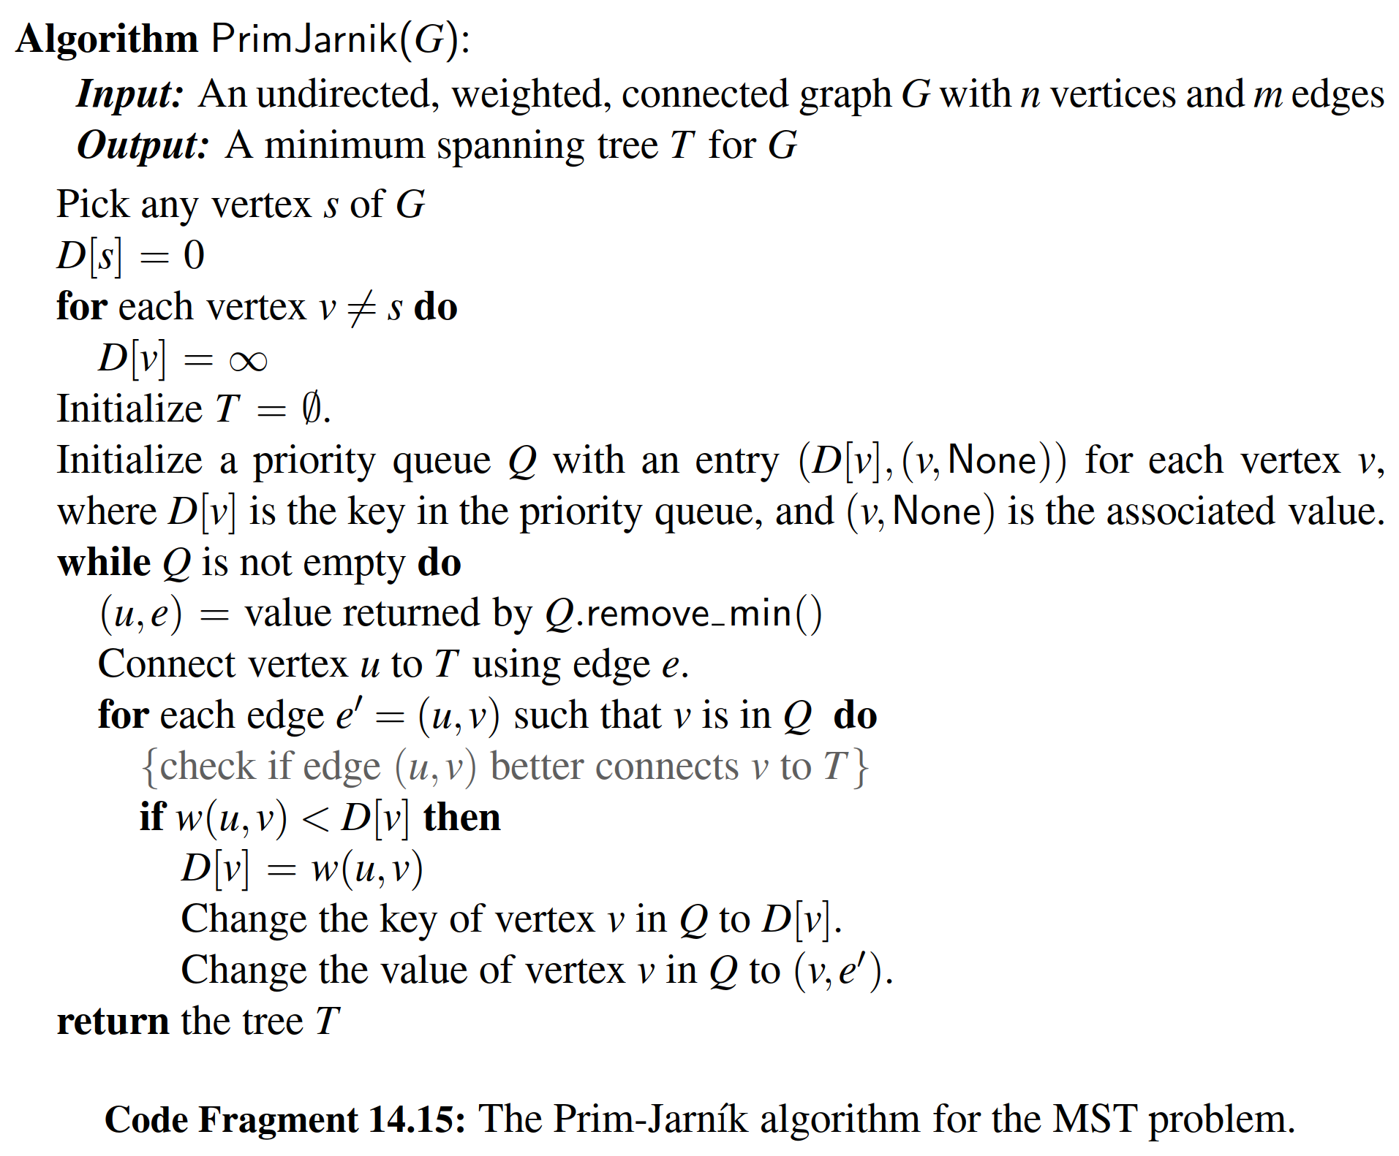

**Analyzing the Prim-Jarn´ık Algorithm**

The implementation issues for the Prim-Jarn´ık algorithm are similar to those for Dijkstra’s algorithm, relying on an adaptable priority queue Q (Section 9.5.1). We initially perform n insertions into Q, later perform n extract-min operations, and may update a total of m priorities as part of the algorithm. Those steps are the primary contributions to the overall running time. With a heap-based priority queue, each operation runs in O(log n) time, and the overall time for the algorithm is O((n + m) log n), which is O(m log n) for a connected graph. Alternatively, we can achieve O(n2) running time by using an unsorted list as a priority queue.

Illustrating the Prim-Jarn´ık Algorithm

We illustrate the Prim-Jarn´ık algorithm in Figures 14.20 through 14.21.

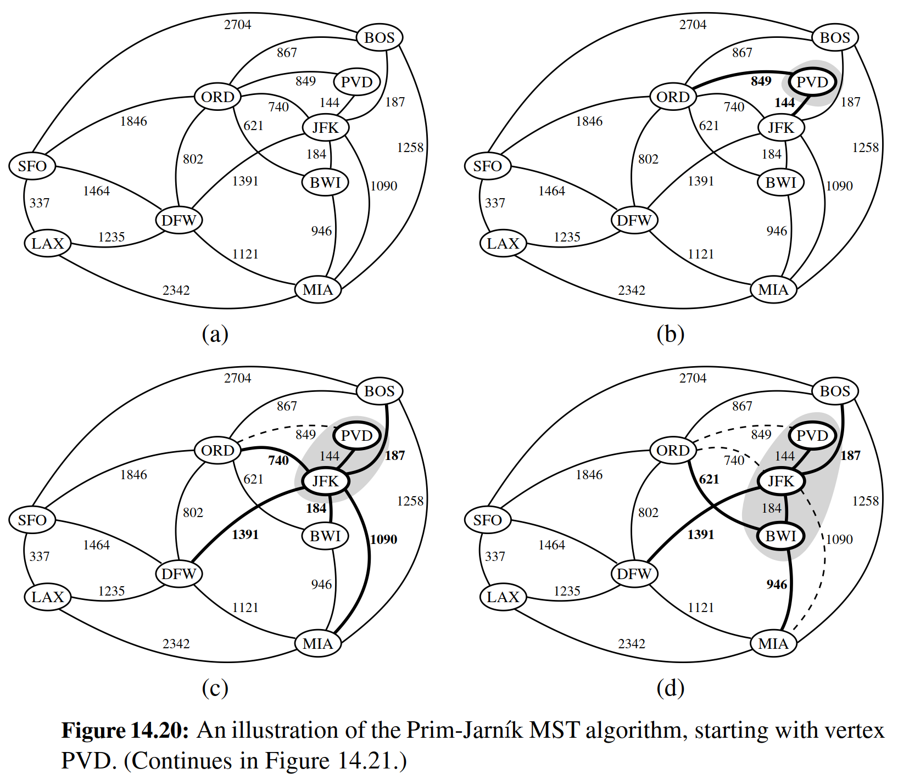

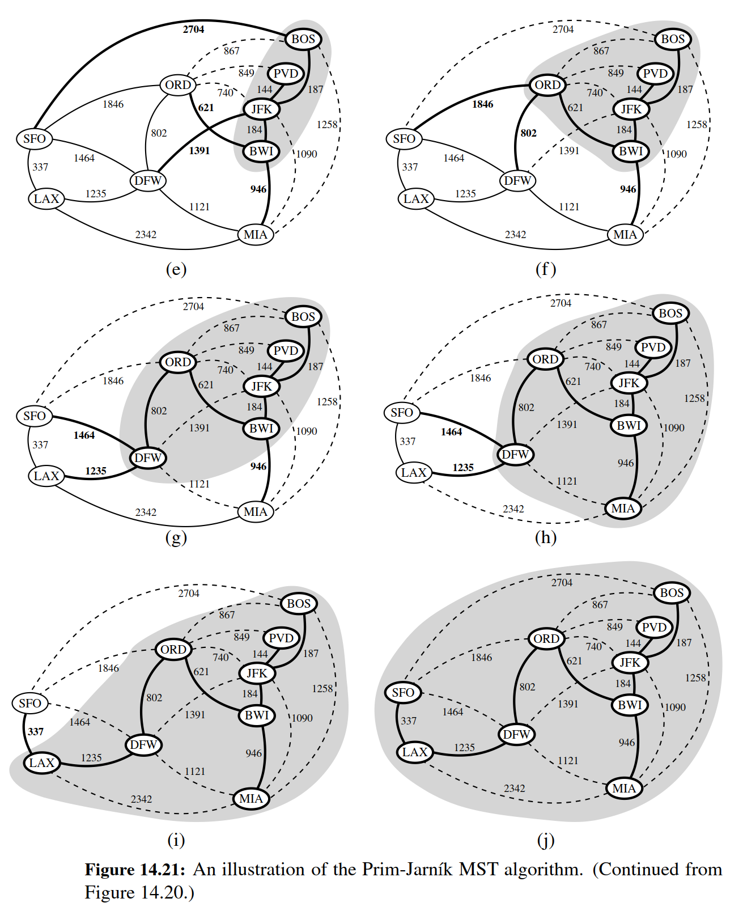

Python Implementation

Code Fragment 14.16 presents a Python implementation of the Prim-Jarn´ık algorithm. The MST is returned as an unordered list of edges.

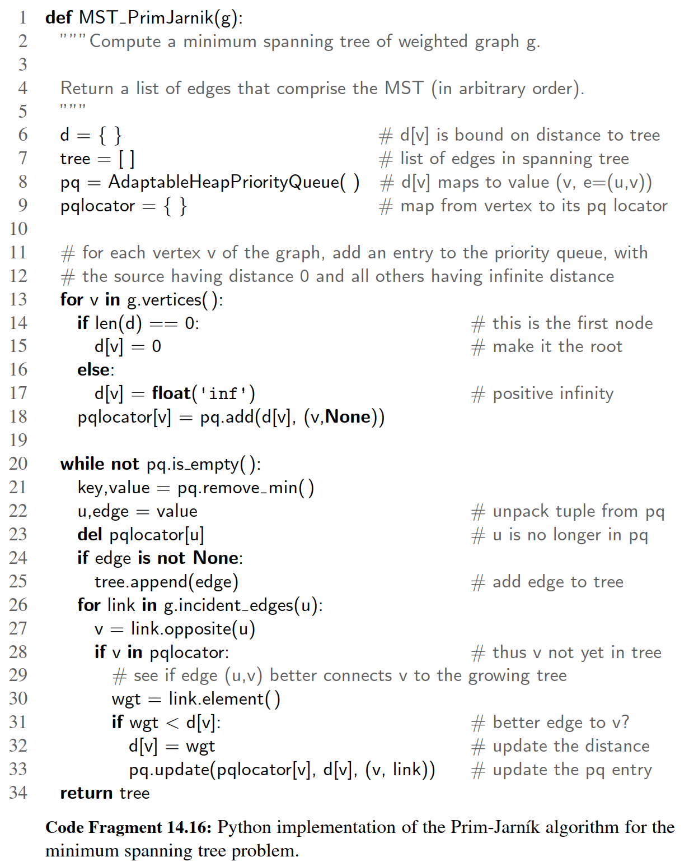

14.7.2 Kruskal’s Algorithm

In this section, we introduce Kruskal’s algorithm for constructing a minimum spanning tree. While the Prim-Jarn´ık algorithm builds the MST by growing a single tree until it spans the graph, Kruskal’s algorithm maintains a forest of clusters, repeat- edly merging pairs of clusters until a single cluster spans the graph.

Initially, each vertex is by itself in a singleton cluster. The algorithm then considers each edge in turn, ordered by increasing weight. If an edge e connects two different clusters, then e is added to the set of edges of the minimum spanning tree, and the two clusters connected by e are merged into a single cluster. If, on the other hand, e connects two vertices that are already in the same cluster, then e is discarded. Once the algorithm has added enough edges to form a spanning tree, it terminates and outputs this tree as the minimum spanning tree.

We give pseudo-code for Kruskal’s MST algorithm in Code Fragment 14.17 and we show an example of this algorithm in Figures 14.22, 14.23, and 14.24.

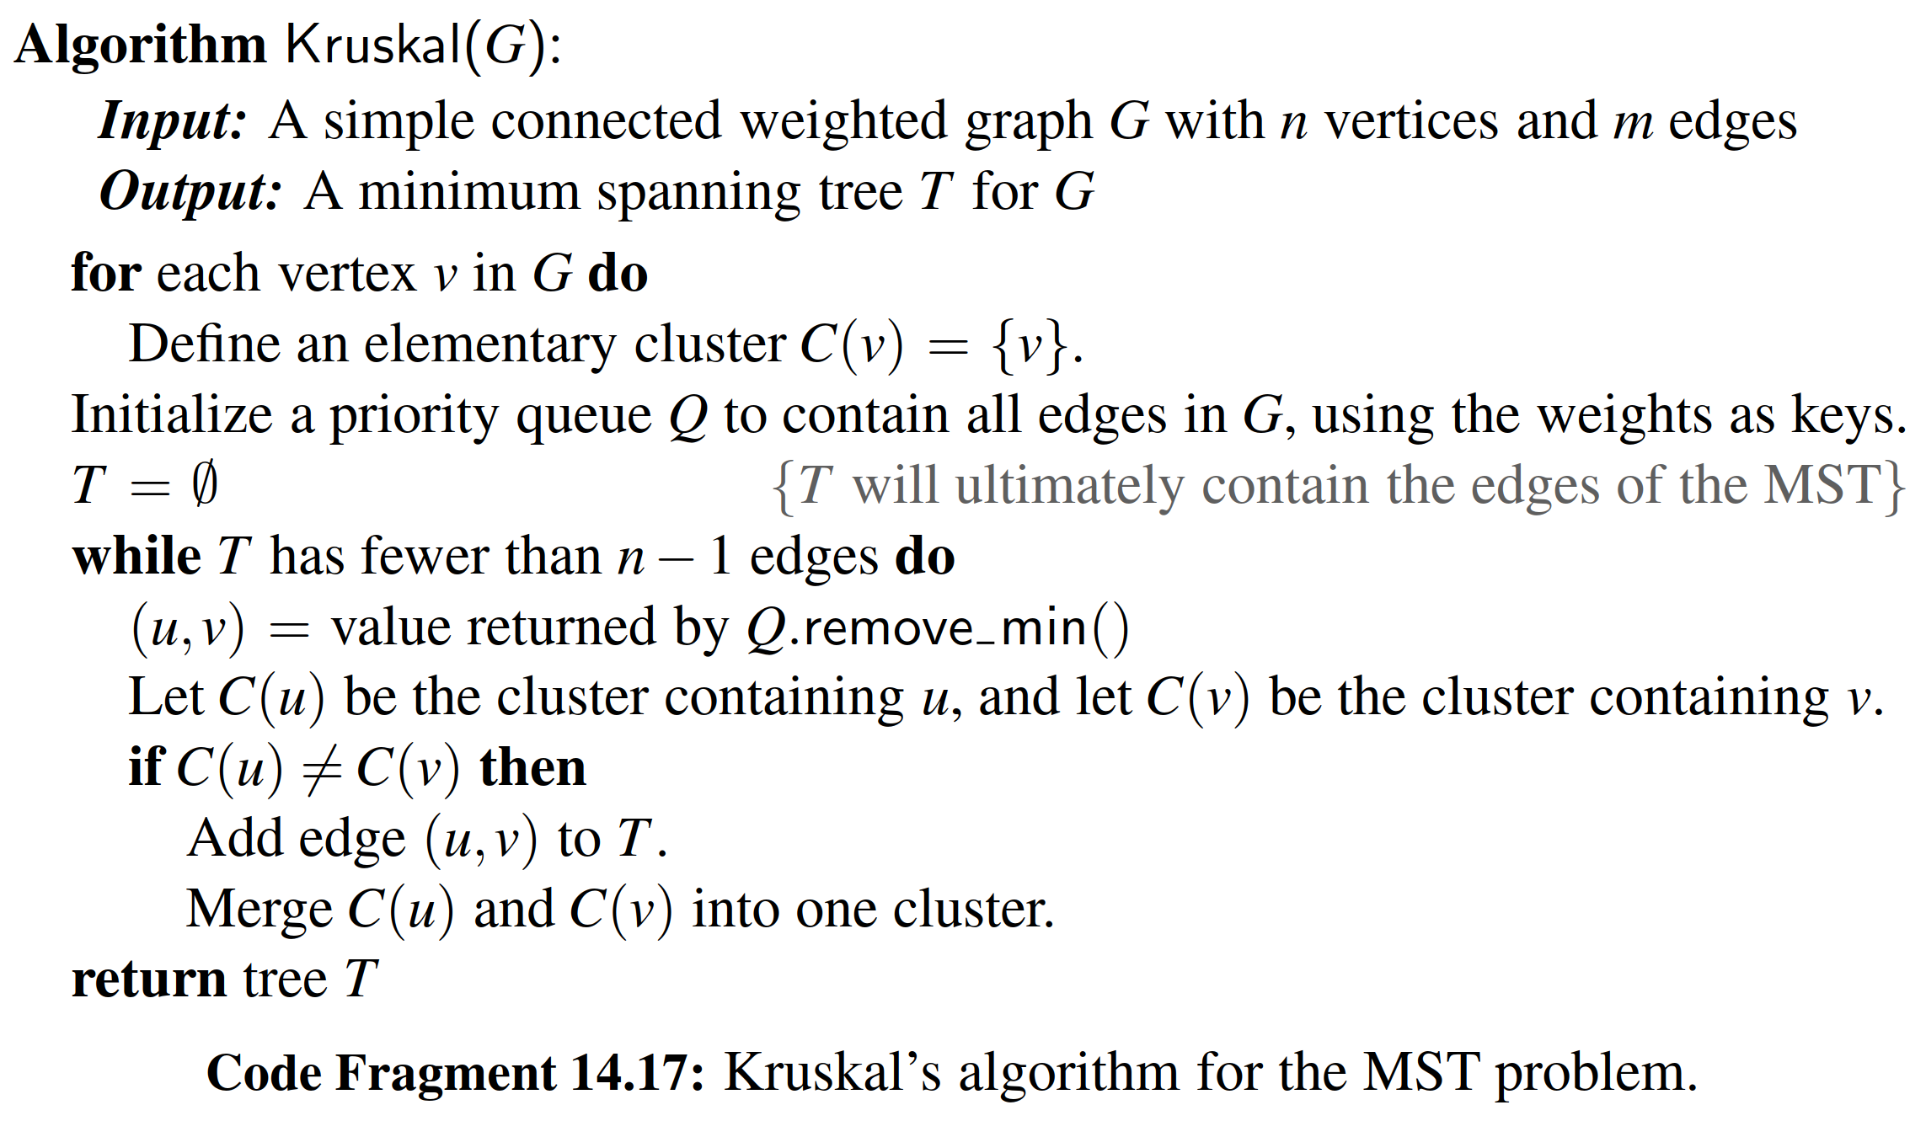

As was the case with the Prim-Jarn´ık algorithm, the correctness of Kruskal’s algorithm is based upon the crucial fact about minimum spanning trees from Proposition 14.25. Each time Kruskal’s algorithm adds an edge (u, v) to the minimum spanning tree T , we can deﬁne a partitioning of the set of vertices V (as in the proposition) by letting V1 be the cluster containing v and letting V2 contain the rest of the vertices in V . This clearly deﬁnes a disjoint partitioning of the vertices of V and, more importantly, since we are extracting edges from Q in order by their weights, e must be a minimum-weight edge with one vertex in V1 and the other in V2. Thus, Kruskal’s algorithm always adds a valid minimum spanning tree edge.

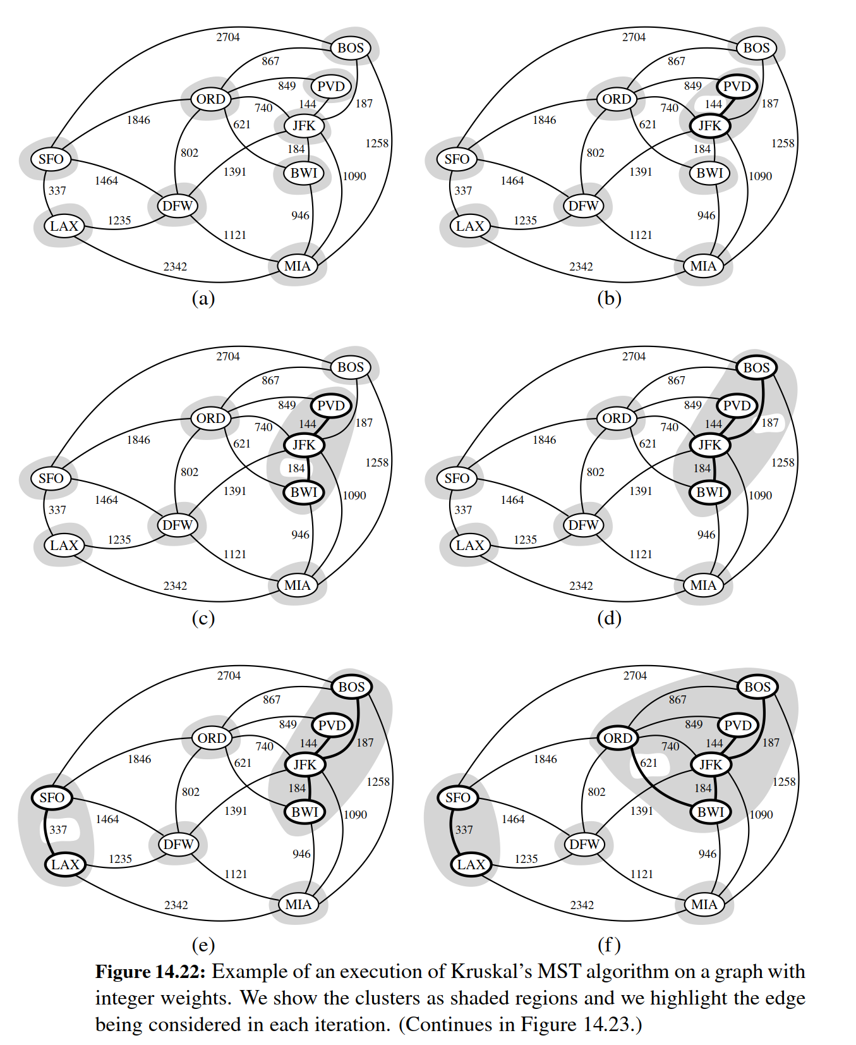

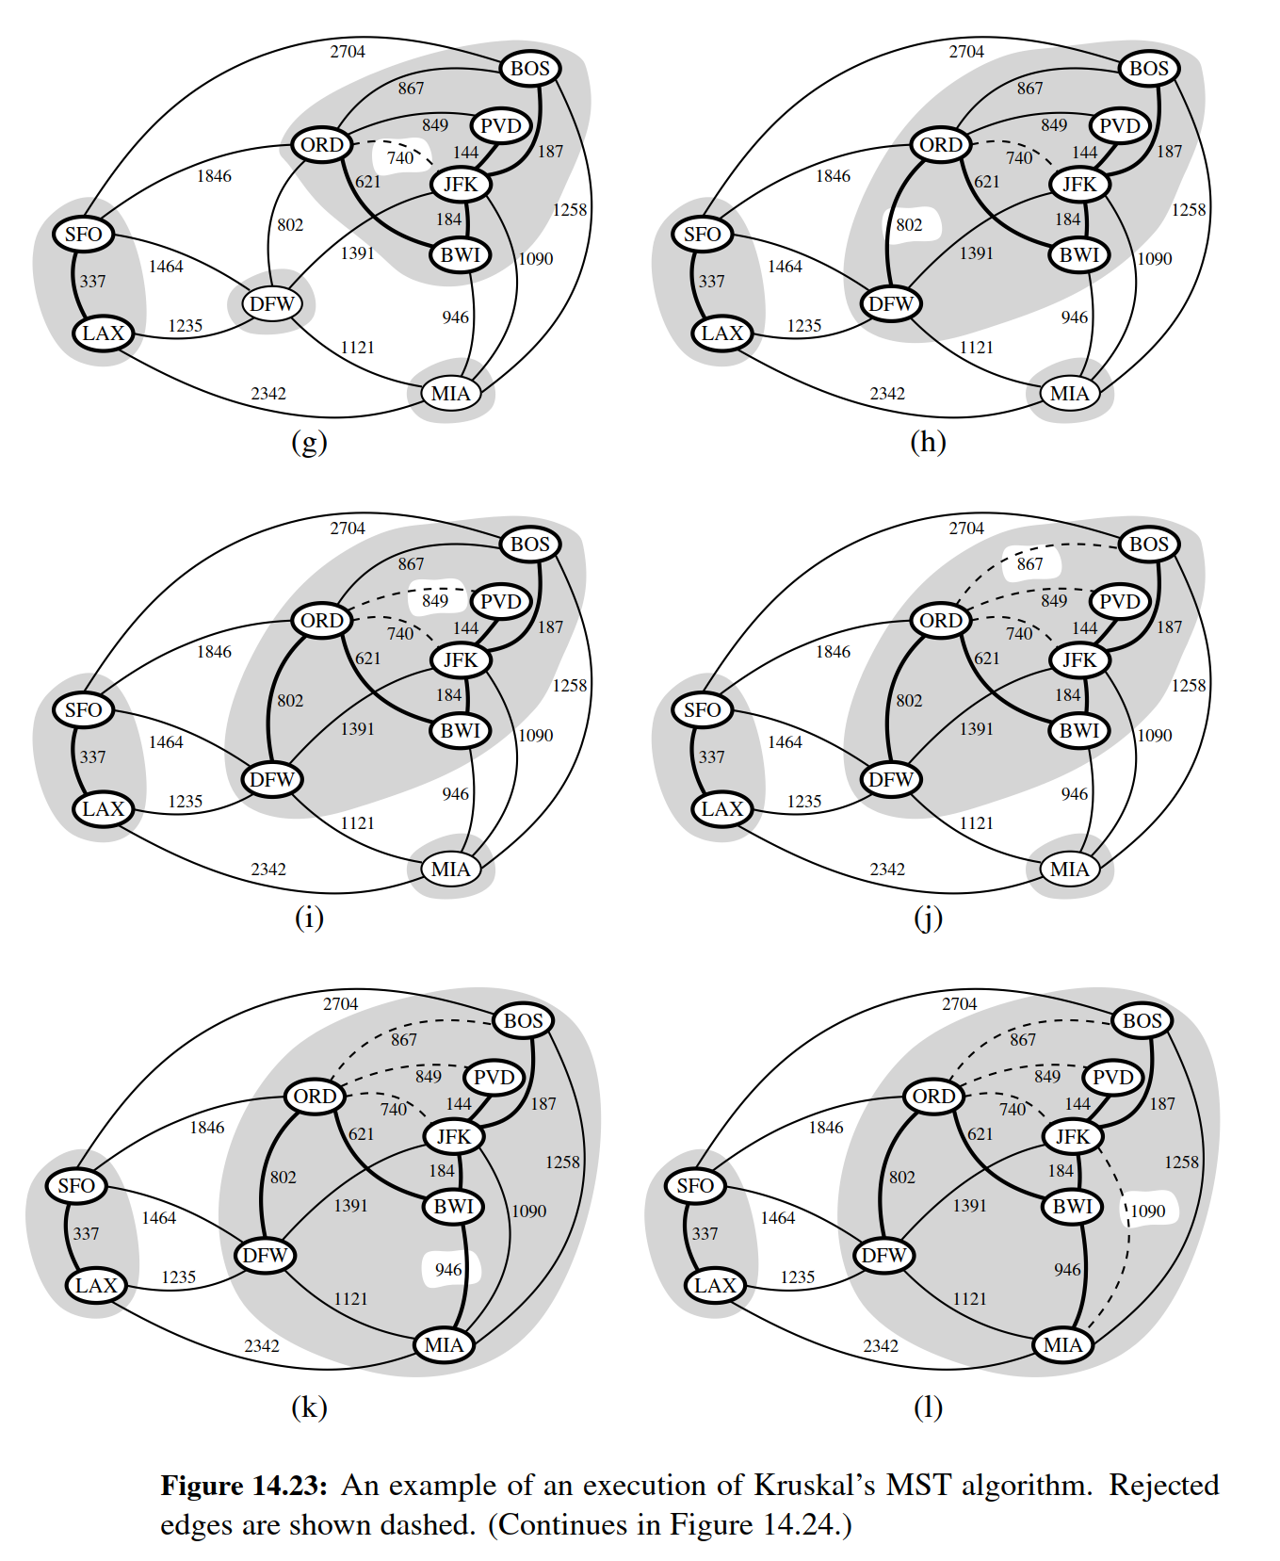

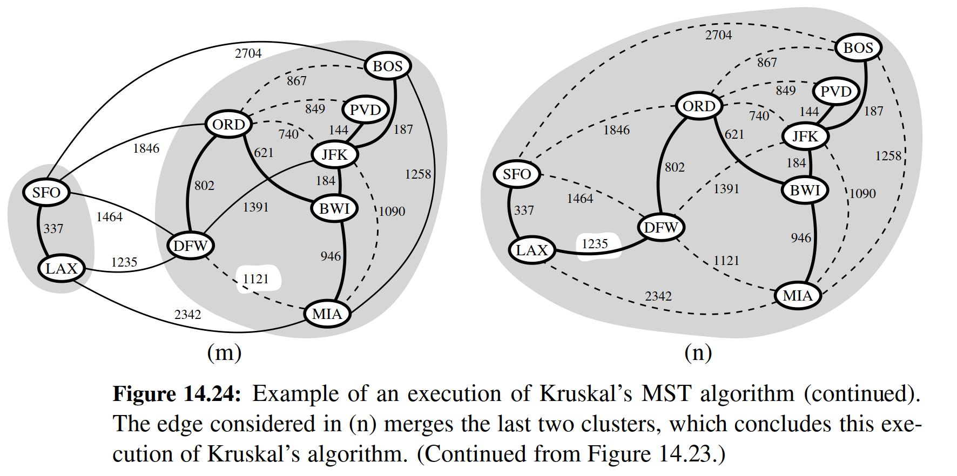

**The Running Time of Kruskal’s Algorithm**

There are two primary contributions to the running time of Kruskal’s algorithm. The ﬁrst is the need to consider the edges in nondecreasing order of their weights, and the second is the management of the cluster partition. Analyzing its running time requires that we give more details on its implementation.

The ordering of edges by weight can be implemented in O(m log m), either by use of a sorting algorithm or a priority queue Q. If that queue is implemented with a heap, we can initialize Q in O(m log m) time by repeated insertions, or in O(m) time using bottom-up heap construction (see Section 9.3.6), and the subsequent calls to remove min each run in O(log m) time, since the queue has size O(m). We note that since m is O(n2) for a simple graph, O(log m) is the same as O(log n). Therefore, the running time due to the ordering of edges is O(m log n).

The remaining task is the management of clusters. To implement Kruskal’s algorithm, we must be able to ﬁnd the clusters for vertices u and v that are endpoints of an edge e, to test whether those two clusters are distinct, and if so, to merge those two clusters into one. None of the data structures we have studied thus far are well suited for this task. However, we conclude this chapter by formalizing the problem of managing disjoint partitions, and introducing efﬁcient union-ﬁnd data structures. In the context of Kruskal’s algorithm, we perform at most 2mﬁnd operations and n − 1 union operations. We will see that a simple union-ﬁnd structure can perform that combination of operations in O(m + n log n) time (see Proposition 14.26), and a more advanced structure can support an even faster time.

For a connected graph, m ≥ n − 1, and therefore, the bound of O(m log n) time

for ordering the edges dominates the time for managing the clusters. We conclude that the running time of Kruskal’s algorithm is O(m log n).

**Python Implementation**

Code Fragment 14.18 presents a Python implementation of Kruskal’s algorithm. As with our implementation of the Prim-Jarn´ık algorithm, the minimum spanning tree is returned in the form of a list of edges. As a consequence of Kruskal’s algorithm, those edges will be reported in nondecreasing order of their weights.

Our implementation assumes use of a Partition class for managing the cluster partition. An implementation of the Partition class is presented in Section 14.7.3.

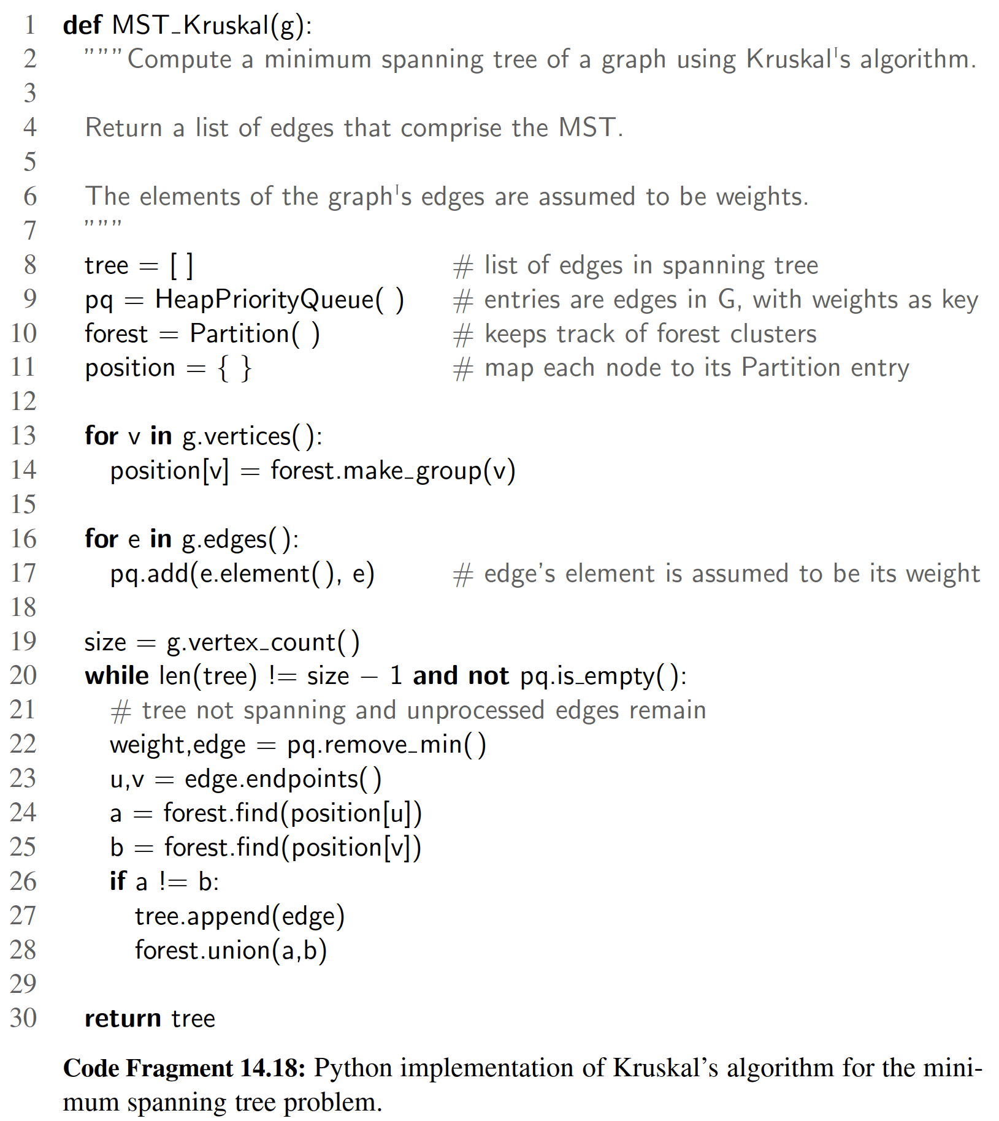

14.7.3 Disjoint Partitions and Union-Find Structures

In this section, we consider a data structure for managing a partition of elements into a collection of disjoint sets. Our initial motivation is in support of Kruskal’s minimum spanning tree algorithm, in which a forest of disjoint trees is maintained, with occasional merging of neighboring trees. More generally, the disjoint partition problem can be applied to various models of discrete growth.

We formalize the problem with the following model. A partition data structure manages a universe of elements that are organized into disjoint sets (that is, an element belongs to one and only one of these sets). Unlike with the Set ADT or Python’s set class, we do not expect to be able to iterate through the contents of a set, nor to efﬁciently test whether a given set includes a given element. To avoid confusion with such notions of a set, we will refer to the clusters of our partition as groups. However, we will not require an explicit structure for each group, instead allowing the organization of groups to be implicit. To differentiate between one group and another, we assume that at any point in time, each group has a designated entry that we refer to as the leader of the group.

Formally, we deﬁne the methods of a partition ADT using position objects, each of which stores an element x. The partition ADT supports the following methods.

make group(x): Create a singleton group containing new element x and return the position storing x.

union(p, q): Merge the groups containing positions p and q.

ﬁnd(p): Return the position of the leader of the group containing position p.

**Sequence Implementation**

A simple implementation of a partition with a total of n elements uses a collection of sequences, one for each group, where the sequence for a group A stores element positions. Each position object stores a variable, element, which references its associated element x and allows the execution of an element() method in O(1) time. In addition, each position stores a variable, group, that references the sequence storing p, since this sequence is representing the group containing p’s element. (See Figure 14.25.)

With this representation, we can easily perform the make group(x) and ﬁnd(p) operations in O(1) time, allowing the ﬁrst position in a sequence to serve as the “leader.” Operation union(p, q) requires that we join two sequences into one and update the group references of the positions in one of the two. We choose to imple- ment this operation by removing all the positions from the sequence with smaller size, and inserting them in the sequence with larger size. Each time we take a po- sition from the smaller group a and insert it into the larger group b, we update the group reference for that position to now point to b. Hence, the operation union(p, q) takes time O(min(np, nq)), where np (resp. nq) is the cardinality of the group con- taining position p (resp. q). Clearly, this time is O(n) if there are n elements in the partition universe. However, we next present an amortized analysis that shows this implementation to be much better than appears from this worst-case analysis.

Proposition 14.26: When using the above sequence-based partition implementation, performing a series of k make group, union, and ﬁnd operations on an initially empty partition involving at most n elements takes O(k + n log n) time.

Justiﬁcation: We use the accounting method and assume that one cyber-dollar can pay for the time to perform a ﬁnd operation, a make group operation, or the movement of a position object from one sequence to another in a union operation. In the case of a ﬁnd or make group operation, we charge the operation itself 1 cyber-dollar. In the case of a union operation, we assume that 1 cyber-dollar pays for the constant-time work in comparing the sizes of the two sequences, and that we charge 1 cyber-dollar to each position that we move from the smaller group to the larger group. Clearly, the 1 cyber-dollar charged for each ﬁnd and make group operation, together with the ﬁrst cyber-dollar collected for each union operation, accounts for a total of k cyber-dollars.

Consider, then, the number of charges made to positions on behalf of union operations. The important observation is that each time we move a position from one group to another, the size of that position’s group at least doubles. Thus, each position is moved from one group to another at most log n times; hence, each po- sition can be charged at most O(log n) times. Since we assume that the partition is initially empty, there are O(n) different elements referenced in the given series of operations, which implies that the total time for moving elements during the union operations is O(n log n).

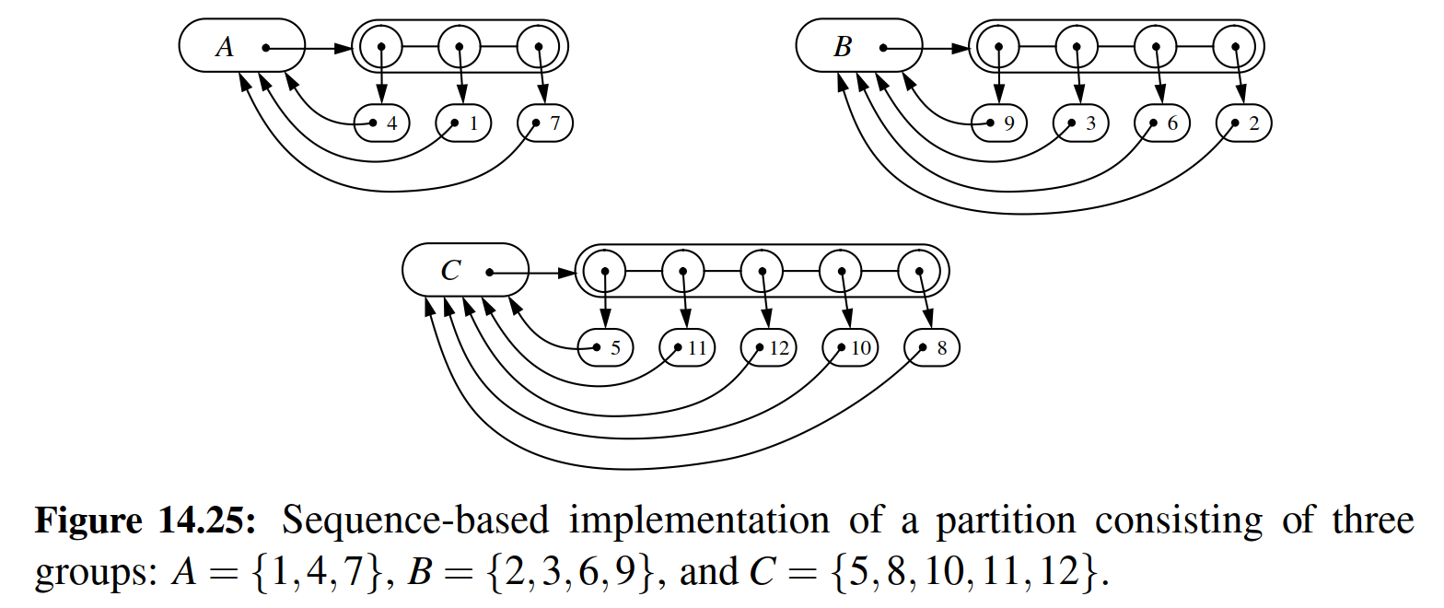

**A Tree-Based Partition Implementation \***

An alternative data structure for representing a partition uses a collection of trees to store the n elements, where each tree is associated with a different group. (See Figure 14.26.) In particular, we implement each tree with a linked data struc- ture whose nodes are themselves the group position objects. We view each position p as being a node having an instance variable, element, referring to its element x, and an instance variable, parent, referring to its parent node. By convention, if p is the root of its tree, we set p’s parent reference to itself.

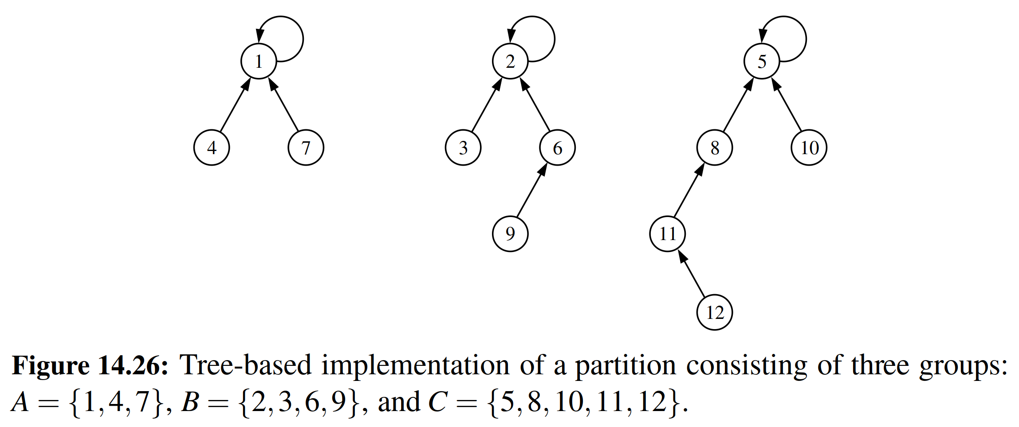

With this partition data structure, operation ﬁnd(p) is performed by walking up from position p to the root of its tree, which takes O(n) time in the worst case. Operation union(p, q) can be implemented by making one of the trees a subtree of the other. This can be done by ﬁrst locating the two roots, and then in O(1) additional time by setting the parent reference of one root to point to the other root. See Figure 14.27 for an example of both operations.

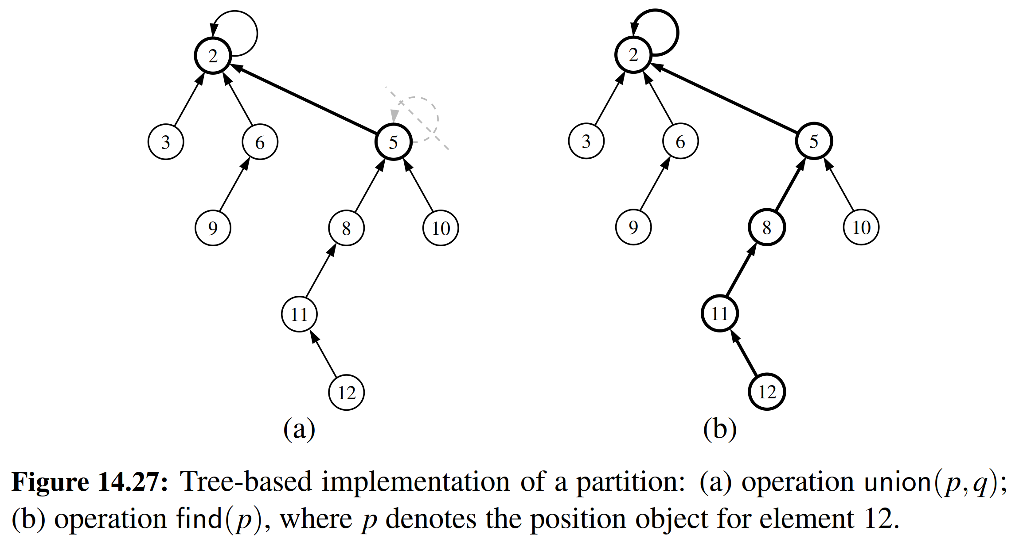

At ﬁrst, this implementation may seem to be no better than the sequence-based data structure, but we add the following two simple heuristics to make it run faster.

Union-by-Size: With each position p, store the number of elements in the subtree rooted at p. In a union operation, make the root of the smaller group become a child of the other root, and update the size ﬁeld of the larger root.

Path Compression: In a ﬁnd operation, for each position q that the ﬁnd visits, reset the parent of q to the root. (See Figure 14.28.)

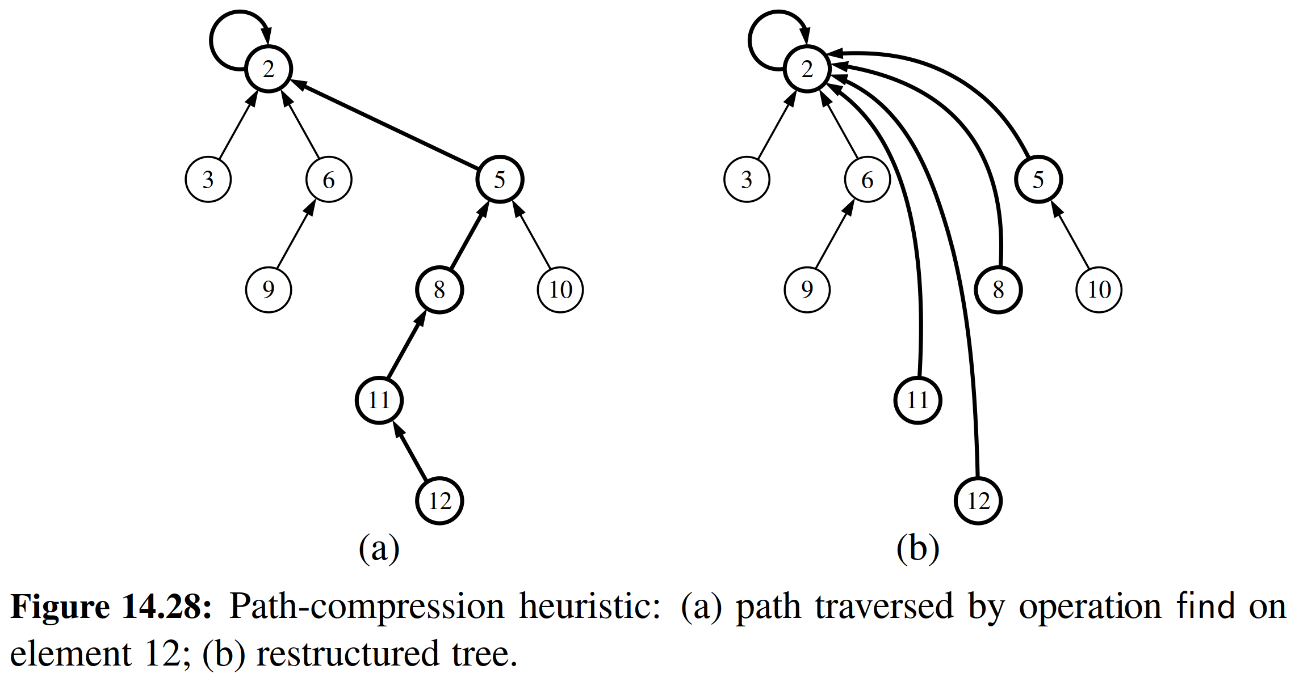

A surprising property of this data structure, when implemented using the union-by-size and path-compression heuristics, is that performing a series of k operations involving n elements takes O(k log∗ n) time, where log∗ n is the log-star function, which is the inverse of the tower-of-twos function. Intuitively, log∗ n is the number

of times that one can iteratively take the logarithm (base 2) of a number before getting a number smaller than 2. Table 14.4 shows a few sample values.

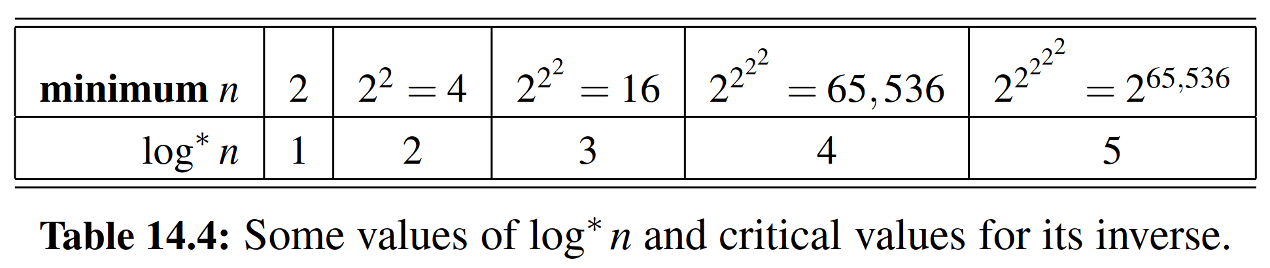

Proposition 14.27: When using the tree-based partition representation with both union-by-size and path compression, performing a series of k make group, union, and ﬁnd operations on an initially empty partition involving at most n elements

takes O(k log∗ n) time.

Although the analysis for this data structure is rather complex, its implemen- tation is quite straightforward. We conclude with complete Python code for the structure, given in Code Fragment 14.19.

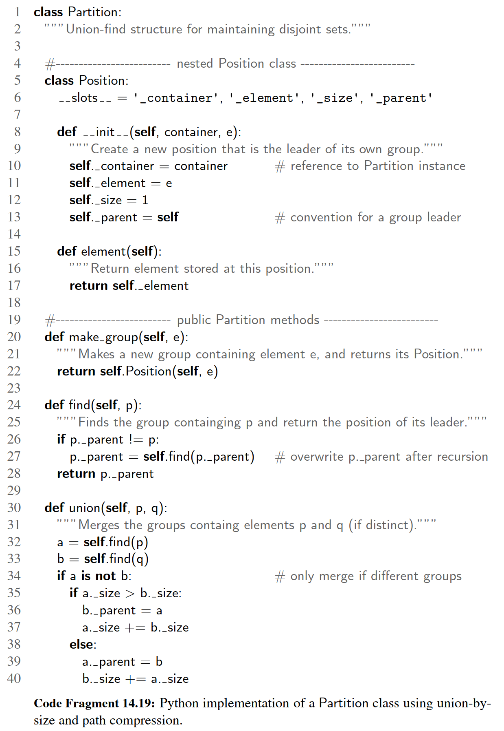

**END**

# 六、实验体会

# 七、参考文献

[1] Michael T. Goodrich, Roberto Tamassia, Michael H. Goldwasser, Data Structures and Algorithms in Python

[2] 数据结构与算法分析：C语言描述（原书第二版），（美）维斯著；冯舜玺译. 北京：机械工业出版社

[3] 算法导论（原书第三版），（美）科尔曼（Cormen，T.H.）等；殷建平等译. 北京：机械工业出版社